PBS Unit 1 Review Sheet Name_____________________

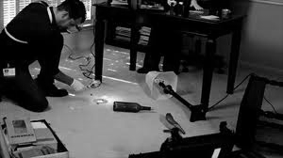
- List four types of evidence that could be collected and analyzed from a crime scene.

- How can bloodstain patterns left at a crime scene help investigators establish the events that took place during the crime?

- Determine if the following sentences are inferences or observations.
- _____ The woman wore a short sleeved red dress because it was very hot outside.
- ______ The vampire dove off the skyscraper and went after the zombie walking nearby.
- ______ Beyoncé pulled JayZ toward her and stopped inches from his lips.
- ______ Mr. Vest has students in his classroom between blocks because he is the coolest teacher.
- ______ She screamed as the body fell from the roof of the building.

- Put the following statements in the correct order to show experimental design
______ There is a chicken on the other side of the road.
______ Set up buckets of food across the road from 5 chickens.
______ My hypothesis was supported because 4/5 chickens crossed the road to get to food on the
other side.
______ Why did the chicken cross the road?
______ 4/5 chickens cross the road
______ The chickens were crossing to get food.

- Go to the following webpage and cite it using APA formatting.
http://www.nij.gov/topics/law-enforcement/investigations/crime-scene/guides/general-scenes/process.htm

- What are two reasons it is important to document the source of the information we use?
a.
b.

- List how each career played a role in the Anna Garcia mystery.
- EMT
- 911 operator
- CSI
- Forensic pathologist

- What is the difference between a Medical Examiner and a Coroner?

- What are three manners of death?

- How is manner of death different from cause of death?

- Name three parts of an autopsy.

- Name four tools used during an autopsy and what they are used for.

- What are two ways for a forensic pathologist to tell time of death?

- Explain in your own words what HIPPA is.

- Is HIPPA being violated in the following situations? Circle the answer.
I work in admitting. A friend who works in the ER told me that she just saw a famous movie star get on the elevator. My friend read in the paper that the movie star has cancer and asked me to find out what floor the star is on because we know which floors are where cancer patients are treated. I tell her the floor. YES NO

A news reporter comes into the ER and tells the attending physician that there is
suspicion that the accident in which the 25-year-old female was injured was caused by a
sniper shooting on the freeway and he is doing a story for the nightly news. He wants
the patient’s name and condition for his report. The information is given after receiving consent from the patient. YES NO

A 19-year-old UCLA student is admitted through the ER for injuries sustained in a
motor vehicle accident. He is in stable condition, but awake and alert. His father calls
from Minnesota asking for information on his condition. You give the information after verifying that he is the patient’s father. YES NO

- On the following diagram label adenine (A), thymine (T), cytosine (C), guanine (G), phosphate, nucleotide, hydrogen bonds, sugar
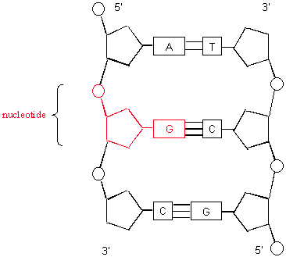

- What type of molecule is the structure in the diagram above? _________
- If you compare this molecule from several different humans, what would be different about the molecule?

- On the first gel below draw an arrow from the wells in the middle in the direction the DNA would move during electrophoresis (HINT: look at the +/-). For the second gel mark where the shortest DNA fragments would be found if the DNA were to move down the gel from the wells at the top.

- During electrophoresis, what causes the DNA to move out of the wells and through the gel?

- Look at the gel below, which suspect number matches the crime scene (CS) DNA. ________
#1 #2 #3 #4 #5 CS Marker

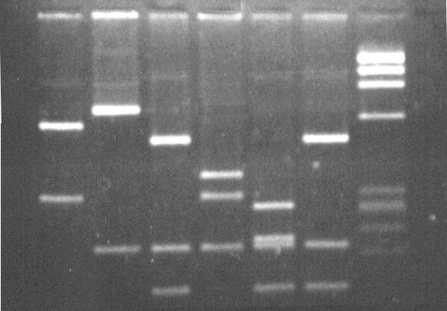

- Write the strand of DNA that would bind with this strand: A T C G T C A G G

- The restriction EcoR1 cuts at the following sequence TATT C (cut between the last T and C)
Mark on this strand of DNA where the restriction enzyme EcoR1 would cut.

T A T T C C G G T A T T C A C G G C T A A T A C C G G T T A T T C A G C G
A T A A G G C C A T A A G T G C C G A T T A T G G C C A A T A A G T C G C

- How many RFLPs will the above strand of DNA have after being cut with EcoR1? ______

- Put the following steps in the correct order when you are designing an experiment.
  - _____ Hypothesis
  - _____ Experiment
  - _____ Conclusion
  - _____ Problem statement
  - _____ Analyze data

- For the following scenarios list the independent and dependent variables.

Smithers thinks that a special donut will increase the productivity of workers. He creates two groups of 50 workers each and assigns each group the same task (in this case, they're supposed to sort envelopes). Group A is given the special donut to eat before they work. Group B is given a regular donut to eat before they work. After an hour, Smithers counts how many envelopes each group has sorted. Group A sorted 1,587 envelopes, Group B sorted 2,113 envelopes.
independent variable ___________________________________________________________________
dependent variable_____________________________________________________________________
Bart believes that turtles fed chocolate will become extra strong. He decides to perform this experiment by giving 10 turtles chocolate for 4 days. He compared these 10 turtles to another 10 turtles that have been fed turtle food for 4 days. His test consisted of a heavy block of wood that blocked the turtle bed. He found that 8 out of 10 of the chocolate fed turtles were able to push the block away. 7 out of 10 of the turtles fed turtle food were able to do the same.
independent variable ___________________________________________________________________
dependent variable_____________________________________________________________________

- A student was so excited to come to school for his biomed test that he bolted across the street without looking both ways like his parents taught him. He was hit by a car and the panel from the car punctured his lungs, causing lung failure. The poor boy died without ever getting to take the test.
What is the cause of death:
What is the manner of death:

- If the following pieces of evidence were analyzed form a crime scene, which one would have the best chance to stand up in court to identify the specific person who was at the crime scene?
  - A muddy footprint at the scene that matched the suspects work boots
  - A strand of hair found at the scene that had similar characteristics as the suspect
  - Blood found at the scene that had the same blood type as the suspect
  - A fingerprint at the scene that shared 12 minutiae with the suspect

- List three things that should be done when examining a crime scene.

- Match these key structures with their body system.
Cardiovascular system

Immune system

Endocrine system

Respiratory system

Digestive system

Skeletal system
bone

pituitary gland

lungs

liver

spleen

heart

- Match these functions with their body system.
Gets rid of liquid waste for the body

Responds to internal and external stimuli with electrical and chemical messages

Releases hormones to regulate body functions

Breaks down molecules to be used as nutrients for the cells

Protects the body from pathogens

Transports oxygen, nutrients, hormones to all cells in the body
Cardiovascular system

Immune system

Endocrine system

Urinary system

Digestive system

Nervous system

