Part IV: Getting Help
John finally agreed to go in for simple testing. The report from his ABI testing is found below:

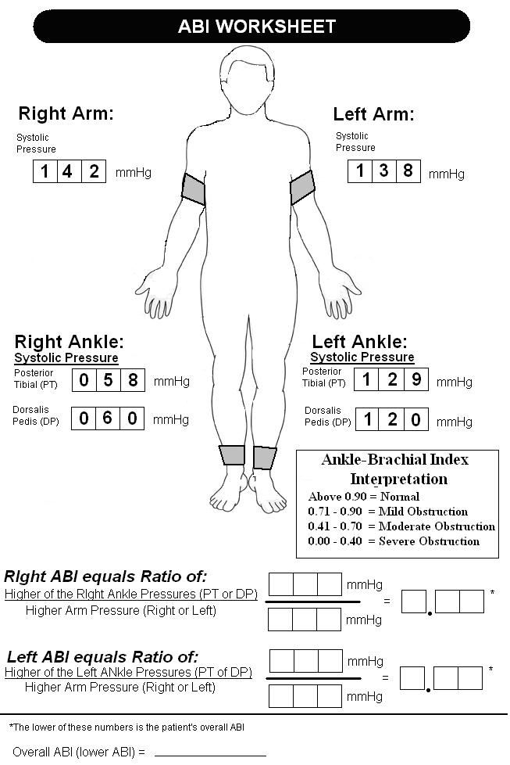

- Compute John Jones’ ABI.
- Copy the chart of normal and abnormal ABI values into your laboratory journal.
- Work with your partner to analyze your findings, discuss treatment and answer the following:
- What do the values for ABI imply about John’s legs?

- What is most likely occurring inside John’s leg to cause this increase in peripheral pressures? How does this relate to smoking?

- What is arteriosclerosis? What is the difference between arteriosclerosis and atherosclerosis?

- How can atherosclerosis be linked to PAD?

- What other tests can be performed to confirm this diagnosis?

- If tests confirm that John has a clot in his leg, what treatment options may help relieve his pain and save his leg?
- Visit the Howard Hughes Medical Institution BioInteractive site at http://media.hhmi.org/hl/98Lect1.html and view the “Of Hearts and Hypertension: Blazing Genetic Trails – Lecture 1” video webcast. Once the video begins playing, move the cursor to fast forward the video to 34:20. You will watch the clip from this point until 40:00. The video clip shows damage to blood vessels in the heart. How can what you saw be applied to the blood vessels of the leg?
- Work with your team of four to design a way to show PAD on your Maniken®. Also, use your model to demonstrate a medical intervention that may help treat this condition.
- Share your Maniken® medical intervention with the class.
Conclusion
- What is your ABI? What does this value tell you about your risk of peripheral artery disease?

- Explain how PAD might impact other body systems.

- How do the chemicals in smoke relate to the development of atherosclerosis?

- Why do you think diabetics are also at increased risk for PAD?

- Explain why untreated PAD can lead to the loss of a leg. Make sure to mention the specific arteries of the leg.

- Explain how the endocrine system and the kidneys help play a role in regulating blood pressure.

