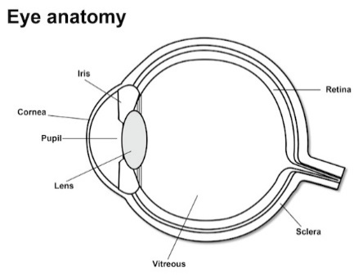
Choose 4 of the 7 conditions below to research and create a poster.
- Myopia
- Hyperopia
- Age-related Macular Degeneration
- Glaucoma
- Retinitis Pigmentosa
- Cataracts
- Colorblindness

Poster Requirements for 4 chosen conditions:
- What is it? What happens in the eye? ____5pts
- What causes it? ____5pts
- How does it affect your eyesight? ____5pts
- Treatment ____5pts
- Interesting information ____5pts
- Creative, included a relevant visual, aesthetically pleasing, and in your own words and includes work cited APA____10 pts
Total: 35 points

