Activity 4.4.2: Mind over Muscle

Introduction
You push through the last stretch of the race and your muscles start to burn. You do not think you can make it, but something inside you tells you to push through the pain. Physiologically, our muscles will fatigue and they will fail. But do we have the ability to push through the pain and fight this fatigue? In this activity you will explore both the limits of your muscles as well as the ability of your nervous system to exert “mind over muscle.”

Every skeletal muscle is supplied with at least one nerve, one artery, and one vein. This is to ensure that every muscle can receive incoming nerve impulses while being fueled by fresh blood from the arteries. Veins carry deoxygenated blood back for refueling and help dispose of harmful wastes. Active muscles require energy and therefore require a continuous supply of oxygen and nutrients. For fuel, muscles rely on glucose from the bloodstream, glycogen stored in the muscle fibers, and oxygen you breathe in from the air. When energy availability fails to keep pace with the demands being placed on the muscle, the muscle will lose its ability to contract in a controlled fashion. Even though the muscle may still receive nerve stimulation to move, muscle fatigue sets in.

Muscle fatigue occurs with prolonged or repetitive use of a muscle group. Your muscles feel weak, often forcing you to stop what you are doing. The mechanism for fatigue is multifactorial and not fully understood, but it is thought to involve the central nervous system, peripheral nervous system, muscle units, and individual muscle fibers. Depletion of energy stores and ATP also play a huge role in feeling this fatigue.

In this experiment you will use a device called a hand dynamometer to measure your maximum grip strength and relate this value to the electrical activity of the muscle. The strength of contraction of a whole muscle is dependent on the total number of muscle fibers involved and can be correlated with electrical activity measured over the muscle with an EKG sensor. We can use this technology to monitor muscle activity over time and see what happens when the muscle begins to fatigue. After you have completed your initial investigation, you will design an experiment to test your ability to overcome fatigue. Can you push through the pain and exert mind over muscle?

This activity is a modification of “Experiment 18: EMG and Muscle Fatigue” in Human Physiology with Vernier written by Diana Gordon and Steven L. Gordon and is used with permission.
Equipment
- Computer with Internet access and Vernier Logger Pro® software
- Vernier LabQuest Mini®
- Vernier hand dynamometer
- Vernier EKG sensor
- Electrode tabs
- Laboratory journal
Procedure
- Work with a partner for this activity. One partner should act as the subject while the other partner collects and records data. When you have completed the baseline experiment, switch roles.
- Follow your teacher’s instructions to familiarize yourself with the equipment you will be using in this experiment.
- Click on File Open and open the Human Physiology with Vernier folder.
- Open the program titled 18 EMG and Muscle Fatigue.
- Connect the hand dynamometer into CH 1 and the EKG sensor to CH 2 of the LabQuest Mini.
- Connect the LabQuest Mini to the computer using the USB cable.
- Zero the readings for the hand dynamometer.
- Click the Zero button in the toolbar.

- Hold the hand dynamometer along the sides in an upright position. Do not put any force on the pads of the hand dynamometer.
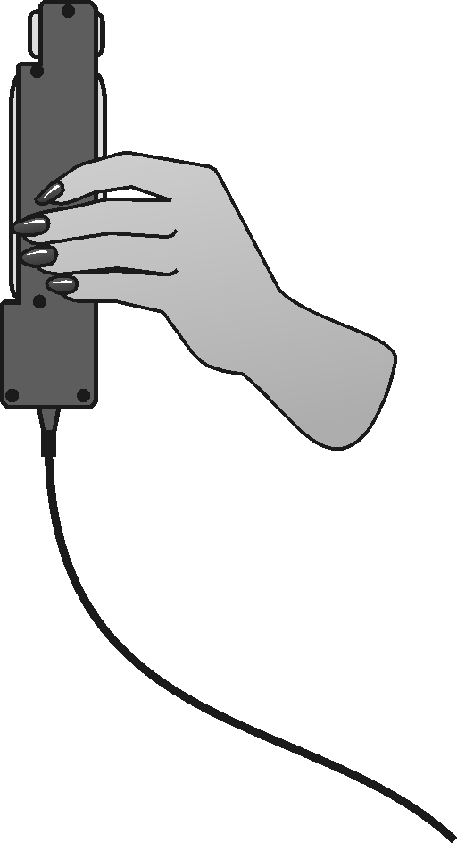

- Click the box in front of hand dynamometer to select it and click OK.
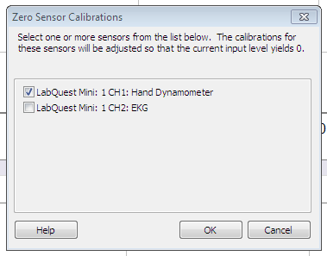

- Attach three electrode tabs to the arm of the subject. Two tabs should be placed on the ventral forearm, 5cm and 10cm from the medial epicondyle along an imaginary line connecting the medial epicondyle and the middle finger. Attach the third tab to the upper arm.
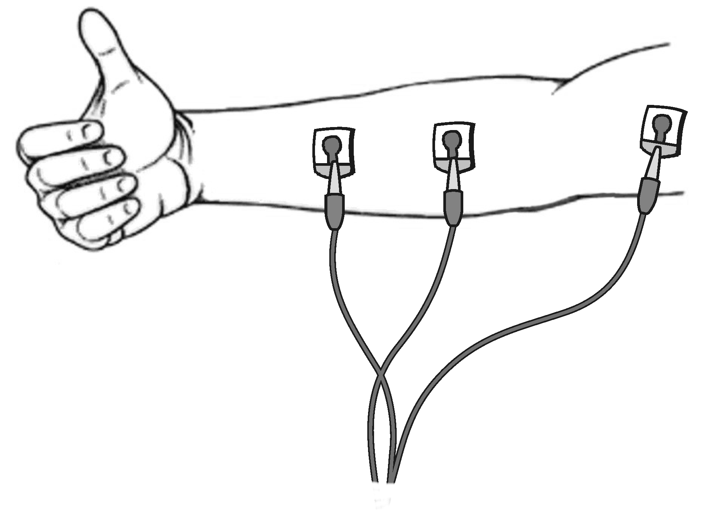

- Attach the red and green leads to the tabs on the forearm. For this lab, the red and the green leads are interchangeable. Attach the black lead to the tab on the upper arm.
- Sit with your back straight and feet on the floor. The elbow should be at a 90° angle, with the arm unsupported. You should be turned away from the computer screen.
- Instruct the subject to grip the sensor with full strength and click the green Collect button to begin data collection. The subject should exert maximum effort throughout the data collection period.
- After 80 seconds, the recorder should encourage the subject to grip even harder. The program will stop data collection after 100 seconds.
- Copy the table shown below into your laboratory journal.
Continuous Grip Strength
Time Interval | Mean grip strength (N) | EMG data  Max (mV) Min (mV) ∆mV
0 – 20 s
20 – 40 s
40 – 60 s
60 – 80 s
80 – 100 s

- Record statistical information about the grip strength data.
- Position the cursor at zero on the grip strength graph. Click and drag to highlight 0 to 20 seconds on the graph.

- Click the Statistics button. Record the mean force during that interval in your data table, rounding to the nearest 0.1N.
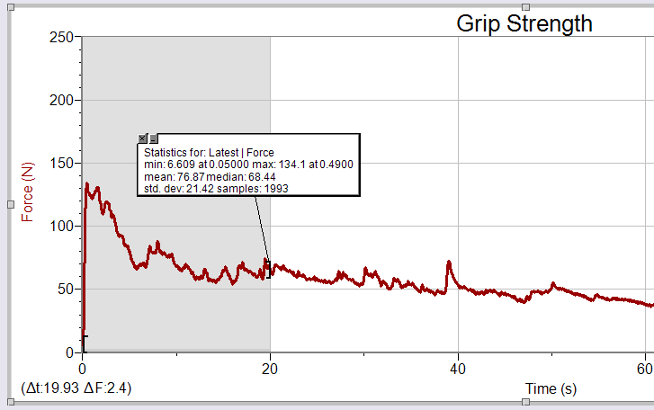

- Move the statistics bracket to highlight the time interval between 20 and 40 seconds on the same graph.

- Click the Statistics button. Record the mean force during that interval in your data table, rounding to the nearest 0.1N.

- Continue to determine and record the maximum and minimum force for each 20 second interval.

- Record statistical information about the EMG data.
- Position the cursor at zero on the EMG graph. Click and drag to highlight 0 to 20 seconds on the graph.

- Click the Statistics button. Record the maximum and minimum mV during that interval in your data table, rounding to the nearest 0.01mV.
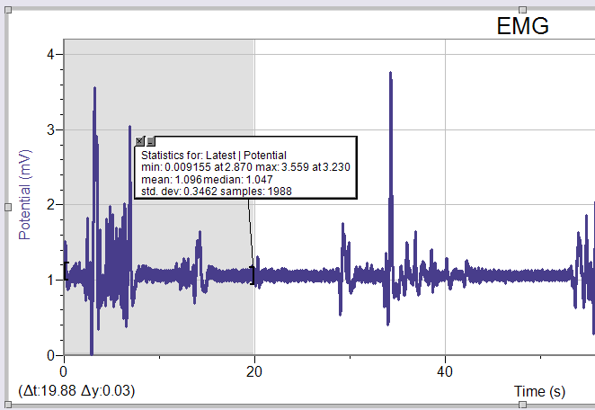

- Move the statistics bracket to highlight the time interval between 20 and 40 seconds on the same graph.

- Click the Statistics button. Record the maximum and minimum mV during that interval in your data table, rounding to the nearest 0.01mV.

- Continue to determine and record the maximum and minimum mV for each 20 second interval.

- Calculate the difference between each minimum and maximum value and record this value in the ∆mV column of your data table.

- Copy and paste the two graphs into a Word file. Alternatively, print the files directly from the screen or use the print screen button.
- Print the graphs and tape them into your laboratory journal (near your data table). Make sure to add appropriate titles.
- When both partners have completed the baseline trial, compare data and discuss trends.
- Answer conclusion questions 1-3.
- Now design a controlled experiment to test the effect of two of the following factors on muscle fatigue.
  - Visual feedback
  - Coaching
  - Competition (you will most likely need to pair with another group to complete a competition experiment)
- Work with your partner to outline the steps of your experiment. Think about how you are going to test each of the variables you have picked to explore. Write out your plan in your laboratory journal. Use baseline data from the first part of the activity.
- Create any necessary data tables in your laboratory journal.
- Make any corrections or additions as suggested by your teacher and then begin your experiments.
- Record and analyze your data using Logger Pro. Print necessary graphs and attach them in your laboratory journal.
- Summarize your findings for the experiment in your laboratory journal and compare the outcome of your trials. Which factor seemed to have a greater effect of your ability to overcome fatigue? Why do you think this is?
- Answer the remaining conclusion questions.
Conclusion
- Use the data in your table to calculate the percent loss of grip strength that occurs between the 0-20s and 60-80s intervals. Describe a situation in which such a loss of grip strength is noticeable in your day-to-day life.

- Use the data in your table to calculate the percent change in amplitude (∆mV) in electrical activity that occurs between 0-20s and 60-80s. What accounts for the difference in the percent change observed in grip strength and ∆mV for the two time intervals? What’s going on in your muscle?

- How did your mean grip strength in the last 20 seconds of the experiment compare to the 60-80s interval? Explain this result.

- Do the findings from your experiments support or refute the practice of “coaching from the sidelines” at sporting events? Can you exert “mind over muscle?”

- What role does the nervous system play in muscle fatigue?

- Is the hand grip test an example of an isometric or an isotonic muscle contraction? Explain your reasoning.

- What conclusion can you draw about the number of individual muscle fibers that fired in the last 10 seconds as compared with the first 10 seconds?

- What energy systems does your body use to support the 100s trial in the experiment? Refer back to information presented in Activity 4.4.1.

- Describe one way a person can train to overcome muscle fatigue.

