Part III: Taking an ABI
The ABI is a painless measurement that evaluates the circulation in your legs. In this simple test, the doctor listens to the flow of blood and measures the blood pressure in both the arms and the feet. Normally, these two pressures should be about equal. A significantly lower pressure in the ankle usually indicates that there is a problem with blood flow in the legs.

Doppler ultrasound uses reflected sound waves to assess blood flow through a vessel. In this activity, you will use a Doppler device to listen to blood moving through the vessels of the arm and ankle, and use systolic pressure values to compute an ABI.

- View the list of pulses you located in Activity 4.3.4. Which two pulses can you use to get a measure of how well blood is flowing to the feet? Find these two pulses on your own foot and write down their names in your laboratory journal.
- Obtain a Student Resource Sheet: ABI Worksheet from your teacher. Collect data on this ABI Worksheet. Additional supplies will be located at each lab station.
- Work in groups of three or four. Take turns being the patient and the recorder. If you do not wish to act as the patient, use data from another member in the group to calculate an ABI.
- The patient should lie in a supine (on back) position with shoes and socks removed for approximately five minutes before testing. The other group members should use this time to read the instructions and gather supplies.
- Wrap the blood pressure cuff snugly around the arm with the lower end of the cuff about 1 inch above the antecubital area. Note whether you are starting with the right or left arm.
- Apply a small amount of ultrasound gel to the antecubital area (the site of the brachial artery).
- If instructed to do so by your teacher, attach headphones to the Doppler device.
- Turn the Doppler device on and place the probe on the gel at a 45-60 degree angle to the surface of the skin. Slowly move the probe around until you find and hear the clearest arterial pulse. It will sound like an amplified version of your heartbeat.
- Keeping the probe in the same position, inflate the blood pressure cuff to approximately 20mmHg above the point where the sound ceases.
- Slowly deflate the cuff by controlling the release valve. Listen for the blood flow sounds to return. Record the pressure at which the sound returns on the ABI Worksheet. This is the systolic pressure. When this number is determined, deflate the cuff completely.
- Remove the gel from the skin with a tissue or paper towel.
- Repeat this process for the other arm and record the results on the ABI Worksheet.
- Now determine pulses and pressures in the ankles. Start with the side you were on for your first arm blood pressure.
- Wrap the blood pressure cuff snugly around the ankle.
- Use your fingers to find the posterior tibial (PT) pulse on the inside of the ankle.
- If you feel the pulse, apply a small amount of ultrasound gel to the area. If you can not feel the pulse, apply the gel to the general area and use the probe to locate the artery.
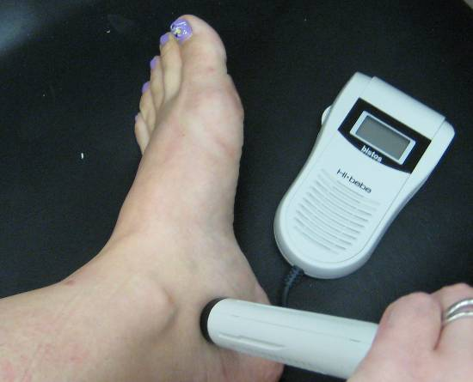
- Turn on the Doppler probe and slowly move the probe until you hear the movement of blood through the vessel.
- Keep the probe in position. Inflate the blood pressure cuff as before, followed by deflation and reading of the systolic pressure. Record the results on the ABI worksheet.

- Use your fingers to find the dorsalis pedis (DP) pulse on the top of the foot.
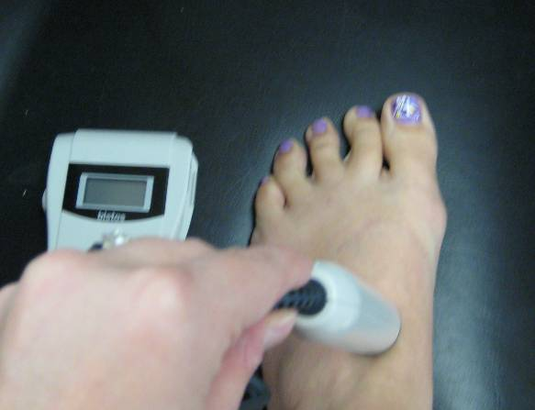
- Apply the gel and use the probe to find the pulse and determine pressure as described in Step 16-18.
- Wrap the blood pressure cuff on the opposite ankle and record PT and DP pressures for this leg.
- Use the worksheet to figure out the ABI for each foot. Remember ABI is a ratio of the ankle pressure to the arm pressure.
- Switch positions and allow other group members to practice recording pressures.
- When all group members have completed ABI calculations, obtain Part IV from your teacher.

Part IV: Getting Help
John finally agreed to go in for simple testing. The report from his ABI testing is found below:

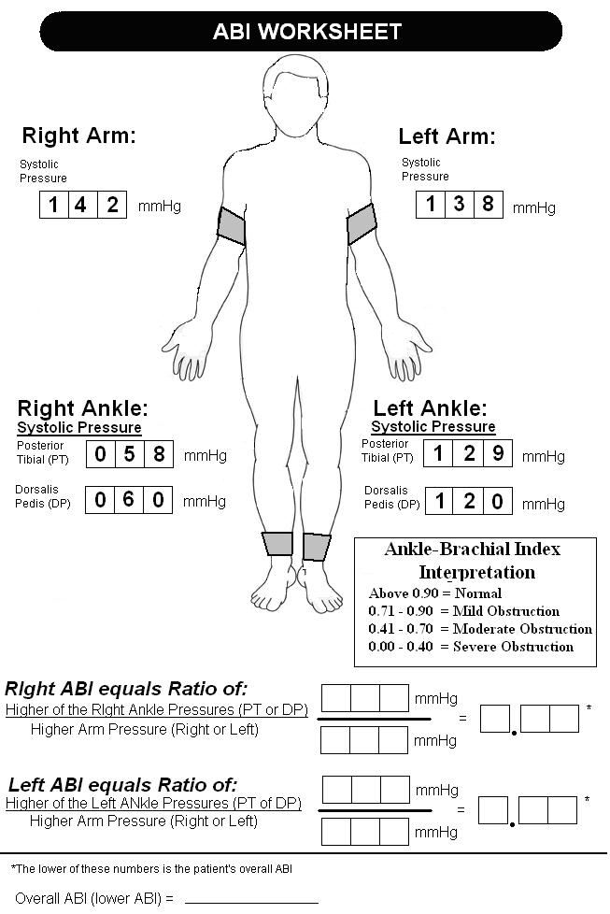

- Compute John Jones’ ABI.
- Copy the chart of normal and abnormal ABI values into your laboratory journal.
- Work with your partner to analyze your findings, discuss treatment and answer the following:
- What do the values for ABI imply about John’s legs?

- What is most likely occurring inside John’s leg to cause this increase in peripheral pressures? How does this relate to smoking?

- What is arteriosclerosis? What is the difference between arteriosclerosis and atherosclerosis?

- How can atherosclerosis be linked to PAD?

- What other tests can be performed to confirm this diagnosis?

- If tests confirm that John has a clot in his leg, what treatment options may help relieve his pain and save his leg?
- Visit the Howard Hughes Medical Institution BioInteractive site at http://media.hhmi.org/hl/98Lect1.html and view the “Of Hearts and Hypertension: Blazing Genetic Trails – Lecture 1” video webcast. Once the video begins playing, move the cursor to fast forward the video to 34:20. You will watch the clip from this point until 40:00. The video clip shows damage to blood vessels in the heart. How can what you saw be applied to the blood vessels of the leg?
- Work with your team of four to design a way to show PAD on your Maniken®. Also, use your model to demonstrate a medical intervention that may help treat this condition.
- Share your Maniken® medical intervention with the class.
Conclusion
- What is your ABI? What does this value tell you about your risk of peripheral artery disease?

- Explain how PAD might impact other body systems.

- How do the chemicals in smoke relate to the development of atherosclerosis?

- Why do you think diabetics are also at increased risk for PAD?

- Explain why untreated PAD can lead to the loss of a leg. Make sure to mention the specific arteries of the leg.

- Explain how the endocrine system and the kidneys help play a role in regulating blood pressure.

