Activity 4.3.3: Go With the Flow

Introduction
Arteries flow away from the heart and branch into smaller vessels called arterioles. These arterioles lead into the capillary beds, thin nets of vessels where gas exchange occurs. Blood then converges back into small veins called venules and eventually back into the major veins to be returned to the heart. Vessel size varies dramatically along this path. The aorta, the largest artery in the body is almost the diameter of a garden hose. The capillaries, on the other hand, are so tiny that about ten of them would be as thick as one of the hairs on your head.

You have looked at the structural differences between arteries and veins. Now you will “get the blood pumping” by creating circulatory routes on your Maniken®. You will follow the steps to create the blood vessels that service the arm and the neck and then you will work independently to bring blood to and from other parts of the body. As you create each branch, think about how these vessels bring needed oxygen and nutrients to the tissue and how they remove harmful waste.
Equipment
- Computer with Internet access
- Anatomy in Clay® Maniken®
- Pink and blue clay
- Red and blue marker or colored pencil
- Clay extruder
- Wire tool or wooden knife
- Tape flags
- Body system graphic organizer
- Skeletal system graphic organizer
- Laboratory journal
- Meter stick (optional)
- Reference textbooks (optional)
Procedure
This activity is a modification of activities in Section H of Starla on Maniken® produced by Zahourek Systems, Inc. and is used with permission. Refer to Starla on Maniken® for helpful graphics and for additional ideas.
Part I: Arteries
In Part I of this activity, you will follow directions to build arteries of the neck and arms on your Maniken®. You will then build additional arteries independently.

- Use the following websites or pictures in reference textbooks to visualize the path of blood vessels around the body.
- Texas Heart Institute http://www.texasheartinstitute.org/HIC/Anatomy/index.cfm
- Human Anatomy Online http://www.innerbody.com/image/cardov.html
- Use the clay extruder to create long strands of spaghetti using pink clay. Lay the long strands over the edge of your desk or over a meter stick. Your teacher may do this for you in advance.
- Your group should pair with another group to form a team of four. Create vessels on your own Maniken®, but work with your team to discuss and debate placement.
- Label each artery you build on the model with a tape flag. Artery names are listed in bold in the directions that follow.
- Find a web page or a textbook page that clearly illustrates the arteries of the arm and neck. Keep this reference handy as you build on your Maniken®. The directions will be easier to follow if you refer back to the illustration.
- Open your notebook to your skeletal system organizer. Use this resource if you have trouble remembering the location of key bones.
- Carefully take a long strand of pink clay and press the end of the clay on the medial end of the clavicle. The clay strand should run behind the clavicle. This branch will represent the subclavian artery. This artery services the upper limb.
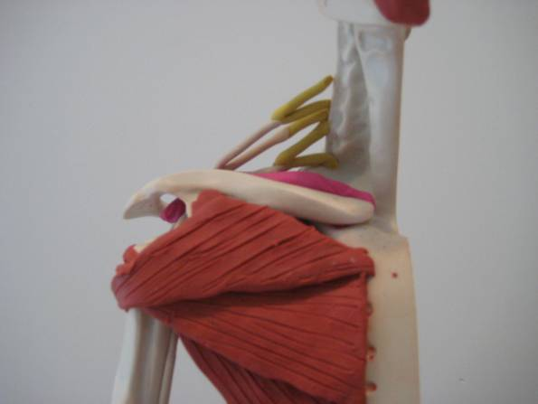
- Run the strand along the clavicle and drop the end through the armpit. You will most likely need to go behind some of the muscle you created. If you find it difficult to drop the piece down the arm, simply break off the piece and begin the strand past the muscles. The artery will look as if it passed through the area.
- Continue the long strand out of the armpit along the medial side of the humerus (next to the ulnar nerve). This represents the brachial artery. Note that the vessel takes the name of the area in which it travels.
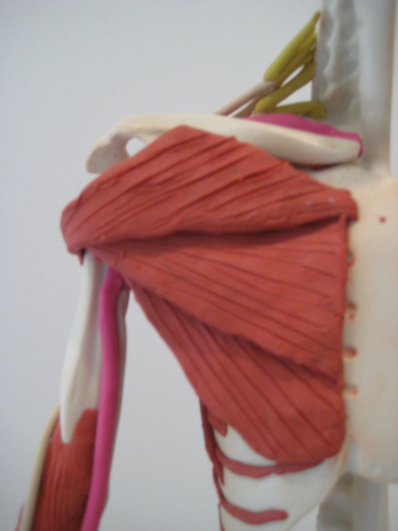
- Bring the strand forward to the fold of the elbow (antecubital region). When the brachial artery enters this region, it splits and travels down both bones of the forearm. What do you think we call each of these arteries?
- Angle the strand to run along the medial side of the radius down towards the palm. The strand running along the radius represents the radial artery.
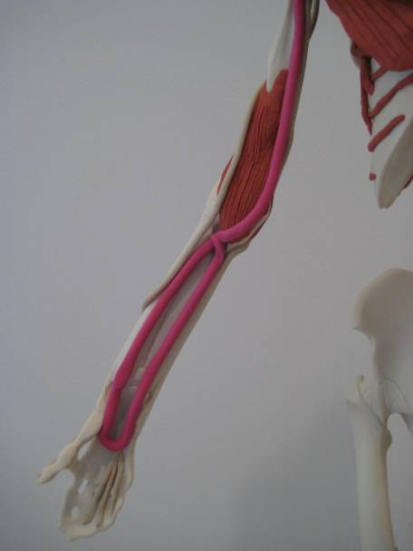
- Curve the strand back around so it begins traveling up the medial side of the ulna. This strand will continue until it rejoins the brachial artery at the antecubital region. The strand in the palm represents the superficial palmar arch. The strand that runs along the medial side of the ulna represents the ulnar artery.
- Think about how we supply blood to the fingers. Create thin spaghetti strand out of pink clay. Add individual strands coming off the palmar arch and down to each finger. These strands will represent the digital arteries.
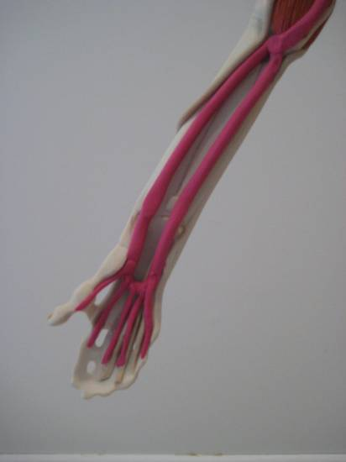
- Remember that muscle requires a constant supply of blood. Using small strands of clay, form small arteries that feed this tissue of the brachialis muscle. Branch these arterioles off one of the major arteries you have built.
- Return to the clavicle region. Use your textbook or web resource to focus on the arteries of the neck.
- Break off a piece of pink spaghetti approximately 1-1 ½ inches long.
- Join the end of the clay to the medial end of the clavicle (where the subclavian artery begins). Place the strand upward along the side of the neck. This strand represents the carotid artery.
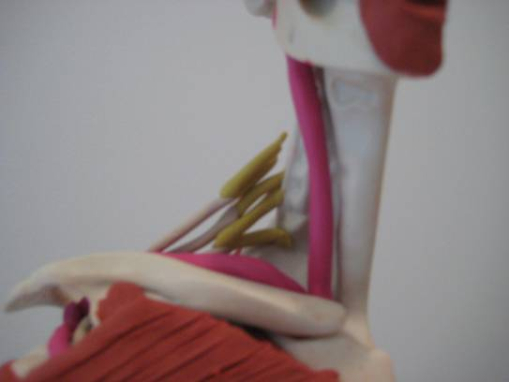
- Create more pink spaghetti strands if necessary.
- Build the following arteries on your Maniken®. Refer to textbooks and web resources for visualization. Discuss placement of these vessels with your team.
- Descending aorta
- Renal Artery (hook up that kidney!)
- Iliac Artery
- Femoral Artery
- Popliteal Artery
- Posterior Tibial Artery
- Label each new artery with a tape flag.
- Obtain a blank human body systems organizer. Label the diagram “Circulatory Routes.”
- Using red marker or colored pencil, carefully draw and label the arteries you have created on your model.
- Next to the name of the artery, briefly describe the area being serviced by this vessel.
Part II: Veins
In Part II of this activity, you will follow directions to build veins of the arms on your Maniken®. You will then build additional veins independently.

- Create blue spaghetti using the designated clay extruder or obtain blue spaghetti strands created by your teacher.
- Answer conclusion question 1.
- Label each vein you build on the model with a tape flag. Vein names are listed in bold in the directions that follow.
- Find a web page or a textbook page that clearly illustrates the veins of the arm and neck. Keep this reference handy as you build on your Maniken®.
- Position your model so the dorsal side of the arm is facing you.
- Take a small piece of blue spaghetti and run this vessel along the subclavian artery. This vessel will represent the subclavian vein.
- Hang both of your hands down in front of you and observe the veins on the back of your hands – the dorsal venous network. Does the network of veins look the same on both your right and left hands? You have most likely had your blood drawn at the doctor. Think about how the variation in vein networks relates to how easy it is to draw blood from these vessels. These veins that are found on the surface are referred to as superficial veins.
- Take a single strand of blue clay and grab both ends of the loop with one hand. Let the clay hang down and form a loop.
- Place the loop on the dorsal side of the metacarpals to form the dorsal venous network.
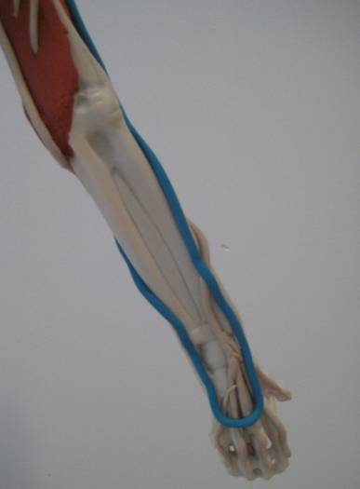
- Place the strand that is on the radial side (lateral) along the radius. The vein will stay on the dorsal side of the arm and will travel up the radius. When you reach the antecubital region (fold of the elbow), bring the strand forward, keep it lateral and run it over the biceps, over the shoulder and under the muscle to join to the subclavian vein. You will most likely have to break off the strand and fake that it goes through the muscles of the chest. The vein you have created, that travels laterally and superficially along the arm is known as the cephalic vein. This vein is often visible when a bodybuilder flexes his/her biceps.
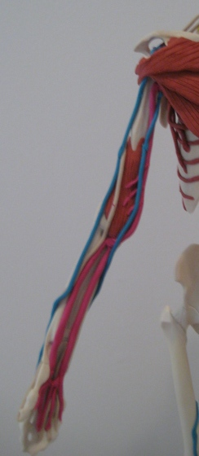
- Take the other end of the strand that is hanging unattached and run this vein along the medial side of the arm. Place the strand along the ulna and keep the strand dorsal. Before reaching the fold of the elbow, bring the strand ventral and continue on the medial side of the humerus up into the axillary (armpit) region. Connect this vessel, the basilic vein, with the subclavian vein in the neck.
- Position your model so the ventral side is facing you.
- Observe that the cephalic vein and the basilic vein travel parallel to one another at the antecubital region, but do not touch. Take a short piece of blue spaghetti and attach it to the cephalic just below the antecubital region and angle it upward so it attaches the basilic vein just above the antecubital region. This represents the medial cubital vein, the vein often used for blood draws and IV sites.
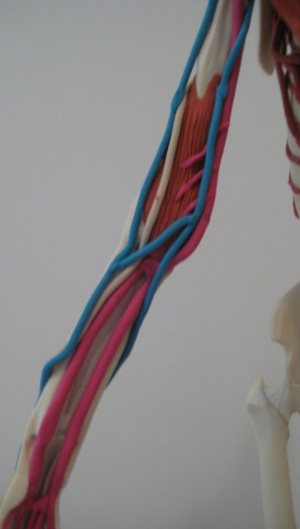
- Use one of your tools or the tip of a pencil to form several “V” shaped valves in the veins. Make sure the tip of the “V” points upward to show that the valve points to the direction that the blood is moving. Valves are not very far apart so each vein you have built will have a valve approximately every centimeter.
- Use thin strands of blue spaghetti to form the dorsal venous network of your model’s hand to resemble your own.
- Use small strand of blue clay to create small veins, or venules, that service the brachialis muscle. Arteries take blood to these muscles, but there must be a way to take blood away.
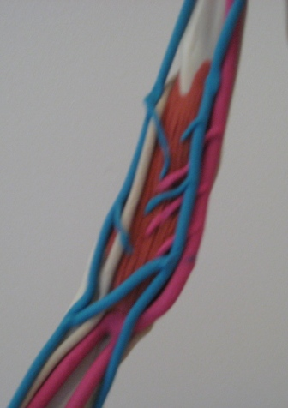
- Create more blue spaghetti strands if necessary.
- Build the following veins on your Maniken®. Refer to textbooks and web resources for visualization. Discuss placement of these vessels with your team. As you build, be observant of “traveling partners.” Nerves, arteries and veins follow a similar path.
- Superior Vena Cava
- Inferior Vena Cava
- Renal Vein
- Common Iliac Vein
- Femoral Vein
- Posterior Tibial Vein
- Internal Jugular Vein
- Remember to add valves to each vein.
- Label each new vein with a tape flag.
- Refer back to your “Circulatory Routes” organizer. Using blue marker or colored pencil, carefully draw and label the veins you have created on your Maniken®.
- Next to the name of the vein, briefly describe the area being serviced by this vessel.
- Answer the remaining conclusion questions.
Conclusion
- Why do you think the clay used to represent veins is thinner than the clay used to represent arteries?

- What do you think would happen in the body if blood flow to right femoral artery was blocked? How would this change impact movement of blood and movement of the body?

- Suggest a reason why the veins of a bodybuilder “pop out” more than a person who does not lift weights. Why don’t we see arteries “pop out”?

- Why do you think arteries, veins and nerves always travel together? Provide an example that illustrates your reasoning.

