Activity 4.2.6: You’ve Got Nerve

Introduction
Let’s put it all together. You have looked at the requirements for muscle contraction and you have seen how communication from the nervous system is crucial to getting a muscle to fire. Neurons are packed together in wiring called nerves, and these nerves serve as a highway for electrical messages. Efferent nerves take messages from the brain to our tissues and afferent nerves are on the other side of the road, bringing messages from the body to the control center. This highway of neurons is buried deep in the body. The ulnar nerve, at the elbow, is one of the few that grazes the surface. If this nerve is knocked against the humerus, the “funny bone,” you feel that familiar tingly sensation down your arm that is anything but funny.

Spinal nerves are a vital part of the peripheral nervous system. They connect the central nervous system to sensory receptors, muscles and glands in all parts of the body. Depending on their points of connection with the central nervous system, nerves fall into two categories. Twelve pairs of cranial nerves connect directly with the brain and bring signals to and from the head and neck. Thirty-one pairs of spinal nerves supply the rest of the body and connect directly with the spinal cord. Nerves divide and divide, with ends reaching even the body’s most remote tissues. Some nerves, such as those that service the arm and hand, first converge in clusters called plexuses and then disperse to control fine motor movement.

The brachial plexus is a group of nerves that begin in your neck and provide feeling and movement to the arms and hands. Think about how these nerves interact with the muscles of the arm to cause even the tiniest movement. This coordination allows you to type, to play an instrument or even brush your teeth. Your life would be very difficult if you could not move your digits or flex your wrists.

In this lesson, you will build the brachial plexus on your Maniken® and begin to attach the nerves of the arm. Visualize how this network of wires brings needed electrical stimulation to your muscles and see if you can figure out which types of muscles are controlled by each nerve you build.
Equipment
- Computer with Internet access
- Anatomy in Clay® Maniken®
- Yellow and white clay
- Clay gun and extruder (or prepared clay spaghetti strands)
- Laboratory journal
- Reference textbook (optional)

Procedure
Part I: Wiring Up the Arms
This activity is a modification of activities in Section G of Starla on Maniken® produced by Zahourek Systems Inc and is used with permission. Refer to Starla on Maniken® for helpful graphics and for additional ideas.

- View the muscles you have built on the arm of your Maniken®. Remember that nerves usually do not travel on top of muscle, but rather between muscles or below muscle for maximum protection. As you build, do not worry that the anatomy is perfect, but do take time to show the correct path of each nerve.
- Work with your muscle building team to build the nerves listed below. After each building step, compare placement and discuss any changes that may need to be made.
- View the simple diagram of the brachial plexus at MedicaLook – Your Medical World http://www.medicalook.com/systems_images/Brachial_Plexus.jpg or find a diagram in a reference textbook. The brachial plexus is the root of all of the nerves of the arm.
- Note the orientation of the brachial plexus. The main root looks like a sideways “V” followed by a line and then another sideways “V”. The connections hook up the nerves of the arm.
- Follow the directions below to build the brachial plexus nerve by nerve.
- Note that the first nerve you are going to build is the ulnar nerve. As the name implies, this nerve runs close to the ulna of the arm. Locate the ulna on your Maniken®. Use your skeletal system organizer if needed.
- View the pathway of this nerve on the websites listed below or in a reference textbook.
- New England Musculoskeletal Institute – University of Connecticut Health Center: Ulnar Nerve http://nemsi.uchc.edu/images/image_cubital.jpg
- eOrthopod: Nerve Routes of the Arm http://www.eorthopod.com/images/ContentImages/hand/hand_guyon_canal/hand_guyon_canal_anat01.jpg
- Follow your teacher’s instructions to visually track the nerve on your own arm.
- Use a clay extruder to create white or bone-colored clay spaghetti strands. Create two or three, two-foot strands and put them off to the side. Your teacher may have already completed this step for you. In this activity, you will create nerves using white spaghetti strands.
- Create a small spaghetti strand about 6 inches long out of yellow clay. In this activity, you will create the nerve roots in yellow.
- Using the strand of yellow spaghetti, pinch off a piece approximately 1 ½ long.
- Fold the piece into a “V” shape. One leg of the “V” should be slightly longer than the other. This “V” will represent the nerve root (the on and off ramp of the nerve) that forms the lower part of the plexus.
- Locate the vertebrate on the neck and thorax of your model. Intervertebral foramen, or neural foramen, are openings between the vertebrate that allow the spinal nerves to extend to other parts of the body. Remember that we have seven cervical vertebrae followed by twelve thoracic vertebrae. These bones are referred to as C1 – C7, counting down from the top, followed by T1 - T12.
- Connect the short leg of the “V” to C7 and the long leg to T1.
- Point the “V” laterally away from the spinal cord.
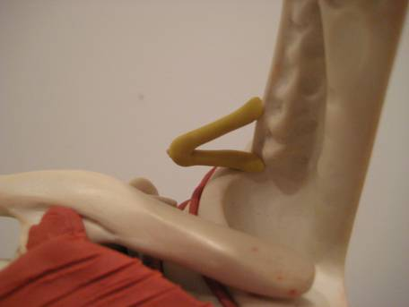
- Slip one end of a white spaghetti string up the armpit, under the clavicle and connect this string to the “V”. NOTE: Depending on which muscles you have built on your model, you may have to be creative when placing nerves. If you have created too many muscles in the chest and shoulder area and cannot reach under the clavicle, simply connect a small piece to the “V” and then start another on the other side of the muscle. Fake it! It will look like the nerve runs through your muscle!
- Drop the free end of the nerve down the arm. Press the nerve on the medial side of the humerus and take the strand down to the medial epicondyle (the bump near the elbow). Make sure the nerve notches around the bump. This is the nerve responsible for the sensation you feel when you hit your “funny bone”. Think about where you need to hit yourself to feel this sensation. Press the nerve gently onto the Maniken®.
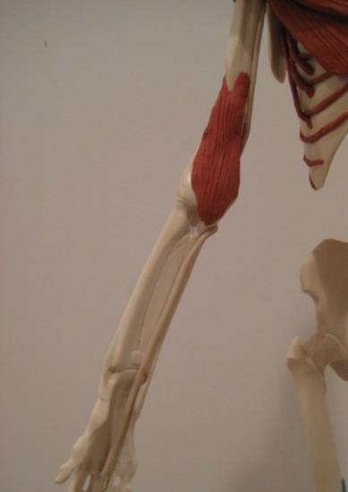
- Note that the string from the dorsal elbow spirals to the ventral forearm along the ulna. Stop the nerve before it runs downs the middle finger.
- Roll pieces of spaghetti out even thinner and use these small pieces to create digital branches of the ulnar nerve to the ring and little finger. Note the fingers that are fed by this nerve.
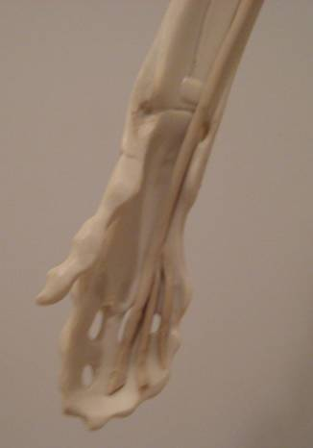
- Answer Conclusion questions 1-2.
- Now work to build the radial nerve. As the name implies, this nerve runs close to the radius of the arm. Locate the radius on your Maniken®. Use your skeletal system organizer if needed.
- View the pathway of this nerve on the website listed below or in a reference textbook. Note the orientation of the hand.
- eOrthopod: Nerve Routes of the Arm http://www.eorthopod.com/images/ContentImages/elbow/elbow_radial_tunnel/elbow_radtun_anatomy02.jpg
- Follow your teacher’s instructions to visually track the nerve on your own arm.
- Note that the nerve root for the radial nerve is a bit more complicated than the root for the ulnar nerve. This nerve has a very complicated system of on-ramps and off-ramps because it goes so many places.
- Pinch off a two inch piece from a new white spaghetti strand.
- Form a “V” as you did for the ulnar nerve.
- Place the end of the longer strand (the one you took the piece from) in the middle of the “V” you just made. Press down to connect the two pieces.
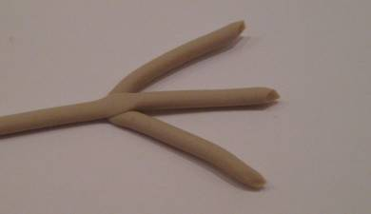
- Make sure this piece now looks like the letter “W” or a bird’s foot with a long middle leg. This piece of clay represents the complex nerve root of the radial nerve. Lay this structure down on your desk.
- Take a piece of yellow spaghetti that is only about 1 inch in length. Connect this piece to the foramen of C6. The end will extend laterally from the spinal cord.
- Use a small piece of yellow spaghetti to form a small “V”- about the size of the “V” you created for the ulnar nerve.
- Place one end of the “V” in the foramen of C4 and the other in the foramen of C5. From top to bottom, you should now see a “V”, a single strand, and the ulnar root with the nerve attached to it coming from the side of the cervical region.
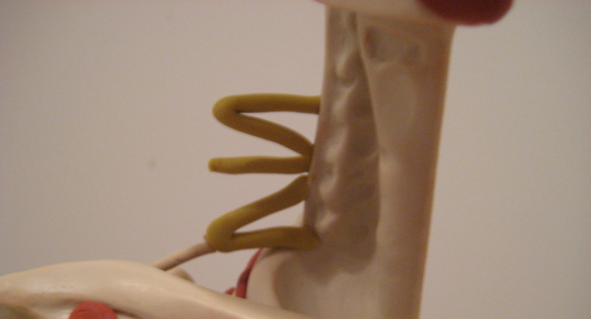
- Pick up the strand with the “W” attached at its end. Drop the free end under the clavicle and down through the armpit so the nerve is hanging down.
- Hook up the “W” to the nerve root at three different areas.
- The top end of “W” is attached to the V coming out of C4 and C5.
- The middle of the “W” is attached to the single strand leaving C6.
- The last end is attached to the end of the V where the ulnar root is attaching (they share this nerve root!).
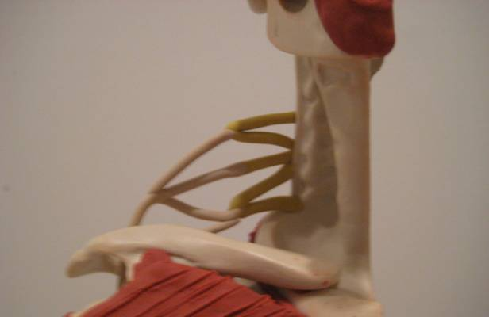
- Grasp the nerve that is hanging down from the “W” you just attached.
- Refer to the diagrams on the Internet as you complete the attachment of the nerve.
- Move the nerve dorsally and wrap it around the humerus from the back to the front. Angle the nerve downwards towards the antecubital region (where they draw your blood).
- Place the nerve through the antecubital region and stay on the medial side of the radius for about ¼ of the way down the radius.
- When you are ¼ of the way down the radius, take the nerve over the radius and have it travel along the radius on the dorsal side.
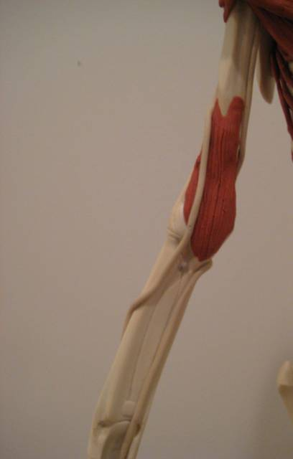
- Upon reaching the wrist, branch the nerve to the tips of each digit on the dorsal side (opposite your palm). Use additional small spaghetti strings to form these nerves.
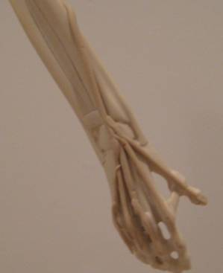
- Use small white spaghetti strings to “wire up” the triceps medial head muscle on the model’s arm. Branch these tiny strands from the radial nerve into the muscle. As you add these nerves to the muscle, think about the direct connection between the nervous system and the muscular system.
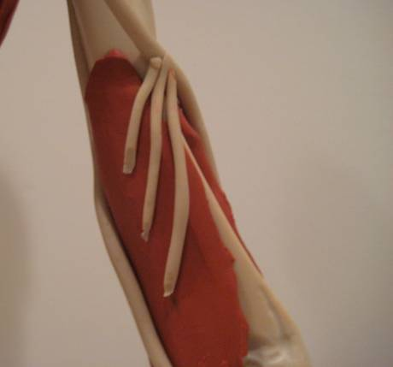
- Answer Conclusion questions 3-4.
- In your laboratory notebook, draw an arm and trace in the placement of the ulnar and radial nerves. You may need multiple views of the arm to provide a complete picture.
Part II: Repeat That! Repetitive Motion Injury
Injury to the extensor muscles of the arm is often caused by repetitive motion. Too much stress on a muscle can weaken the tendons, expose nerves or inflame tissue. The radial nerve you built on your Maniken® is the largest nerve of the brachial plexus and supplies electrical stimulation to all extensors in the arm. But what about the flexors? A repetitive motion injury you most likely have heard of is carpal tunnel syndrome. What muscles of the arm are affected in this condition? The extensors or the flexors? What nerves supply these muscles and are affected in this case?

- Think about the injury name - carpal tunnel syndrome. Locate the carpals on your Maniken®.
- Use the Internet to research carpal tunnel syndrome. In your laboratory journal, take notes on the anatomy of the condition, the cause of this injury, and the reason this condition falls under the category of repetitive motion injuries. Most importantly, identify the nerve(s) that is (are) affected in carpal tunnel syndrome.
- Use a reliable website to visualize and track this nerve.
- Using what you learned about building nerves in Part I, build the nerve(s) responsible for the pain of carpal tunnel on your model.
- Discuss your building plan with your team and with your teacher before you begin working with the clay.
- Use green clay to model the carpal tunnel and use this tunnel as well as the nerves you have built to show what causes carpal tunnel syndrome. Be prepared to explain your model.
- In your laboratory journal, describe how problems at the carpal tunnel can lead to pain and discomfort.
- Answer the remaining conclusion questions.

Conclusion
- Given the placement of the ulnar nerve, what type of forearm muscles do you think this nerve stimulates? Explain. HINT: What type of muscles is found on the ventral side of the body?

- Explain how the placement of the ulnar nerve is linked to the pain and discomfort you feel when you bang your “funny bone.”

- Given the placement of the radial nerve, what type of muscles do you think this nerve stimulates? Explain. HINT: What type of muscles is found on the dorsal side of the body?

- What do you think would happen to a person’s ability to use his/her arm if the radial nerve were damaged?

- Explain how the central and the peripheral nervous system work together to allow you to pick up a can of soda. Mention muscles of the forearm in your answer.

- Describe at least three different jobs that put the worker at risk for carpal tunnel syndrome. How can these individuals lower their risk of injury?

- What happens at the junction between a nerve and a muscle to initiate muscle contraction?

