Activity 4.2.3: EKG

The following is used with permission of Vernier Software and Technology. This activity is based on the experiment “Analyzing the Heart with EKG” from the book Human Physiology with Vernier, written by Diana Gordon and Steven L. Gordon, M.D.
Introduction
Human body systems depend upon electrical impulses to send and receive messages. Electrical energy is what directs and choreographs the rhythmic beating of your heart. Each beat is initiated by an electrical signal. This electrical activity can be monitored and recorded in the form of a graph. The graph made in this process is called an electrocardiogram and is abbreviated as EKG or ECG. Medical professionals are trained to study an EKG and use the graphical display to diagnose heart abnormalities such as irregular heartbeat, irregular speed of contractions, angina (chest pain that can indicate tissue damage), or even tissue death (myocardial infarction, also known as a heart attack).

In this experiment you will use the EKG sensor to make a graphical recording of your heart’s electrical activity. You will identify the different components of the waveforms and use them to determine your heart rate. You will also analyze Anna’s EKG readings in her cardiac workup and investigate how the function (or dysfunction) of her heart may have played a role in her death.
Equipment
- Project 4.2.1 Medical History Resource Sheet
- Computer with Vernier Logger Pro® Software and Internet access
- Vernier LabQuest Mini®
- Vernier EKG Sensor
- Markers or colored pencils
- Heart box diagram from Activity 4.1.1
- Timer or watch
- Graph paper
- Laboratory journal
- PBS Course File
Procedure
- Note that contraction of the heart muscle is involuntary. It happens without you thinking about it. Use the websites below to investigate the conduction system of the heart, the structures that “keep the beat.” Pay attention to how what is happening in the heart relates to the electrocardiogram (EKG). Take notes in your laboratory journal.
- McGraw Hill – Conducting System of the Heart animation http://highered.mcgraw-hill.com/sites/0072495855/student_view0/chapter22/animation__conducting_system_of_the_heart.html

- MyHeartCentral.com – Intrinsic Conduction System of the Heart http://www.healthcentral.com/heart-disease/animation-44725-71.html
- Take out your heart box drawing from Activity 4.1.1.
- Use a yellow marker or colored pencil to add the main structures of the conduction system (listed below) on your diagram.
- Sinoatrial (SA) node
- Atrioventricular (AV) node
- Atrioventricular (AV) bundle (bundle of His)
- Bundle branches
- Purkinje fibers
- Use your yellow marker or colored pencil to draw the path of the electrical signal in the heart.
- Read the information below about EKGs. Pay attention to how the shape of an EKG tracing relates to the information about conduction you learned in Step 1.
An electrocardiogram (ECG or EKG) is a graphical recording of the electrical events occurring within the heart. In a healthy heart, there is a natural pacemaker in the right atrium (the sinoatrial node) which initiates an electrical sequence. This impulse then passes down natural conduction pathways between the atria to the atrioventricular node and from there to both ventricles. The natural conduction pathways facilitate orderly spread of the impulse and coordinated contraction of first the atria and then the ventricles. The electrical journey creates unique deflections in the EKG that tell a story about heart function and health (Figure 1).
The electrodes of the EKG sensor detect the electrical current in the hearts’ cells. The electrodes detect the electrical impulse being produced by the heart by detecting the difference between the charges in the areas where the electrodes are attached. The greater the intensity of the impulse, the greater the difference in the charges, and the larger the upward or downward peak will appear on the EKG.

Figure 1:
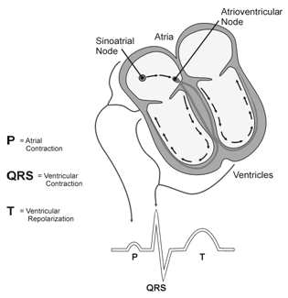

Five components of a single beat are traditionally recognized and labeled P, Q, R, S, and T. The P wave represents the start of the electrical journey as the impulse spreads from the sinoatrial node downward from the atria through the atrioventricular node and to the ventricles. Ventricular activation is represented by the QRS complex. The T wave results from ventricular repolarization, which is a recovery of the ventricular muscle tissue to its resting state. By examining several beats, you can calculate the rate for each component.

- Draw the EKG tracing shown above on your heart box poster. Label the P wave, QRS complex, and the T wave. Next to each label, draw a text box that explains how this wave or complex relates to heart function – think about what is contracting or relaxing during this part of the tracing and where the signal is being sent. Make sure to mention the relevant structures of the conduction system.
- Note that you will now take an EKG of your own heart. Note: This EKG is not to be used for diagnostic purposes.
- Watch your teacher demonstrate how to connect the equipment and open the Logger Pro® program to take an EKG.
- Refer to the Logger Pro® resource sheet as needed throughout the experiment.
- Start the Logger Pro® software and open the Human Physiology with Vernier folder. Open experiment 12 Analyzing Heart EKG.
- Connect the LabQuest Mini to the computer using the USB cable.
- Connect the EKG Sensor into CH 1 of the LabQuest Mini.
- Attach three electrode tabs to your arms, as shown below. Place a single patch on the inside of the right wrist, on the inside of the right upper forearm (below the elbow), and on the inside of the left upper forearm (below the elbow).
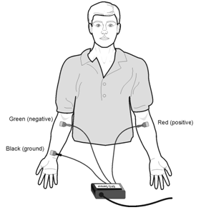
- Connect the EKG clips to the electrode tabs as shown in the diagram above. Sit in a relaxed position in a chair, with your forearms resting on your legs or on the arms of the chair. Because muscle movement also involves electrical activity, it is important to remain still while the EKG is being recorded. Muscle movement will interfere with the EKG sensing and will cause artifacts in the graph.
- Click on the Data Collection icon and set the Length to 3 seconds. Set the Sampling Rate to 200 samples/second. Click done.
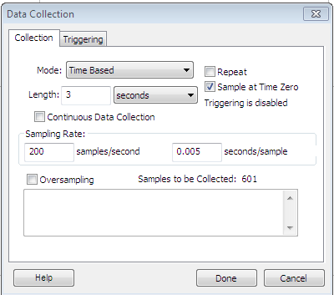

- Click the green Collect arrow in the top toolbar.
- Notice that data is plotted on the graph.
- Save your data to a file as instructed by your teacher.
- Copy Table 1 below into your laboratory journal.
Table 1
Interval | Time (s)
P–R
QRS
Q–T
R–R
- Examine the diagram below to determine the specific waves, intervals, and complexes.
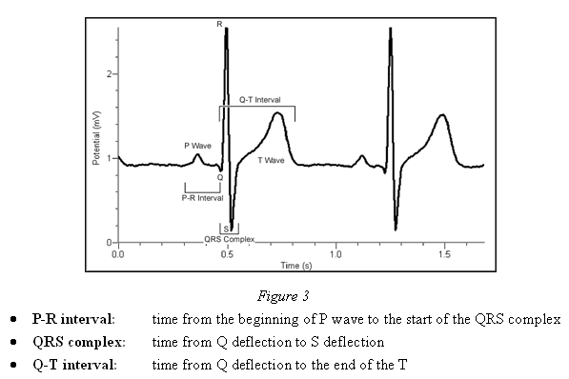
- Click the Zoom In icon to zoom in on your data.
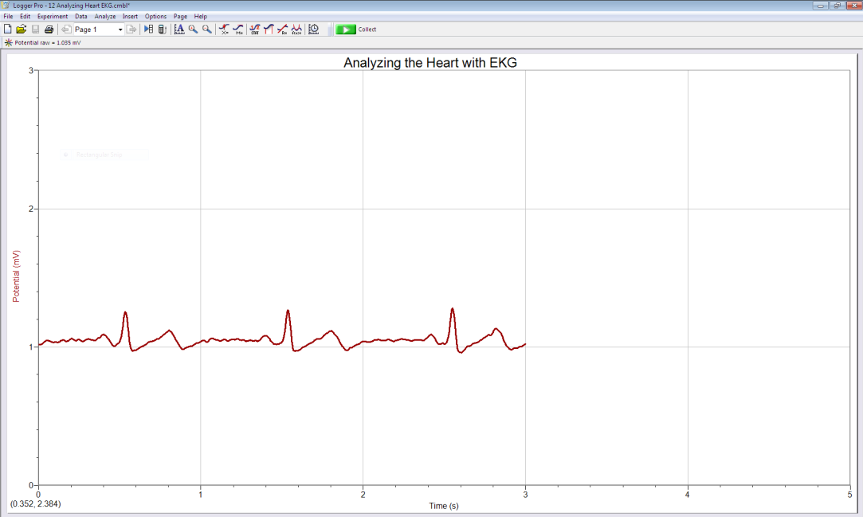
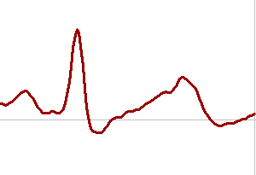
- Click and drag the cursor bar to highlight each interval listed in Table 1. Notice that the time and potential values, which correspond to the cursor bar location, appear at the bottom of the screen (shown as Δt and Δy).
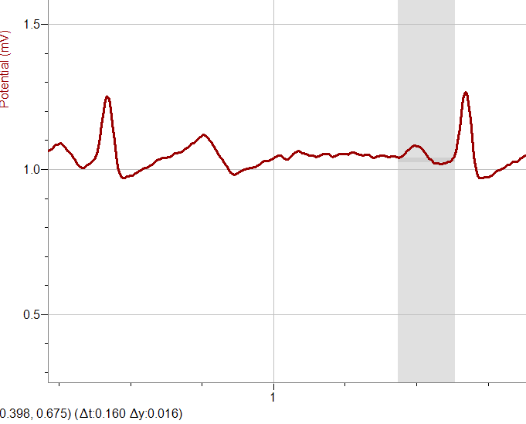

- Enter the value of each time (Δt) to the nearest 0.01 S for each interval listed in Table 1.
- Compare your measurements to the normal ranges shown in Table 2 below. Describe any differences in your laboratory journal.
 | Table 2
 | Standard Resting Electrocardiogram Interval Times
 | P–R interval | 0.12 to 0.20 s
QRS interval |  | less than 0.12 s
Q–T interval |  | 0.30 to 0.40 s

- Calculate the heart rate in beats/min using the EKG data and record it to the nearest whole number in Table 1.
- Copy the analysis graph and paste it into a Word document. Save the document as instructed by your teacher. (Remember, place the mouse cursor over the graph, left click on the graph, press both the Control and the C keys, and then paste [press both the Control and V keys] the graph into a new document in Word.)
- Refer to the Project 4.2.1 Medical History document and view Anna’s EKG. If you are having trouble opening the file, right click and select “Packager Shell Object Object.” Once highlighted, select “Activate Contents.” Click “Open” when prompted.Analyze the strip presented, both the still shot and the video clip. Are the beats rhythmic? Read the doctors’ notes associated with her EKG findings. Use the Internet to research premature ventricular contractions (PVCs), ventricular tachycardia, and ST elevation. In the Follow-up/Diagnosis section of the medical history document, explain why these findings are dangerous. Report any recommendations in the Recommendations section of the report.
- Refer to the Activity 4.1.2 Autopsy Report and review the X-ray image of Anna’s heart. Note that Anna’s autopsy shows placement of a device called a pacemaker. Research the function of a pacemaker as well as why a person would have one implanted.
- Add any additional ideas regarding possible causes of death to the Activity 4.1.2 Autopsy Report.
- Update the classroom evidence board with information from Lesson 4.2.
- Answer the Conclusion questions.
Conclusion
- Anna’s autopsy revealed that she had an internal pacemaker. What does the pacemaker replace in the heart? Explain.

- Given Anna’s medical history, describe the most likely reason she needed a pacemaker.

- What do you think would happen in the heart if the AV node could no longer do its job? Explain how this would affect the contraction of the heart and the movement of blood.

- In the space below, explain what an EKG can tell a physician about the heart of a specific patient.

