Project 4.2.2: Blood Pressure

Introduction
A pill bottle for blood pressure medication was found in the home of Anna Garcia; however, the autopsy reports that she was most likely not taking her pills. In this activity you will explore what blood pressure really means and begin to think about the ways in which uncontrolled blood pressure can lead to a breakdown in the cardiovascular system.

You have known since you were a child that water pressure in a hose changes based on several factors. In fact, you probably made changes like squeezing the hose or narrowing the outlet to increase the speed at which the water was released, bending the hose to stop the flow of water completely, or turning the faucet to slow the speed so you could get a drink. All of these are ways to change the water pressure inside the hose. The vessels in your cardiovascular system exhibit some of these same properties.

Blood pressure is caused by the movement of blood through the vessels in your body, the veins, and arteries. It measures the force applied to the arterial walls as the heart pumps blood. The pressure is determined by the amount of force and the quantity of blood being pumped. High blood pressure can be dangerous and even fatal. Many factors can influence changes in blood pressure. In fact, blood pressure continually changes based on activity, diet, temperature, emotional state, body position, medication use, and overall health.

In this activity you will work with a partner to measure blood pressure, explore factors that might influence this value, and learn what blood pressure readings indicate about the health of a person. You will use the experimental design process to create a procedure to investigate a factor that might influence blood pressure and write a formal laboratory report for this experiment or the experiment you designed in Project 4.2.1.
Equipment
- Computer with Vernier Logger Pro® software
- Vernier LabQuest Mini® with USB cable
- Vernier Blood Pressure Sensor
- Logger Pro resource sheet
- Activity 4.2.1 Medical History Resource Sheet
- Sphygmomanometer
- Stethoscope
- Ice water bath
- Graph paper
- Watch, clock, or timer
- Laboratory Journal
- PBS Course File
- Experimental Design resource sheet
- How to Write a Scientific Laboratory Report Resource Sheet
Procedure
Part I: Measuring Blood Pressure with a Sphygmomanometer
Blood pressure evaluates the force exerted against blood vessel walls. Since the heart alternately contracts and relaxes, the on and off flow of blood into the arteries causes the blood pressure to rise and fall during each beat. Therefore, blood pressure is usually reported as two values – systolic pressure, the pressure in the arteries when the ventricles are at maximum contraction, and diastolic pressure, the pressure in the arteries when the ventricles are relaxing. Blood pressure values are reported as the systolic pressure over the diastolic pressure and are reported in millimeters of mercury (mm Hg).
The chart below reflects blood pressure categories defined by the American Heart Association. Chronic high blood pressure is referred to as hypertension. Remember that a single high reading does not necessarily mean you have high blood pressure. However, if the readings stay high over time, a doctor will most likely start a treatment program - lifestyle changes, medication, or both.
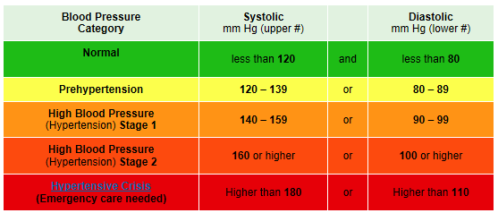
The basic instrument used to take a blood pressure reading is called a sphygmomanometer. This device consists of an inflatable cuff with an attached pressure gauge.
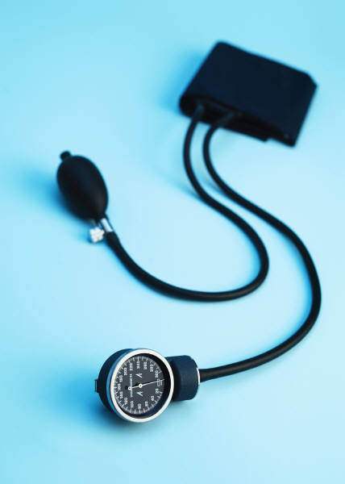
The cuff is placed on the upper arm and is inflated to cut off blood flow. Pressure in the vessel is measured as the cuff is released and blood flow returns to the artery.
- Obtain a sphygmomanometer and a stethoscope from your teacher.
- Watch the Mayo Clinic How to Measure Blood Pressure Using a Manual Monitor video available at http://www.mayoclinic.com/health/how-to-measure-blood-pressure/MM00784. Follow the instructions on the video and the steps below to take the blood pressure of a partner.
- Place the cuff snugly on the upper arm, approximately one inch over the elbow. The tubing should run down the inside of the arm.
Image courtesy of iStock images
- Clip the pressure gauge on the cuff, place it on the table or lab bench, or hold it in your hand so you can clearly see the values.
- Put the stethoscope in your ears and slide the disc ¼ to ½ of the way under the cuff. You should be close to the inside of the elbow over the artery called the brachial artery (see image).
- Inflate the blood pressure cuff by pumping the bulb. When the blood pressure cuff is inflated enough to stop blood flow, you should hear no sounds through the stethoscope. For most patients your age, pumping the cuff to 160-180 mm Hg is sufficient.
- Slowly deflate the cuff by gently turning the release valve. If you hear heart sounds immediately, you need to re-inflate the cuff to a higher value. Release the pressure slowly, approximately 2-3 mm Hg per second.
- Listen for heart sounds, which may sound like a tapping or beating. The first occurrence of rhythmic sounds heard as blood begins to flow in the artery is the systolic pressure. Note the pressure reading on the gauge at the first true sound.
- Continue to release the pressure and listen to the heart sounds as they begin to fade. Remember, the vessel is open now and the blood should be able to flow easily through the pathway. Note the gauge reading when the heart sounds stop. This pressure value is the diastolic pressure. Record your blood pressure in your laboratory journal.
- Take turns taking blood pressures and recording readings.
Part II: Measuring Blood Pressure with Probes
Many hospitals and doctor’s offices use automated blood pressure cuffs to take and record blood pressure values. You will now do something similar using a Vernier Blood Pressure sensor to acquire blood pressure data and Logger Pro® software to analyze your results.
- Refer to the Logger Pro® Resource Sheet as needed.
- Start the Logger Pro® software and open the Blood Pressure program.
- Click on File Open and open the Human Physiology with Vernier folder.
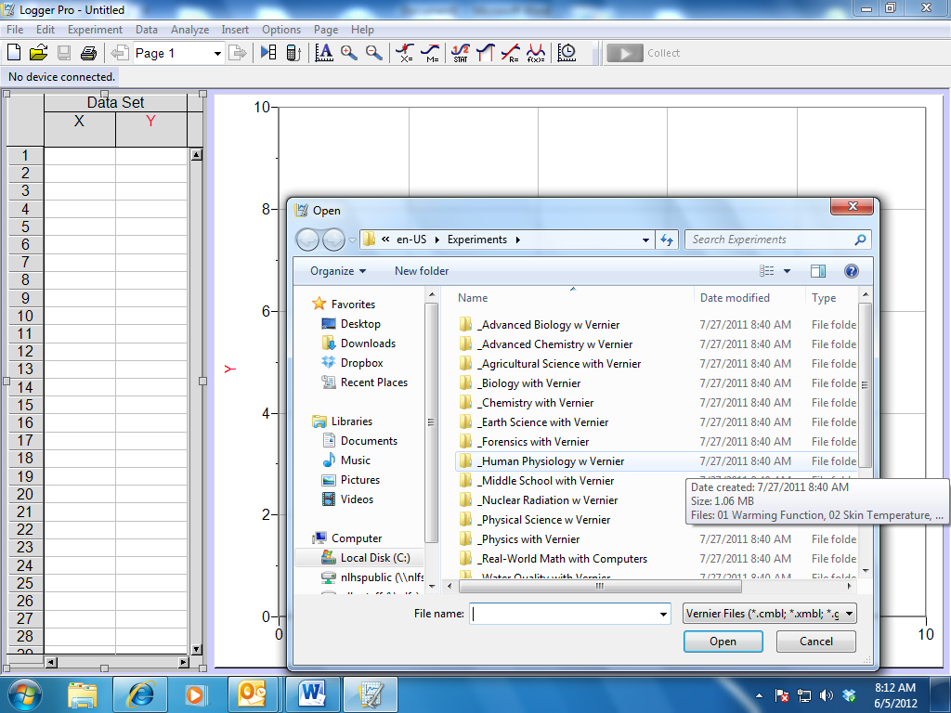
- Open the program titled 07 Blood Press Vital Sign.
- Connect the LabQuest Mini to the computer using the USB cable.
- Connect the Blood Pressure Sensor into CH 1 of the LabQuest Mini.
- Wrap the blood pressure cuff around your partner’s upper arm. Be sure to secure the cuff around the arm very snugly. Also make sure that the arrow on the cuff is pointing toward the index finger and that the tubes run down the inside of the elbow. Do not inflate the cuff yet.
- Position the person whose blood pressure is being taken so that they are seated with an arm resting on the table. It is important for the person to be quietly resting for a few minutes before the measurement is taken. While the blood pressure measurement is being taken, this person should remain seated and not move.
- Click the green Collect arrow in the top toolbar.
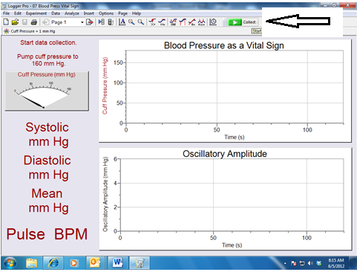
- Pump up the cuff using the rubber bulb.
- Notice the gauge moves and readings appear on the upper graph for the cuff pressure.
- Pump the cuff until the pressure reaches 160 mm Hg in the gauge.
- Stop pumping. The cuff will gradually lose pressure automatically. Do not use the release valve.
- Note that during this time, the systolic, diastolic, and pulse will be calculated by the software and displayed on the computer screen. When the cuff pressure drops below 50 mm Hg, the program will stop calculating blood pressure. At this point you can terminate data collection by clicking the red Stop button.
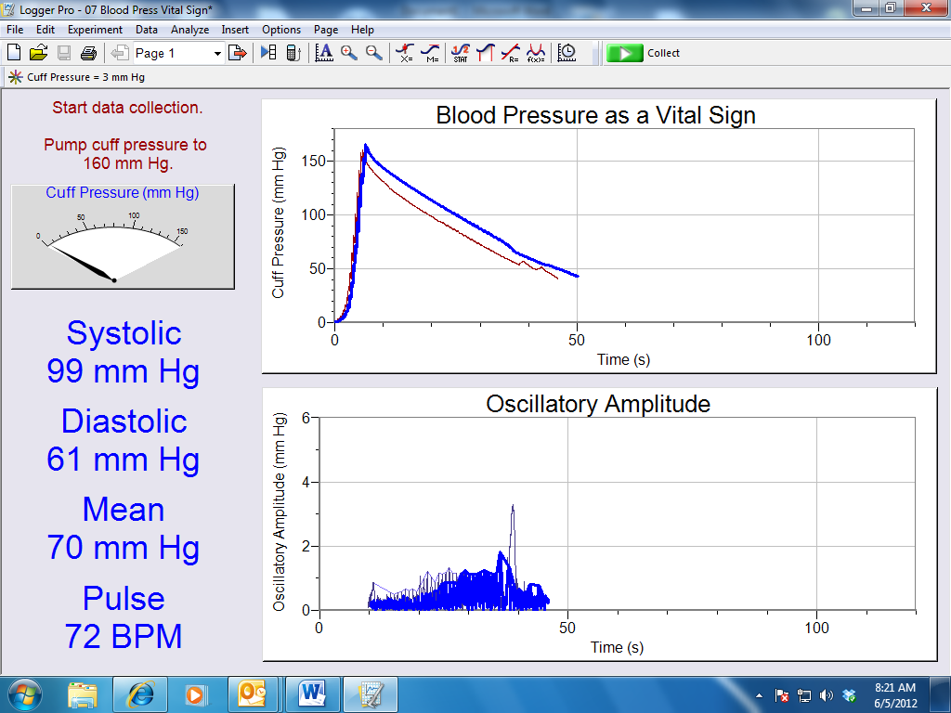
- Note that the pressure from the cuff will release, but do not remove the cuff.
- Under the Experiment menu, select Store Latest Run.
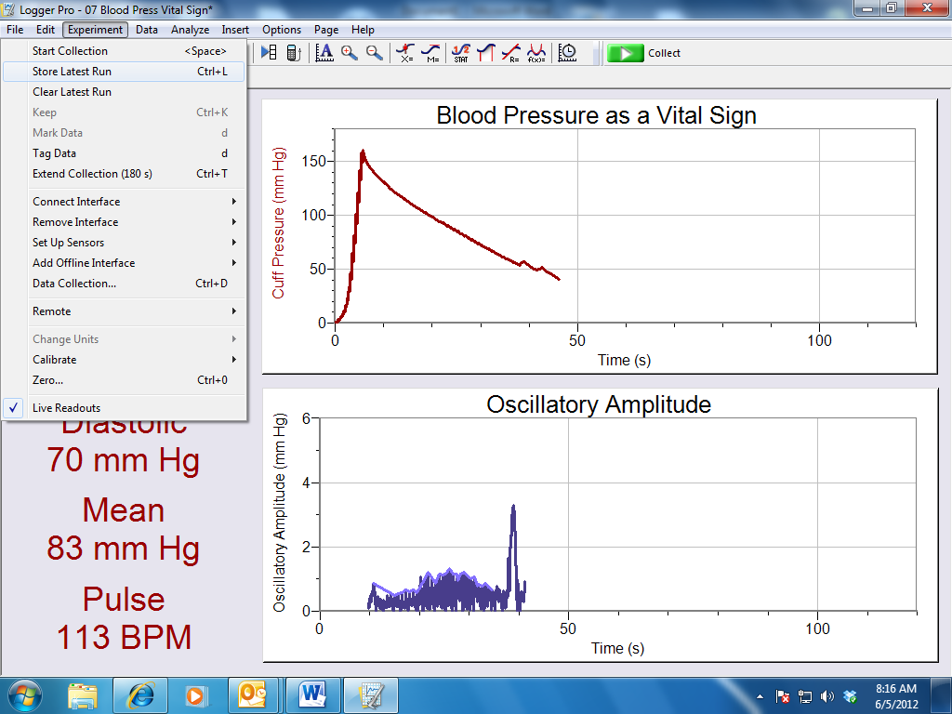
- Record the systolic and diastolic pressures in your laboratory journal.
- Wait three minutes and repeat steps 18-28. The person whose blood pressure is being measured should remain seated and relaxed during the wait period.
- Switch partners and take two readings as described above.
- Click on the Next Page button in the toolbar. Notice that the data from each trial is recorded on the graph. Note that you can rename the trials with your group members’ names, etc.
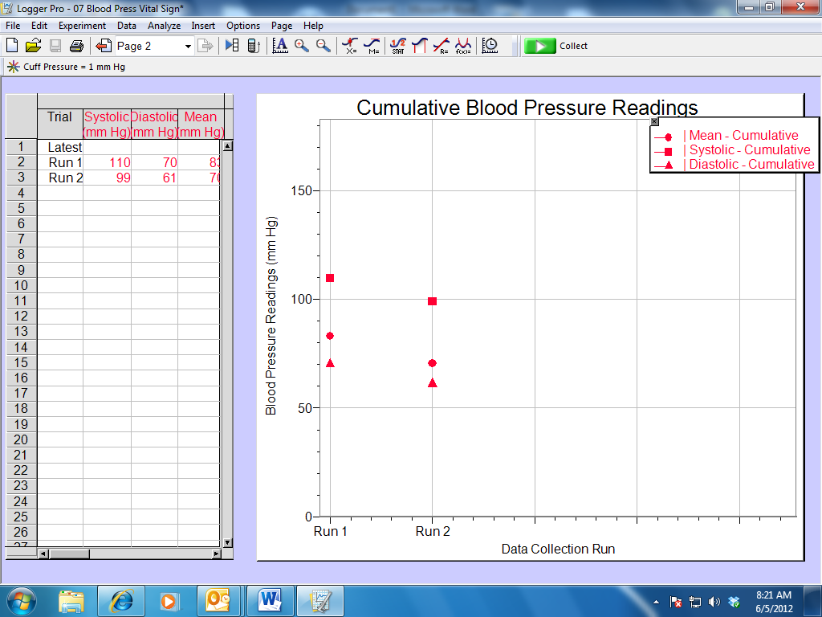
- Copy the analysis graph by left clicking on the graph and then pressing both the Control and the C keys simultaneously. Open a new Word document and Paste the graph into the new document. To paste press the Control and V keys simultaneously or use the Paste command in the Edit menu. Keep this information in your laboratory journal.
- Save the data to a file as directed by your teacher.
- Compare your blood pressure readings from Part I to those taken in Part II.
- Answer Conclusion question 1.
Part III: Experimental Design
- Refer to the Experimental Design Resource Sheet.
- Design an experiment to study the effect of the same factor you chose in Activity 4.2.1 (exposure to cold, physical activity, or body position) on blood pressure. Your experimental design should include use of the blood pressure sensor.
- Show your experimental design to your teacher before beginning your experiment.
- Use the Logger Pro® software as outlined in Part II to complete your experiment.
- Record all your data in your laboratory journal.
- Obtain a How to Write a Scientific Laboratory Report Resource Sheet from your teacher. Read the document. Note that scientists routinely report their experimental findings in papers or journal articles that follow the basic format outlined in a scientific laboratory report. Scientists describe their experimental setup in a manner that would allow other scientists to repeat their work.
- Write a formal laboratory report for either the experiment you completed in Project 4.2.1 or in this activity. Make sure to complete each section and to include diagrams, graphs, or data tables as needed.
- Review the American Heart Association recommendations for blood pressure listed in Part I.
- Refer to and review the Activity 4.2.1 Medical History document. Find Anna’s blood pressure values. Compare Anna’s blood pressure to the values presented in the American Heart Association chart located in Part I. Add notes under the Follow-up/Diagnosis section of the medical history sheet about what Anna’s values mean. Use the Internet to help you propose at least two lifestyle changes Anna could make to achieve a healthier blood pressure. Record these findings on the Recommendations portion of the medical history document.
- Note that Anna was supposed to be taking a class of medication called an ACE inhibitor. Use the Internet to investigate how this medication works to control blood pressure.
- Pretend you are Anna’s doctor and add information about this medication, specifically how it will help Anna’s blood pressure, on the Recommendations portion of the medical history document.
- Note that high or low blood pressure can sometimes lead to other serious medical problems. Use the Internet and find two examples, one for high and one for low blood pressure, of medical problems that can occur if these conditions are allowed to continue for long periods of time. Briefly describe the conditions, symptoms, and treatments in your laboratory journal.
- File the How to Write a Scientific Laboratory Report Resource Sheet in the appropriate tab of your course file. Use the PBS Course File – Table of Contents as a guide.
- Answer the remaining Conclusion questions.
Conclusion
- Did you get the same blood pressure reading manually as you did with the use of probes? Provide at least two reasons these values may be different.

- What are two causes of blood pressure changes that might occur in a person within a given day?

- What did you need to keep constant in your experiments? Why was it important to keep these factors constant?

- What is prehypertension? Why do you think it is valuable to know if you are considered prehypertensive?

- Explain how an ACE inhibitor might have helped Anna mediate her blood pressure.

