Activity 4.2.2: Student Resource Sheet – Building the Muscles of the Chest

This activity is a modification of Activity E in Starla on Maniken® produced by Zahourek Systems Inc. and is used with permission. Refer to Starla on Maniken® for helpful graphics and for additional ideas.

In this activity, you will guide students in the creation of some of the muscles of the chest. As this is the first time the students are working on adding major muscles, you should walk them through the steps and check their progress. Reinforce the muscle rules the students learned in Activity 4.2.1. Add muscles on your demonstration model and allow students to compare placement as you add each new structure.

Students will move from inside out and build the following muscles of the chest:
- Intercostals
- Serratus Anterior
- Pectoralis Minor
- Pectoralis Major (three major pieces or “heads” of this muscle)

Some of these muscles will be created using spaghetti strands while others will be made with larger balls of clay. Before the lesson, make terra cotta spaghetti strands for the students or have students do the preparation for you ahead of time. Use the clay extruder with the widest hole for these strands. Students can create spaghetti strands in class, but this process is time-consuming and can distract from the content.

NOTE: The arm of the Maniken® should be removed before the first muscles are built. Students should use the Allen wrench to carefully unscrew the arm and remove both the arm and the small stand-off that helps attach the limb to the body. The stand-off will be attached after the intercostal muscles are complete. The arm will be reattached after the serratus anterior is complete.

Muscle #1: Intercostals
Students will build the external intercostals of the chest. These muscles are found in between the ribs and extend from the front of the ribs, around back and past the bend in the bones. Write the name of the muscles in your notebook

- Describe the function of the muscles that are found between the ribs and write it down in your notebook.
- Place a strand of spaghetti between each rib, starting at the back of the rib where it attaches to the vertebral column, all the way around to the rib’s attachment at the sternum.
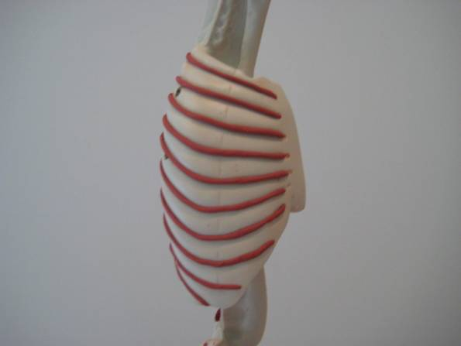

- Use your thumb or one of the clay tools to flatten down these strands. The intercostal muscles do not stick out of the chest.

Muscle #2 – Serratus Anterior
A diagram of serratus anterior can be found in the Myologik™ muscle atlas #5, page 82 or at the Get Body Smart website available from http://www.getbodysmart.com/ap/muscularsystem/shouldermuscles/anteriormuscles/serratusanterior/tutorial.html. Students can use these visuals or those in their reference textbook to help identify and find the origin and attachment of the muscle.

- Attach the stand-off to the torso. The indentation in the stand-off should face the midline of the model. Do not yet tighten the screws completely.

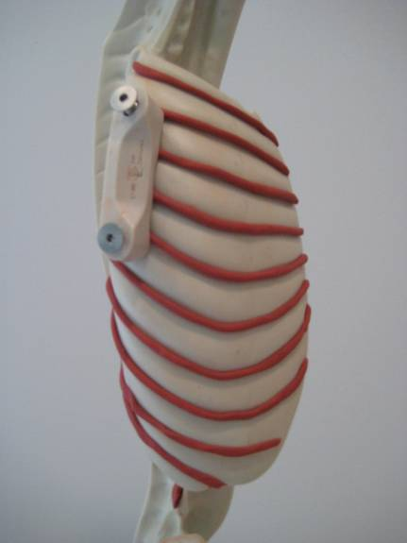

- Point out that the Maniken® displays vertical dashes midway around the ribs to indicate where the bone becomes cartilage.

- Write the name of the muscle in your notebook. Figure out the origin and the insertion of this muscle and write in your notebook.

Origin =
Insertion =
- You will use the stand-off on the arm to help build this muscle. As the scapula or shoulder blade is not present, students will build muscle as if they are extending back to the scapula. By placing the clay from the ribs to the stand-off, these muscles will look like they extend to the scapula once the arm is reattached. Help students see that in reality, these muscles would be attached to the shoulder blade.

- Take small pieces of spaghetti and attach these strands from the medial side of each rib (where the dashes are shown) to the stand-off on the arm. Attach one strand from each of ribs 1-8 to form a saw-like structure – a “serrated” edge.

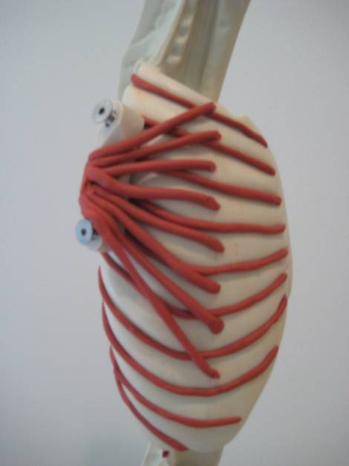

- Discuss the action of this muscle. Write this down in your notebook.
- At this point, attach the arm of their Maniken®. The screws should thread in as easily as they unthreaded on removal.
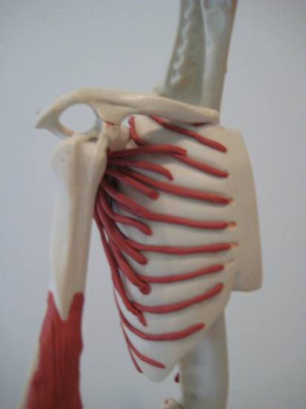

Muscle #3- Pectoralis Minor

- Discuss the origin and insertion of the pectoralis minor. Write the name of the muscle as well as the origin and insertion in your notebook.

Origin =
Insertion =

- Use spaghetti strands to form the pectoralis minor. Place one small strand at the origin of each rib and run these three strands together as they attach at the scapula. The muscle is built in a manner similar to the serratus anterior.

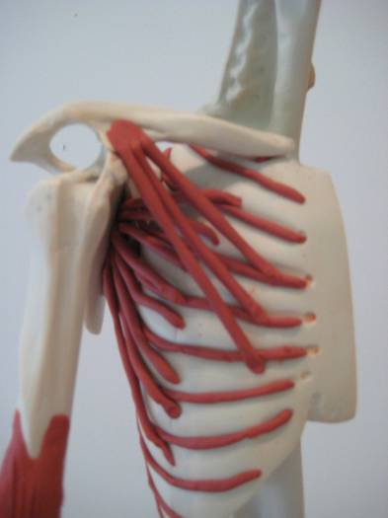

- Act out the movement of this muscle. This muscle works to rotate the shoulder forward.

Muscle #4 – Pectoralis Major
Even though this muscle only has one name, there are actually three different “heads” or pieces to this muscle. Each part will be built separately and will be formed from a carrot-shaped tube that has been rolled flat. Keep these muscles thick and striate each muscle as it is built.
- First construct the abdominal head of the pectoralis major. Write the name of this muscle in your notebook. Where do you think this muscle might attach? Write this down in your notebook.

- Discuss the origin and insertion of the abdominal head of the pectoralis major. Write these down in your notebook.

Origin =
Insertion =

- Make a long carrot out of terra cotta clay. Flatten the carrot slightly to make a tongue.

- Gently lay the muscle across the chest of the Maniken® from the origin to the insertion. The long end of the carrot should point towards the shoulder and the wide end should run down towards the 5th through 7th rib. The muscle will have a teardrop shape. Keep the insertion very narrow and the origin much wider. Do not worry about perfect shape at this point. You will trim the muscle to fit the Maniken®.

- Use the wire tool or a pencil to carefully outline the shape of the muscle and trim off any jagged edges.

- Take the muscle off the model and use the knife to trim the edges you have marked with your tool or pencil. Gently roll out the muscle if you need to stretch it a bit to fit from the origin to the attachment.

- Attach the muscle to the model. Next striate the muscle. Remember that the striations of the muscle indicate the direction the muscle moves.

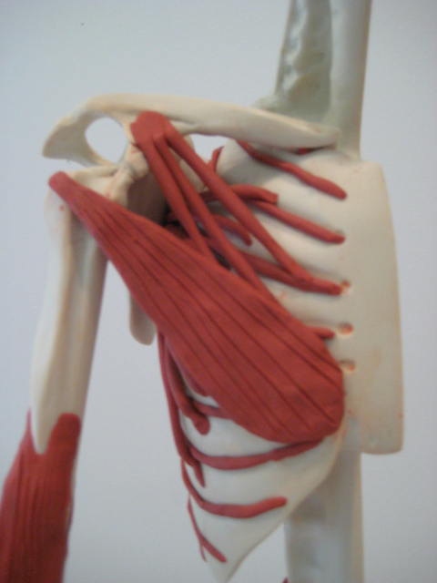

- Ask students to act out the motion of this portion of the pectoralis major. Describe which sports or exercises utilize this muscle. Write this down in your notebook.

- You will now create the largest portion of the muscle – the sternal or sternocostalis head. Write the name of the muscle in your notebook. Given the name only, where do you think this muscle might attach? Write this down in your notebook.

- Discuss the origin and insertion of the sternal head of the pectoralis major. Write this down in your notebook.

- Origin =
- Insertion =

- Make a short, fat carrot out of terra cotta clay. Flatten the carrot slightly to make a thick triangle. Do not worry about perfect shape at this point. You will trim the muscle to fit the Maniken®.

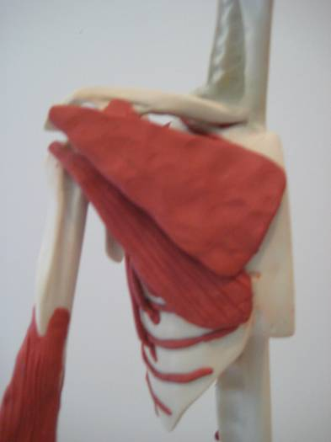

- Gently lay the muscle across the chest of the model from the origin to the insertion. The long end of the carrot should point towards the humerus and the wide end should run along the lateral edge of the sternum. The origin of this muscle will overlap the origin of the abdominal head.

- Use the wire tool or a pencil to carefully outline the shape of the muscle.

- Take the muscle off of the model and use the knife to trim the edges you have marked with your tool or pencil. Gently roll out the muscle if you need to stretch it a bit to fit from the origin to the attachment. Make sure no clay extends over the sternum.

- Attach the muscle to the Maniken®. Make sure to striate the muscle. Remember that the striations of the muscle indicate the direction it moves.

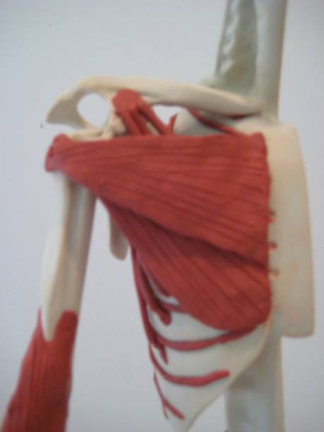

- Act out the motion of this portion of the pectoralis major. Which sports or exercises utilize this muscle. Write this down in your notebook.

- Have students create the smallest portion of the muscle – the clavicular head. Write the name of the muscle on the board. Given the name only, ask where do you think this muscle might attach. Write this in your notebook.

- Discuss the origin and insertion of the clavicular head of the pectoralis major. Write this in your notebook

Origin =
Insertion =

- Make a small carrot out of terra cotta clay. Flatten the carrot slightly to make a shape similar to an isosceles triangle. Do not worry about perfect shape at this point. You will trim the muscle to fit the Maniken®.

- Gently lay the muscle across the chest of the model from the origin to the insertion. The long end of the carrot should point towards the humerus and the slightly wider end should run up against the bottom of the clavicle. The insertion of this muscle will cross over the insertion of the other two muscles on its way to the humeral attachment.

- Use the wire tool or a pencil to carefully outline the shape of the muscle.

- Take the muscle off the model and use the knife to trim the edges you have marked with your tool or pencil. Gently roll out the muscle if you need to stretch it a bit to fit from the origin to the attachment.

- Attach the muscle to the Maniken®. Striate the muscle. Remember that the striations of the muscle indicate the direction it moves.

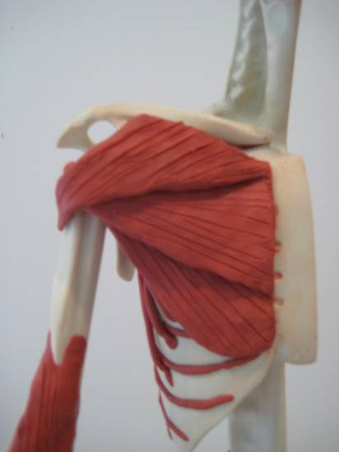

- Ask students to act out the motion of this portion of the pectoralis major. Describe which sports or exercises utilize this muscle. Write this in your notebook.
- Please complete the rest of the activity. By this point, you should appreciate the diversity of muscles in the chest as well as have a good understanding of how to build muscles on their Maniken®. In the next activity, they will be responsible for creating muscles on the models independently.

