Project 4.2.1: Heart Rate

Introduction
Even before you were born, one of the first things your doctor did when you went for an office visit was listen to your heart. Your heart rate, the number of times your heart beats in one minute’s time, is one of the key vital signs physicians use to assess overall health. Heart sounds are a result of blood moving through the various parts of the organ. The rhythm of the heartbeat, as well as the heart rate, provides clues as to the general physical condition of a person. Think back to when you learned about the function of the heart. Changes in heart rate influence the amount of blood that is pumped to the tissues. A high heart rate means that the heart has to work overtime to meet the oxygen demands of the body. If the heart rate dips too low, the body may not get enough oxygen to function.

Every heartbeat sends blood through your vessels to your tissues. After each heartbeat, a pressure wave or pulse passes along an artery as its walls bulge and then relax to withstand the surge of blood. By pressing on an artery, the number of pulses or heartbeats per minute can be counted.

In this activity you will explore the movement of blood in the cardiovascular system and the measures used to assess overall heart health. You will feel the “pulse” through major arteries and monitor your own heart rate manually and with the help of computer probes and software. You and a partner will use the steps of experimental design to plan and conduct an experiment demonstrating the effect of stress (as modeled by extreme temperature), exercise, or position of the body on heart rate.
Equipment
- Computer with Vernier Logger Pro® software
- Vernier LabQuest® Mini with USB cable
- Vernier Heart Rate Hand-Grip Monitor
- Logger Pro® resource sheet
- Project 4.2.1 Medical History resource sheet
- Ice water bath
- Towel
- Timer or watch
- Colored pencils or markers
- Laboratory journal
- PBS Course File
- PLTW Biomedical Science Experimental Design resource sheet

Procedure
Part I: Anna Garcia – Cardiac Work-up
- Obtain a Project 4.2.1 Medical History Resource Sheet from your teacher. Note that due to two instances of severe chest pain at age 37, Anna’s doctors sent her to a cardiologist for a full cardiac work-up. This work-up included blood work, medical tests, and diagnostic images. NOTE: You will receive initial blood work back from the lab in Lesson 4.3.
- Read the information on the Medical History sheet. You will refer to this document, as well as the autopsy report, as you complete this lesson and progress into later lessons. You do not need to complete additional research on any terms or results just yet.
- Discuss what you can already deduce from these medical findings with your partner or with the class.
Part II: Pulses and Heart Rate
When blood flows through the major arteries, you can feel the pulse and count the rate at which the heart churns out blood.
- Locate each of your pulse points as described below. NOTE: Do not use your thumb to find pulse points, as the thumb contains a blood vessel that is large enough for a pulse to be felt.
  - Carotid pulse: Locate this pulse using your index and middle fingers on your neck. Slide your fingers alongside your jaw bone and down into the depression on the side of your neck.

  - Radial pulse: Locate the radial pulse at the wrist. If you have trouble finding this pulse, turn the wrist being measured palm up. Wrap your other wrist (palm up also) around it until your fingers fold over the radial artery.

- Seated comfortably, find your carotid pulse. Each pulse you feel corresponds to one beat of your heart. Your partner should act as a timer as you count the number of beats you feel in 30 seconds. Multiply this number by two to obtain your heart rate in beats per minute (bpm). We refer to this value as your resting heart rate.
- Switch roles and allow your partner to determine his/her heart rate.
- Repeat this process until you have measured your resting heart rate three times. Record these values in your laboratory journal and calculate your average resting heart rate.
- Compare heart rates with those in the class and discuss “normal” values for resting heart rate. The average adult has a resting heart rate of 72 beats per minute.
- Answer Conclusion questions 1and 2.
Part III: Heart Rate Determination Using Probes
Many different types of instruments and measuring devices are used by people working in the biomedical sciences. For example, a nurse may measure several vital signs such as body temperature, blood pressure, heart rate, and blood oxygen content using various probes that are attached to the patient. These probes can send the information to a monitoring post located at the central nursing station. Biomedical professionals can monitor the patient at all times without having to be in the patient’s room.

Electronic monitoring involves two distinct processes: the actual measurement must be taken, and then the data must be collected and presented. A sensor or probe is used to take the actual measurement. Each of the measurements is different and uses a different sensor or probe—a thermometer for temperature, electrodes for the EKG, an arm cuff for blood pressure. Software is then used to collect, display, and analyze the data. In this lesson you will use Logger Pro® software and Vernier probes to simulate tests related to the cardiovascular system.

- Refer to the Logger Pro® Resource Sheet as you are working with Logger Pro® software and Vernier probes.
- Obtain a Vernier Hand Grip Heart Rate monitor. You will use this probe to determine your heart rate and compare this value to the resting heart rate you measured in Part II.
- Turn off any cell phones and disable the wireless connection on the computer. These devices can interfere with the hand-grip heart rate monitor because it is wireless.
- Start Logger Pro® software on your computer.
- Click on File Open and open the Human Physiology with Vernier folder.
- Open the program titled 03 Heart Rate Vital Sign.
- Connect the LabQuest Mini to the computer using the USB cable.
- Connect the Handgrip Heart Rate Monitor into CH 1 of the LabQuest Mini using the British Telecom connector.
- Notice the Handgrip Heart Rate Monitor has two parts. There is a small rectangular box with an arrow, and there are two connected cylinders. The small box has the British Telecom connector and is connected to the LabQuest Mini. The two cylinders are the hand grips, and they have clearly marked hand outlines to show proper hand placement. Both grips must be held by the person being tested.
- Notice the arrow on one of the hand grips and the arrow on the small black receiver. These arrows must be aligned to use the probe. Have one partner hold the receiver next to the hand grip with the arrows aligned when you begin collecting data. Once data appears on the front panel, you will be able to move the receiver up to 2 feet away and still take measurements.
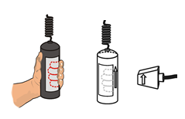
- Adjust the length of time for the experiment. To obtain initial heart rate data, set the timer for 60 seconds. Click on the 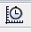 button in the toolbar, adjust the Length accordingly, and click Done.
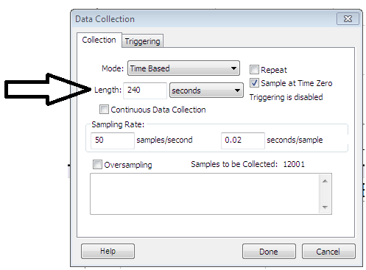
- Click the green Collect arrow in the top toolbar.
- Notice it may take 15 to 20 seconds after you press the Collect arrow for data to appear on the data collection graphs. After that time, you should see a waveform graph appear in the Heart Beats graph and the calculated beats per minute appear on the Heart Rate as a Vital Sign graph. Note that the table on the left hand side of the screen charts the recorded heart rate at 5 second intervals.
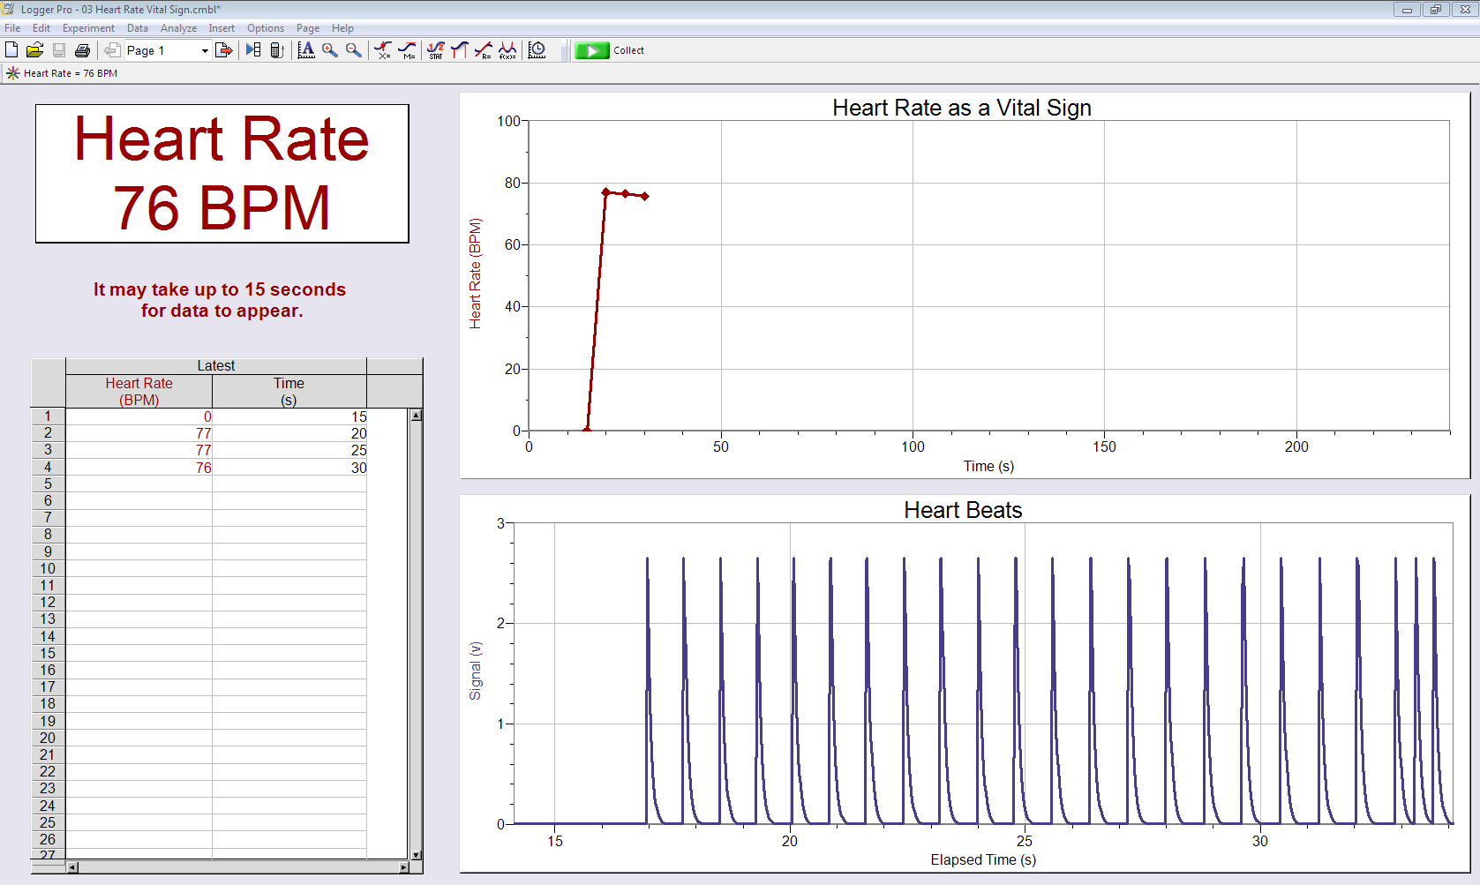
- Click the red Stop bar when you are finished collecting data. Note that if you set the experiment to a predetermined length, the data collection will stop automatically.
- Save the data to a file as directed by your teacher.
- Record in your laboratory journal the average heart rate in beats per minute. This value will appear in the white box on the left side of the screen. Compare this value to the average heart rate you measured in Part I. Discuss why these two values may differ.
- Copy the Heart Rate as a Vital Sign graph by placing the mouse cursor over the graph, left clicking, and then pressing both the Control and the C keys simultaneously. Paste the graph into a Word document and save it. To paste the graph, press both the Control and the V keys simultaneously. Repeat this step in order to copy and paste the Data Table into the Word document. Save your printed data in your laboratory journal.
Part IV: Experimental Design
- Refer to your Experimental Design Resource Sheet. Review the steps of the process.
- Using the steps of experimental design, work with a partner to outline a procedure to address one of the questions listed below or another question you have approved by your teacher. Detail the steps of your experiment in your laboratory journal. Remember to include details such as length of experiment.
- What effect does exposure to extreme temperature, as stimulated by exposure to cold, have on heart rate?
- What effect do changes in physical activity have on heart rate?
- What effect do different body positions (sitting, standing, lying down) have on heart rate?
- Show your experimental design to your teacher for approval before attempting to do the experiment. Once your design is approved, you may proceed with the next steps in the procedure.
- Perform your experiment as you designed it. Follow the instructions presented in Part III to guide your use of the heart rate probe.
- Collect data in your laboratory journal. Print graphs and charts from the computer as needed and include these with your written work. Make sure to clearly explain your results.
- Compare your results with others in your class who completed a similar experiment. Discuss reasons for discrepancies.
- File the Project 4.2.1 Medical History Resource Sheet in the appropriate tab of your course file. Use the PBS Course File – Table of Contents as a guide.
- Answer the remaining Conclusion questions.
Conclusion
- Why do you think it is important to take an average resting heart rate versus relying on one value alone?

- What are some factors that can increase or decrease the heart rate and the beat you feel at each pulse point?

- Propose reasons why the heart rates of different people are different when exposed to the same stressor or to the same physical activity, even though their resting heart rates are identical.

- At the time of her cardiac work-up, Anna Garcia had an average resting heart rate of 98bpm. What does this say about her overall heart health?

