

Project 4.2.1: Medical History

Patient’s Name: | Age: | Date:
Anna Garcia | 37 | May 14th
Height: | Weight: | Temperature:
5’4” | 158 lbs | 98.7°F
Blood Pressure: | Pulse: | Respiration Rate:
140/72 | 98 bpm | 22 bpm
Chief Complaint
Anna is a 37 year old Hispanic woman with both Type 1 diabetes and sickle cell disease who was referred to a cardiologist for a full cardiac evaluation after two incidents of self-resolved chest pain. Anna is a non-smoker who admits to eating a diet high in both calories and fat. Anna consumes three glasses of wine each day after work. Anna used to be an athlete, but has not kept up with formalized exercise. Anna takes a daily aspirin and does do a Yoga home video as needed to help her deal with the stress of her illnesses and her job.

Anna has a family history of early heart disease as well as uncontrolled hypertension. Her father had a heart attack when he was only 41 years old.

Patient was evaluated by physical exam, blood work, cardiac stress test with electrocardiogram (EKG), and an echocardiogram. Results later prompted an angiogram.

Physical Exam
- Patient is tachycardic – average resting heart rate ranged from 90-105 over the course of the day.
- Patient shows no signs of edema (swelling) in her feet or lower legs, although she does mention an occasional tingling sensation in her right calf.
- Blood pressure values averaged 142/85 over the course of the work-up.
- Slight heart murmur detected.
- Waist Circumference – 33 inches

Cardiac Testing
Patient completed a treadmill stress test. The patient experienced drastic increases in blood pressure as well as a few premature ventricular contractions (PVCs) on EKG during the exam. One run of ventricular tachycardia was noted. Additional monitoring using a Holter monitor is suggested given these abnormalities and the noted mitral regurgitation (see below). The patient was only able to walk for 8 minutes before the test was concluded – max speed 3.5 mph at an elevation of 2%, and max blood pressure of 190/110.

EKG tracing from test available. (video courtesy of iStock). A screen capture is shown below.
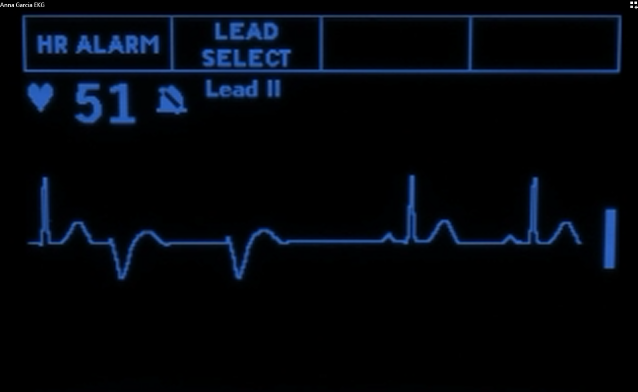

Due to EKG changes during the treadmill test and the patient complaint of chest pain, an angiogram was recommended to explore the cardiac vessels. Scans revealed a blockage in the left anterior descending coronary artery (not fully visible on the summary scan below). Angioplasty is recommended with the potential for stenting.

Summary angiogram available  (video courtesy of iStock)

An Echocardiogram was completed to assess overall heart structure and valve function. Left ventricle was slightly enlarged but still within normal limits. Slight mitral valve regurgitation noted.

Findings/Diagnosis

Recommendations

