Activity 4.1.2: Range of Motion

Introduction
You come home from school, run up the stairs and throw your backpack on your bed. This sequence of events took only minutes, but used joints in your ankles, knees, elbows, shoulders, and wrists. You realize that when you threw your bag, your cell phone slid under your dresser. You try to reach it, but you can not seem to get your arm back far enough. Your twin sister comes in and offers to help. She bends down, stretches and twists her arm and almost instantly, you have your phone back. If we all have the same general arrangement of bones and joints, why was she able to reach the phone with ease when you did not even come close?

Range of motion (ROM) studies assess joint motion and provide a measure of overall flexibility. You may have heard of people who are “double-jointed.” This does not mean that they have twice as many joints as you do; rather, the ones they do have are unusually flexible. We often use the everyday terms such as bend and flex to describe the motion of our limbs, but scientists and doctors use specific terms to describe just how a set of bones move at a joint. These precise terms describe the direction of motion as well as the relationship of one body part to another. As you will see in the next lesson, muscles are often named using terminology that is linked to the type of motion they permit.

In this activity, you will use a device called a goniometer to measure the angles resulting from the movement of various joints in the body. With your team, you will match body actions with range of motion photographs. You will use information from the pictures to measure your own range of motion and to devise a strategy for measuring range of motion of body movements not shown in the photographs. These measurements can be compared from person to person and can be used to rate overall flexibility and range of motion.
Equipment
- Computer with Internet access
- Goniometer
- Activity 4.1.2 Student Resource Sheet
- Laboratory journal
- Pencil
- Paper towels or a folded towel, rag, or article of clothing
- Digital camera (optional)
- Body system graphic organizer (optional)
- Reference textbook (optional)

Procedure
- With a group of three, research the following pairs of terms that describe possible movement at a joint. Use the Internet or reference textbooks to guide your search.
- Depression and elevation
- Rotation and circumduction
- Flexion and extension (and hyperextension)
- Abduction and adduction
- Plantar flexion and dorsiflexion
- In your laboratory journal or on a body system graphic organizer, create a visual that helps you remember the path of motion for each pair of terms. Also describe each motion in words.
- Obtain a goniometer and a Student Resource Sheet from your teacher. A goniometer, like a protractor, allows you to measure angles. In this case, you will be measuring the range of motion of your joints. One arm of the goniometer will remain stationary, while the other arm will move to measure the angle of your limbs. Your teacher will demonstrate proper use of the goniometer.
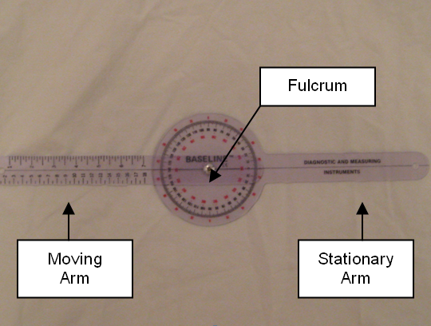
The axis (fulcrum) of the goniometer will be placed over the joint. The moving arm follows the motion. Neutral extension at each joint is recorded as 0 degrees. As the joint flexes, motion progresses towards 180 degrees. In the picture below, the moving arm has progressed approximately 50 degrees.
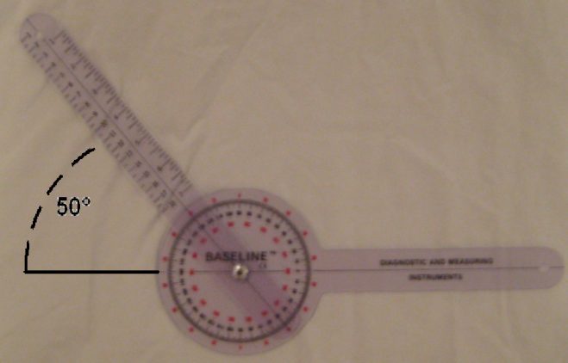

- Look at the pictures on the Student Resource Sheet. Using what you have learned about movement at a joint, match the action with the correct range of motion picture. Each pair of pictures shows the placement of the goniometer at the beginning and end of the motion. Remember, you are measuring the range – how far the limb progresses at the joint while performing a specific motion. NOTE: Three actions do NOT have a corresponding photograph. Later, you will be responsible for describing, drawing, or photographing the missing measurements.
- When you think you have all of the pictures matched with the correct action, check your answers with your teacher.
- Let your teacher know if you are experiencing any pain in your joints or if you are limited in mobility in any way. Help others in your group complete measurements, but do not complete experiments that could cause you pain or injury.
- With your group, choose three of the actions shown in the photographs. You will work as a team to take range of motion measurements for these actions using your goniometer. Use your research from Steps 1 and 2, as well as information presented in the Student Resource Sheet, to help you act out each movement and plan your measurement strategy.
- Before you begin data collection, read the following helpful tips:
- When you are measuring range of motion, think about the path the limb takes to get to the final end position. Make sure that the angle you are measuring corresponds to this path.

- Make sure the body is stabilized so only the joint in question is able to move.

- Once the subject is in position, gently take their limb through the desired ROM. This passive movement provides an estimate of ROM and demonstrates to the subject the exact motion desired.

- When instructed to do so, the subject should move the limb through the desired motion to the natural endpoint. Make sure the subject is not straining. This active movement shows the subject’s range of motion for this particular action.

- Range of motion values can be recorded as a range - 0° - ___° or as the endpoint value.
- Use the goniometer to take measurements for each of the three motions. Come to consensus on where to place the goniometer to take an accurate reading. One member of the group should be the test subject. One member of the group should hold the goniometer steady while the other moves the arm and reads the angle value. Switch roles so each member has a chance to measure range of motion for each of the three chosen movements.
- Record ROM values for your own joints in your laboratory journal.
- Identify the type of joint responsible for each of the three measured movements. Use your notes and sketches from Activity 4.1.1 as a resource. Write the name of the type of joint in your laboratory journal next to the appropriate range of motion measurement.
- Compare your ROM values to those of the other members of your group (and other members of the class who chose the same measurements) and discuss any differences.
- Answer Conclusion questions 1-3.
- As a group, plan a measurement strategy for the three actions that do not have corresponding pictures on the Student Resource sheet. Either photograph, draw, or act out the range of motion for each action. Be sure to clearly show the angle that is being measured. Use other photographs on the Student Resource Sheet to help you plan your measurement strategy. Think about placement of the goniometer and make sure you are measuring the correct motion.
- Try out your measurement strategy and take ROM measurements for these three movements and record the values in your laboratory journal.
- Share your measurement strategies with the class. Either share your photographs or drawings or act out the motion and the measurement. As a class, come to consensus on which measurement strategy best measures an accurate range of motion.
- If instructed to do so by your teacher, compare your range of motion results to suggested values for normal ROM based on existing data.
- Answer the remaining Conclusion questions.
Conclusion
- Describe how your range of motion compares to the range of motion of those in your group. Why might there be differences?

- Which type of joint do you think allows for the greatest number of different movements? Explain your reasoning.

- What factors influence range of motion of a joint?

- Explain how a person can improve flexibility at the joints.

- Your goniometer breaks. Describe another way you might be able to measure range of motion. You may use any other materials.

- Your favorite team is winning the championship game. You drop to one knee, tip your head back, raise one hand over your head, clench your fist and yell, “Yes.” Use the proper terms to describe the movements undertaken by your joints.

- You overhear two men at the gym talking about their extensor muscles of the forearm. Based on what you know about the motion at joints, how would you describe the movement of these muscles?

