Activity 4.1.2: Anatomy of the Heart

Introduction
The human heart is a four-chambered structure designed to pump blood in specific directions. To understand how the heart functions (and sadly, malfunctions), you must first understand the actual physical structure and organization of this amazing organ.

Cells in your body combine to form tissues. Tissues combine to form organs such as the heart. The heart is made of a tissue called cardiac muscle. Muscles contract and relax, and in this case, the involuntary contraction of the heart propels blood around the body. If all is functioning properly, we do not even have to think about it and our heart beats. In this activity you and a partner will dissect a sheep’s heart, a four-chambered structure that is a smaller version of your own heart. You will observe key structures and discuss how structure relates to function. You will also use a microscope to observe the structure of arteries and veins, the vessels that take blood to and from the heart and lungs. At the conclusion of the activity, you will review Anna’s autopsy report and make conclusions about how problems in the cardiovascular system may have contributed to her death.
Equipment
- Computer with Internet access
- Laboratory journal
- PBS Course File
- Activity 4.1.2 Autopsy Report Resource Sheet
- Heart box poster/drawing from Activity 4.1.1
- How to Use a Microscope Student Resource Sheet
- An Illustrated Dissection Guide to the Mammalian Heart by David Hall or other anatomy atlas of the heart (optional)
- Dissection pan and tools
- Latex or nitrile gloves
- Safety goggles
- Prepared slides of arteries and veins
- Microscope
- Paper towels
- Pencil for sketching
- Toothpicks to secure flags
- Adhesive labels to make flags
- Ruler
- Marker
- Camera (optional)

Procedure
Part One: The Dissection
- Obtain a dissection pan,
- Follow your teacher’s instructions, especially concerning safety with dissection equipment. If your teacher has chosen to use the dissection guide written by David Hall titled An Illustrated Dissection Guide to the Mammalian Heart, then read the introduction and the opening paragraphs on page one. You may also be asked to review the steps presented in the Pig Heart Dissection presentation, adapted from the South Carolina Department of Education, available at http://hrsbstaff.ednet.ns.ca/kalberld/PigHeartDissection.ppt. Consider having this presentation or one of the heart websites from Activity 4.1.1 open on your computer as a reference; however, avoid touching the computer if you are the one dissecting. Your heart box diagram from Activity 4.1.1 should also be in view as you dissect.
- Follow the steps listed below to complete the dissection of the heart. In the instructions you will find terms in italics. These are the structures you must identify and mark using a flag. Write the name of the structure in marker and place the toothpick flag in the tissue at the correct location. Use the drawings and definitions in the manual, the presentation, or other resources as guides to help you identify the structures of the heart.
- Sketch or take notes in your laboratory journal to help you remember key structures.
External Dissection
- Obtain one sheep heart as instructed by the teacher.
- Place the heart in your dissecting tray with the ventral side facing you. Refer to the picture in the manual. The ventral position means you would be looking at a person’s chest from the front view.
- Observe the outside of the heart. The darker line running from the upper right diagonally to the lower left is the left coronary artery. Coronary arteries provide blood to the heart muscle itself. Remember that all tissues, including the heart itself, need the oxygen delivered by blood. Label the coronary artery with a flag.
- Note that the bottom of the heart comes to a point called the apex.
- Note that to the right and above the apex is the left ventricle. Remember, it is left because of the presentation – ventral side.
- Use your finger to push on the outside wall of the left ventricle. Notice the firmness of the chamber.
- Note that to the left and above the apex is the right ventricle.
- Use your finger and push on its outside wall. Compare it to the left ventricle. Notice it compresses easier than the left ventricular wall.
- In the space below, differentiate between the functions of the left and right ventricles. Use the Internet or your materials from Activity 4.1.1, if needed.

- Note that above the ventricles is an area called the base of the heart. At each side (left and right), there are “ear like” extensions of the atria called auricles. Under each auricle are the left atrium and the right atrium.
- In the space below, explain the functions of the left and right atria (atria is the plural of the word atrium).

- Extending out of the right atrium is the superior vena cava vein. Place a probe into it and see that it leads directly into the right atrium (this is a good strategy to be sure it is the correct structure).
- In the space below, explain the function of the superior vena cava.

- Next to the superior vena cava is the aorta, a large branching artery that leads to the left ventricle. The aorta has a branch called the brachiocephalic artery. It may seem to be a separate structure but in fact it is part of the aorta. Place your finger or a probe into it and see that it leads directly into the left ventricle.
- In the space below, explain the function of the aorta.

- Look to the right (which is really the left), of the aorta, and see the pulmonary veins. Use a probe or your finger and see that they lead to the left atrium.
- In the space below, explain the function of the pulmonary veins.

- If desired, take a picture of your labeled heart or make a sketch of your heart in your laboratory journal.
Internal Dissection
- Place the heart with the ventral side facing you. The ventral position means you would be looking at a person’s chest from the front view. Refer to your toothpick labels as needed for landmarks. Move the flags if they are getting in the way of your cuts. Add additional flags to the internal structures (when possible).
- Find the right atrium.
- Use the scalpel to cut through the entire length of the right atrium. Cut through to the cavity – not through to the other side.
- Gently pull back the tissue exposing the inside of the cavity.
- Observe the tissue in the wall and the inside of the cavity.
- Use your metric ruler to measure the thickness, in millimeters, of the atrium wall. Record the measurement : _____________
- Cut open the superior vena cava and carefully pull back the tissue. You should see thin flaps of tissue that almost look like leaflets. This is the tricuspid valve. Based on the name tricuspid, how many leaflets should you see? ________
- Feel the leaflets with your finger and describe them in the space below.

- Observe the fibrous chords that are attached to the valve and help hold it in place. These are called the chordae tendinae and they extend to the right ventricle. The chordae tendinae are attached to the papillary muscle, which holds the fibers to the wall of the ventricle. Both the chordae tendineae and the papillary muscle are essential for the valve to work correctly.
- Gently tug on one of the chordae tendinae and observe what happens to the valve.
- Describe the function of the tricuspid valve in the space below.

- Use the scalpel to make a long incision through the wall of the left ventricle. Carefully pull the wall back and observe the various tissues.
- Use the metric ruler to measure the thickness of the wall of the left ventricle (in millimeters). Record the measurement: _________
- Compare the thickness of the wall of the left ventricle to the wall of the right ventricle.

- Find the mitral valve (sometimes called the bicuspid valve) in the left ventricle. It looks similar in appearance to the tricuspid valve. In the space below, describe its appearance.

- In the space below, explain the function of the mitral valve.

- Check which structure is the aorta by placing your finger or a probe into it. It should lead directly to the left ventricle. Cut open the aorta and observe the thickness of the tissue. This may also get you a better view of mitral valve.
- Cut open the other major blood vessels you labeled in the external dissection. In the space below, describe how the thickness of the aorta compares to the other great vessels. Provide a reason for this difference.

- Use your scalpel to cut the heart almost in half. The cut should go through the middle but not all the way through to the other side. Leave a flap holding the organ together.
- Use a probe as a pointer and starting with the superior vena cava, trace the flow of blood through the heart. In the space below, list the structures in the order the blood would meet them during its travel through the heart. Include the valves, the lungs, and the extremities of your body on your list. Refer to your heart box from Activity 4.1.1 if needed.

- Reattach any labels that may have come off both hearts. Have your teacher check your dissection and your external labels.
- Follow your teacher’s instructions to clean up your lab station and dispose of your dissection specimen.
- Complete Conclusion questions 1 and 2.
Part Two: Vessel Viewing and Autopsy Analysis
- Obtain prepared slides of arteries and veins.
- Observe each slide under the microscope. Refer to the How to Use a Microscope Resource Sheet if needed.
- Sketch each image in your laboratory journal. Remember to note the magnification.
- Answer Conclusion question 3.
- Obtain an Activity 4.1.2 Autopsy Report from your teacher.
- Read the additional information presented on Anna’s autopsy report. Underline or highlight information or terms you do not know. Reflect on what you can say about Anna’s heart now that you have completed this lesson. You will continue to analyze this report throughout the unit.
- Look at the X-ray image shown in the External Examination section. Compare the image on the autopsy report to the normal image shown below. Note any differences directly on Anna’s autopsy report, below the X-ray image.
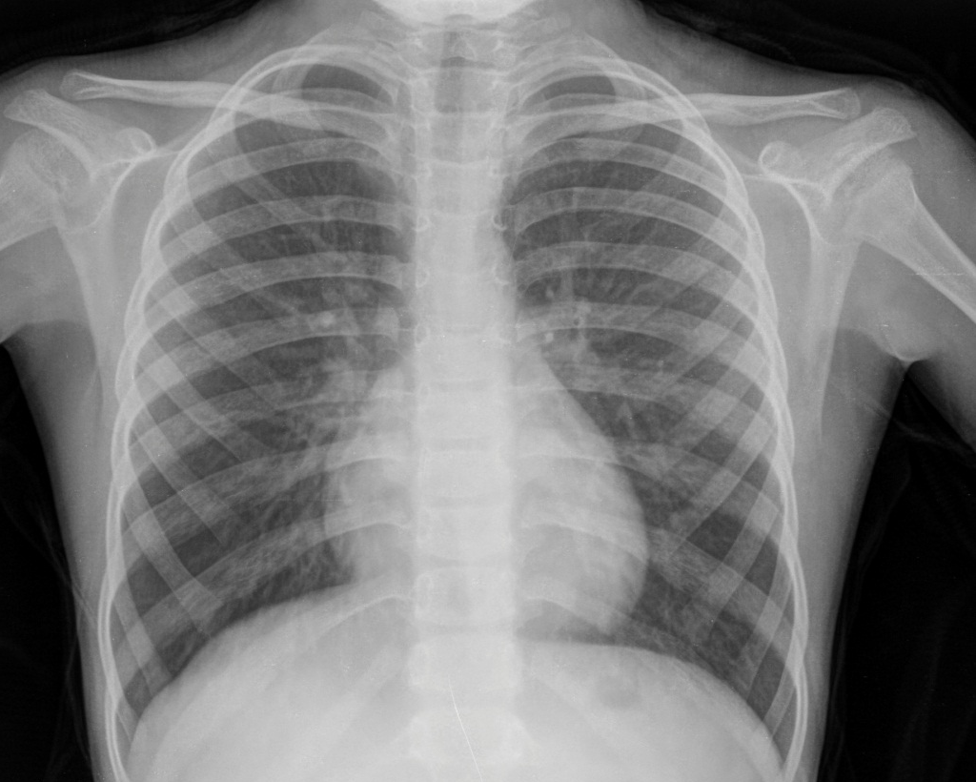
Image courtesy of iStock images

- Note that Anna has signs of left ventricular hypertrophy. Research this condition and provide a one to two sentence definition on the autopsy report. Add information to the report that suggests reasons for this enlargement. Think about Anna’s other medical conditions.
- Discuss the new information about Anna with a partner and with the class. On the autopsy report, add any possible causes of death related to the cardiovascular system.
- File the Activity 4.1.2 Autopsy Report in the appropriate tab of your course file. Use the PBS Course File – Table of Contents as a guide.
- Update the classroom evidence board with information from Lesson 4.1.
- Answer the remaining Conclusion questions.
Conclusion
- What are two differences you see when comparing the four chambers of the heart? Relate these differences to the function of each chamber.

- Describe how the structure of the aorta relates to its function in the heart.

- What structural differences did you notice between arteries and veins? Relate these differences to the function of the vessels.

- Anna’s autopsy report noted mitral valve prolapse. This means that the mitral valve does not close properly. Explain why this could be a problem.

- Using what you have learned about the structure and function of the heart, explain why left ventricular hypertrophy can be fatal if left untreated.

- Now that you have seen a heart up close, explain how the actual structure differs from your heart box study tool.

