Activity 3.4.2: What is the Probability?

Introduction
Sickle cell anemia is an inherited recessive disorder. In a family with a history of sickle cell trait, individuals may want to know whether or not future children will have the trait. If the pattern of how the trait is inherited and the individual’s family pedigree are known, doctors and genetic counselors can calculate the probability that an individual will express a trait. In Activity 3.3.1 you learned that each parent has two copies of every chromosome. Therefore, there is a 50% chance of either chromosome being passed to a child (just as a coin has two sides and there is a 50% chance it will be heads and a 50% chance it will be tails when it lands after being tossed in the air). The science of genes, heredity, and the variation of organisms is called genetics, and the biologists who study genetics are called geneticists. Using their understanding of whether a trait is dominant or recessive, geneticists can predict the likelihood of the inheritance of particular traits.

One of the easiest ways to calculate the mathematical probability of inheriting a specific trait is called a Punnett square. A Punnett square is a simple graphical way of discovering all of the potential combinations of genotypes, given the genotypes of the parents. It also can be used to determine the percent chance of each genotype’s occurrence.

In Activity 3.3.1 How is DNA Passed through the Generations? you “started a family” using paper chromosomes. Together as a class, you compiled all of the traits found in everyone’s first two children. In this activity you will use the chart that you created in Activity 3.3.1 to determine the experimental probability of a child inheriting Sickle Cell Anemia and compare the experimental probability to the probability determined with a Punnett square. You will then examine pedigrees and calculate the probability that an individual has or will receive the mutated chromosome that causes the abnormal hemoglobin associated with sickle cell disease.
Equipment
- Computer
- Laboratory journal
- Chart from Activity 3.3.1
- Activity 3.4.1: Pedigree Resource Sheet
- Career journal
- Career Journal Guidelines
- Documentation Protocol

Procedure
Part I: Predicted Results
- Set up a Punnett square in your laboratory journal. Do this by drawing a grid of perpendicular lines, as shown below.
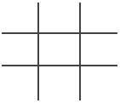
- Write the genotype of one parent across the top and that of the other parent down the left side. Remember, dominant alleles are represented with capital letters and recessive alleles are represented with lowercase letters. Both parents in this case are sickle cell carriers (Ss). Note that only one letter goes in each box for the parents. It does not matter which parents is on the side or the top of the Punnett square.
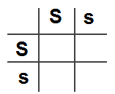
- Complete the Punnett square by copying the row and column-head letters across or down into the empty squares.
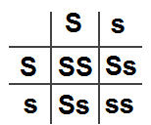
- Determine the phenotypes associated with each genotype.
- Determine the percent chance a child has of having sickle cell anemia for the above Punnett square. Do this by dividing the number of boxes containing a genotype that results in the sickle cell anemia phenotype by four and multiply by 100.
$$(\# of Boxes Containing the Sickle Cell Anemia Phenotype÷\left.4\right)×100$$
($1÷\left.4\right)×100$ = 25% chance of the child having sickle cell anemia
- Determine the percent chance a child will be a carrier for sickle cell anemia for the above Punnett square.
$$(\# of Boxes Containing the Carrier Genotype÷\left.4\right)×100$$
($2÷\left.4\right)×100$ = 50% chance of the child being a carrier for sickle cell anemia
- In Activity 3.3.1 you were given the following chromosomes for each parent.
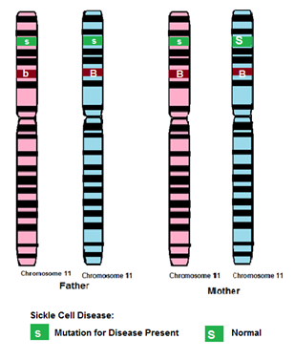
- Determine the genotypes for both parents.
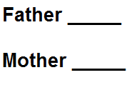
- Complete a Punnett square for these parents.
- Determine the percent chance a child has of having sickle cell anemia for the above Punnett square. Do this by dividing the number of boxes containing a genotype that results in the sickle cell anemia phenotype by four and multiply by 100.
$$(\# of Boxes Containing the Sickle Cell Anemia Phenotype÷\left.4\right)×100$$
($_____÷\left.4\right)×100$ = _____% chance of the child having sickle cell anemia
- Determine the percent chance a child will be a carrier for sickle cell anemia for the above Punnett square.
$$(\# of Boxes Containing the Carrier Genotype÷\left.4\right)×100$$
($____÷\left.4\right)×100$ = _____% chance of the child being a carrier for sickle cell anemia
- Record these percentages in your laboratory journal as the predicted likelihoods that an offspring would show the sickle cell phenotype or be a carrier.
Part II: Experimental Results
- Reference the following data table from Activity 3.3.1. Remember that the data table was a compilation of all of the class data showing the children that were produced when the chromosomes of the mother and father from Step 7 above were randomly combined.
 | # of Children with Sickle Cell Anemia | # of Children with just one allele for Sickle Cell Anemia that do NOT have the disease | # of Children with Best Disease | # Children with Hemophilia | # of Males | # of Females
Group 1
Group 2
Group 3
Group 4
Group 5
Group 6
Group 7
Group 8
Group 9
Group 10
Group 11
Group 12
Group 13
Group 14
Group 15
Totals:
- Determine the percent of children that have sickle cell anemia. Note: The total number of children is the sum of the total number of males + the total number of females.
$$\left(\#of Children with Sickle Cell Anemia\right.÷Total \# of Children)×100$$
- Determine the percent that are carriers for sickle cell anemia.
$$\left(\#of Carriers\right.÷\left.Total \#of Children\right)×100$$
- Record these percentages in your laboratory journal as the experimental findings that an offspring shows the sickle cell phenotype or is a carrier. Compare your predicted percentages to your experimental findings.
- Answer Conclusion question 1.
Part III: Probability in Pedigrees
Punnett squares can be used in conjunction with pedigrees in order to calculate the probability that an individual has or will receive the mutated chromosome that causes the abnormal hemoglobin associated with the sickle cell trait and disease.

- Analyze the pedigree to determine the genotypes of the parents. Use the Pedigree Resource Sheet as your guide.
- Calculate the probability that the child will have sickle cell disease or be a carrier. Complete a Punnett square and show your calculations.
Pedigree 1:
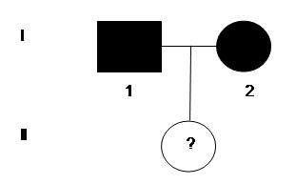
Calculations:

Probability the child will have sickle cell disease is ______________________.
Probability the child will be a carrier for sickle cell disease is __________________.

Pedigree 2:
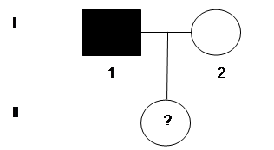
Calculations:
Probability the child will have sickle cell disease is ____________________.
Probability the child will be a carrier for sickle cell disease is __________________.
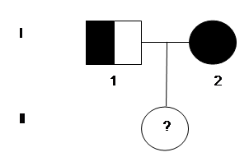
Calculations:
Probability the child will have sickle cell disease is ____________________.
Probability the child will be a carrier for sickle cell disease is __________________.

- Note that one of the biomedical science professionals responsible for investigating, diagnosing, and counseling individuals who may have a genetic condition and their familiesare called clinical geneticists.
- Follow the Career Journal Guidelines and complete an entry in your Career Journal for a clinical geneticist.
- Follow the Biomedical Science Documentation Protocol to correctly document or cite the sources of information you used.
- Answer the remaining Conclusion questions.
Conclusion
- How does your predicted percent chance that an offspring would have sickle cell anemia or be a carrier compare to your experimental results?

- Explain how a genetics counselor or a doctor could use these calculations of probability to counsel prospective parents.

- Anna’s mother passed away three years ago, so she was unavailable for genetic testing. Based upon Anna’s family pedigree that you created in the previous activity, determine her mother’s possible genotypes and phenotypes related to sickle cell anemia. Explain your reasoning and describe the information you used to make your prediction.
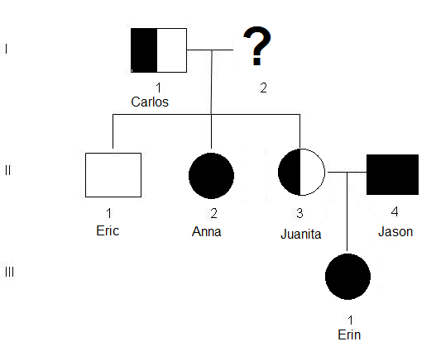

- Juan’s family has a history of sickle cell disease. His father died of sickle cell disease complications when Juan was six years old. He remembers his father being in great pain. Juan marries Gina. Gina’s maternal grandmother and paternal grandfather had sickle cell disease, but neither of her parents has the disease. Juan does not want to have children because he is convinced they will have sickle cell disease. Gina is not so sure. They have come to you for advice about having whether or not to have children. Based on your calculations of the probability of their child getting sickle cell disease, what is your advice? Show your calculations and explain your reasoning for your response. It may be helpful for you to draw pedigrees and possible Punnett squares for both Juan’s and Gina’s families.

