Activity 3.4.1: Family Inheritance

Introduction
In the previous lesson, you learned that there are often several forms of each gene and that each form of a gene present at a specific location on a specific chromosome is called an allele. When one allele in a pair of chromosomes is stronger than the other allele, the trait of the weaker allele is concealed. The stronger allele is known as the dominant gene, and the weaker allele is known as the recessive gene.

Recessive traits are usually less common in the population because two copies of the chromosome with instructions for that trait must be present for the trait to show. That means a child must inherit the gene on chromosomes from both parents. In these cases, both parents must have the gene associated with the trait. Many times neither parent will show the trait because each only has one copy of the gene. When a person has two different alleles for a trait, the person is said to be heterozygous. However, if each parent passes that chromosome with the recessive allele to the child, the child will show the trait. This can lead to surprises for the parents because they do not show the trait and may not know that they were carriers for this trait. When a person has two identical alleles for a trait, the person is said to be homozygous.

Pedigrees are graphic organizers that show the occurrence of a particular trait from one generation to the next. Symbols are used to represent each individual. Males are represented by squares and females are represented by circles. Relationships are represented with lines. Pedigree diagrams make it easier to visualize relationships within families and are used to determine the mode of inheritance (dominant versus recessive) of genetic diseases.

In this activity you will analyze the gel electrophoresis results obtained from the Restriction Fragment Length Polymorphisms of Anna Garcia’s family members. You will use the results to create a pedigree for Anna Garcia depicting the occurrence of sickle cell anemia within her family.
Equipment
- Computer
- Laboratory journal
- PBS Course File
- Activity 3.4.1: Pedigree Resource Sheet
- Activity 3.1.2 Medical History Resource Sheet

Procedure
- Obtain an Activity 3.4.1:Pedigree Resource Sheet.
- Read through the Pedigree Resource Sheet and complete the Check for Understanding questions.
- Analyze the gel electrophoresis results below for Anna’s family members. Because of differences in the genetic code, DNA cut with the same restriction enzyme will produce different cuts. This results in different size DNA pieces, which creates different banding patterns on gel electrophoresis. Therefore Restriction Fragment Length Polymorphisms can be used to diagnose genetic disease status. Remember that sickle cell anemia is an inherited recessive disorder. Determine which of Anna’s family members have sickle cell anemia, which members are carriers, and which family members are unaffected. Record your analysis in your laboratory journal.
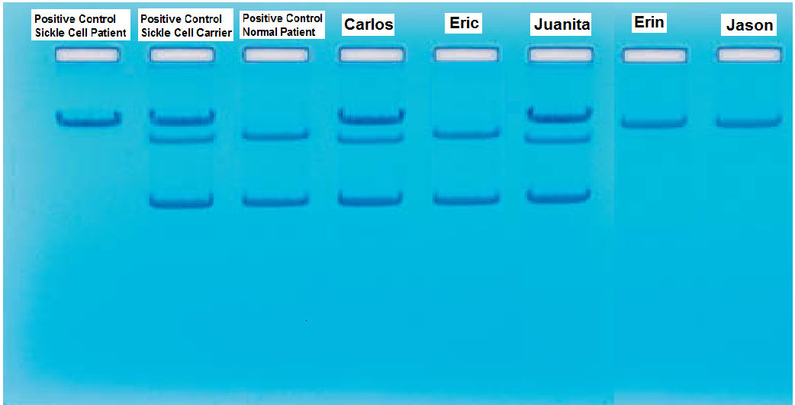
Note:
Carlos – Anna’s Father
Eric – Anna’s Brother
Juanita – Anna’s Sister
Jason – Juanita’s Husband/Anna’s Brother-In-Law
Erin – Juanita and Jason’s Daughter
- Use the Pedigree Resource Sheet to help you create a pedigree for Anna Garcia depicting the occurrence of sickle cell anemia within her family. Draw the pedigree on the Genetic Analysis section of the Activity 3.1.2 Medical History Resource Sheet. Make sure to correctly label each generation. If desired, also include a copy of your gel picture.
- File the Activity 3.4.1 Pedigree Resource Sheet in the appropriate tab of your course file. Use the PBS Course File – Table of Contents as a guide.
- Answer the Conclusion questions.
Conclusion
- Why is sickle cell anemia classified as a recessive disorder?

- If Anna had a child with a man with sickle cell anemia, predict whether that child would also have sickle cell anemia. Explain the reasoning and describe the information you used to make your prediction.

