Activity 3.3.2: Measuring Lung Capacity

Introduction
Oxygen is essential for human life. The lungs are responsible for bringing air into the body and facilitating the contact between the oxygen molecules in the air and the hemoglobin molecules in the red blood cells. But just how much air can the lungs hold?

The primary muscle responsible for your breathing is the diaphragm. This is a powerful, dome-shaped muscle that separates the thoracic or chest cavity from the abdominal cavity. Contraction of the diaphragm causes it to flatten and expand the thoracic cavity. At the same time the intercostal muscles, which span the spaces between the ribs, contract to expand and lift the rib cage. The resulting increase in thoracic volume creates a negative pressure gradient, drawing air into the lungs. You have some voluntary control over these muscles so you can regulate your breathing to take deeper or shallower breaths. You can also contract and hold them in the contracted state in order to hold your breath. When the diaphragm and intercostal muscles relax, the thoracic volume decreases, causing air to be exhaled. Normal exhalation is passive (does not require energy expenditure by cells) and results from the recoil of the chest wall, diaphragm, and lung tissue.

When at rest and breathing normally, most people use only about 10% of their total lung capacity. Greater amounts of lung capacity are used as needed, such as when a person is under stress or exercising. Lung capacity is also affected by numerous disease and medical conditions including emphysema, asthma, and the common cold.

In this activity you will measure lung volumes during normal breathing and with maximum effort using a device called a spirometer. You will then analyze lung function data for your patient, Melissa Martin. Think about how her results may relate to a diagnosis of asthma.

This activity is a modification of “Experiment 19: Lung Volumes and Capacities” in Human Physiology with Vernier written by Diana Gordon and Steven L. Gordon and is used with permission.
Equipment
- Computer with Vernier Logger Pro® software
- Vernier LabQuest® Mini with USB cable
- Spirometer sensor
- Disposable Spirometer Bacterial Filters
- Disposable Spirometer Mouth Pieces
- Laboratory journal
- Activity 3.3.2 Medical Resource – Visit #3 Resource Sheet
- Nose clip (optional)
Procedure
- Take a moment to think about your breathing. As you are reading, you are probably breathing at a slow, steady rate that is very rhythmic. Now take a large breath and hold it for a couple seconds. Now exhale as much air from your lungs as you can. Return to breathing normally. Was the volume of air you took into your lungs the same when you took the big breath as when you were reading? Did you feel your thoracic cavity get larger when you took the deep breath?
- Note that the volume of air taken into the lungs can be varied by consciously controlling the muscles to take shallow or deep breaths. There are multiple terms to describe the different volumes of air in the lungs. These terms are defined below.
- Tidal Volume (TV): The volume of air breathed in and out without conscious effort.
- Inspiratory Reserve Volume (IRV): The additional volume of air that can be inhaled with maximum effort after normal inspiration.
- Expiratory Reserve Volume (ERV): The additional volume of air that can be forcibly exhaled after normal exhalation.
- Vital Capacity (VC): The total volume of air that can be exhaled after maximal inhalation: VC = TV + IRV + ERV.
- Residual Volume (RV): The volume of air remaining in the lungs after maximum exhalation (under normal conditions, the lungs are never completely emptied).
- Total Lung Capacity (TLC): Total volume of the lungs is the sum of the vital capacity and the residual volume: TLC = VC + RV.
- Minute Volume: The volume of air breathed in one minute without conscious effort: MV = TV x (breaths/minute).
- Work with a partner to measure lung volumes during normal breathing and with maximum effort. You will complete these measurements using a device called a spirometer. If you have a cold or other respiratory concern, do not use the spirometer. Instead use the measurements of someone else in your group to complete the activity.
- Obtain a spirometer probe, a bacterial filter, and a disposable mouthpiece.
- Start the Logger Pro program.
- Click on File Open and open the Human Physiology with Vernier folder.
- Open the program titled 19 Lung Volumes.
- Connect the spirometer sensor into CH 1 of the LabQuest Mini.
- Connect the LabQuest Mini to the computer using the USB cable.
- Use a marker to write your initials or name on a bacterial filter and a mouth piece. You will use these today and save them to use another day for a different activity.
- Attach the larger diameter end of the bacterial filter to the Inlet of the spirometer, and attach a gray disposable mouthpiece to the other end of the bacterial filter.
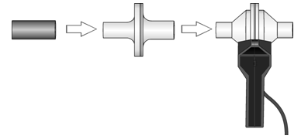
- Place the nose clip over your nose, or pinch your nose closed using your fingers. You need to breathe through your mouth while using the spirometer. Do not breathe through the spirometer until directed to do so.
- Hold the spirometer straight up and down; it may be helpful to brace your elbows against the table. Click Zero to zero the sensor.
- Note that the spirometer must be held straight up and down. It is important that the spirometer does not move during data collection.
- Use your lips to naturally seal around the mouth piece and press the green Collect arrow in the top toolbar.
- Taking normal breaths, begin data collection with an inhalation and continue to breathe in and out. After four cycles of normal inspirations and exhalations, fill your lungs as deeply as possible and exhale as fully as possible. It is essential that maximum effort be expended when performing tests of lung volumes.
- Return to normal breathing for two inhalations and exhalations.
- Click on the red Stop button.
- Name and save the file when instructed to do so. Follow your teacher’s instructions regarding the file name and location to save the file.
- Click the Next Page button on the toolbar to see the lung volume data. If the baseline of your graph has drifted, use the baseline adjustment feature to bring the baseline volumes closer to zero. Click on the up or down arrows on the adjustment feature to move the graph up or down until the exhalation values are close to zero. See the sample graph below.
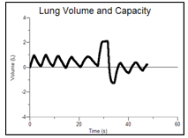

- Examine the labeled diagram below. It is taken from a graph of lung volume (L) on the y axis and time (seconds) on the x axis. Use the diagram to determine how to calculate the tidal volume, inspiratory reserve volume, expiratory reserve volume, and vital capacity using the graph of your respiration data. Step 23 will walk you through an example analysis.
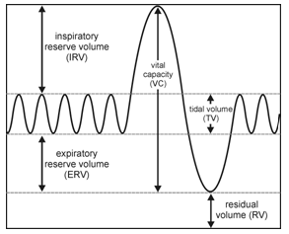
- Make a chart in your Laboratory journal similar to the one below.

Volume Measurement  (L) | Individual (L) | Class Average (Male)  (L) | Class Average (Female)  (L)
Tidal Volume (TV)
Inspiratory Reserve (IRV)
Expiratory Reserve (ERV)
Vital Capacity (VC)
Residual Volume (RV) | ≈1.5 | ≈1.5 | ≈1.5
Total Lung Capacity (TLC)
Minute Volume (MV) at rest

- Select a representative peak and valley in the Tidal Volume portion of your graph. Place the cursor on the peak and click and drag to the valley that follows it. Enter the Δy value displayed in the lower left corner of the graph to the nearest 0.1 L as Tidal Volume (TV) in your data table.
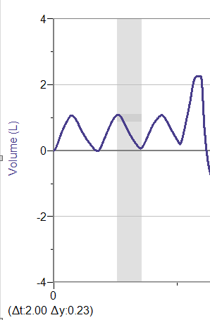
- Use Step 23 as a guide as you determine Inspiratory Reserve (IRV) and Expiratory Reserve (ERV). Record these volumes in your data table.
- Calculate the Vital Capacity using the equation listed below and record the calculated value rounded to the nearest 0.1 L in the data table in your laboratory journal.
  - Vital Capacity (VC): The total volume of air that can be exhaled after maximal inhalation: VC = TV + IRV + ERV
- Using the equation listed below and the lung volumes you recorded, compute your Total Lung Capacity (TLC). Show your calculations in your laboratory journal and record your results in your data chart.
- Total Lung Capacity (TLC): Total volume of the lungs is the sum of the vital capacity and the residual volume: TLC = VC + RV.
- Calculate your Minute Volume (MV) at rest. Breathe normally and count the number of breaths you take in one minute. Then use the tidal volume you calculated and the number of breaths you took in one minute to calculate your Minute Volume. Show your calculations in your laboratory journal and record your results in your data chart.
- Minute Volume: The volume of air breathed in one minute without conscious effort: MV = TV x (breaths/minute).
- Share your data with the class as directed by your teacher.
- Calculate and record the class averages for males and females.
- Answer Conclusion questions 1-4.
- Obtain Activity 3.3.2 Medical History – Visit #3 Resource Sheet.
- Note that in the case of obstructive airway disease, a disease that reduces lung function, and conditions such as asthma, doctors also look at a value called the Forced Expiratory Volume (FEV1) to characterize impairment. FEV1 is the maximal amount of air that can forcefully be exhaled in one second. It is then converted to a percentage of a normal value (taking height, weight, and race into account). In general,
  - FEV1 greater than 80% of predicted = normal
  - FEV1 60% to 79% of predicted = mild obstruction
  - FEV1 40% to 59% of predicted = moderate obstruction
  - FEV1 less than 40% of predicted = severe obstruction
- Review Melissa’s spirometry results on the Medical History Resource Sheet. Note the FEV1 value before and after the use of an inhaled bronchodilator, a medication that helps increase the ability for a person to move air in and out of the lungs.
- As a group, discuss if you believe there is now enough information to diagnose Melissa as an asthmatic. Report your conclusions on the Diagnosis/Follow Up section of the Medical History Resource Sheet.
- Research treatment and management of asthma. Add recommendations to the Medical History Resource Sheet under your conclusions.
- Answer the remaining Conclusion questions.
Conclusion
- Was there a difference between lung volumes for males and females? Propose an explanation for any difference or lack of difference.

- Why might the lung volume of an athlete, singer, or wind instrument musician be different from someone who does not participate in any of these activities?

- Suppose you suffered a rib injury that inhibited your ability to take regular breaths due to the pain. If you needed to maintain the same minute volume as you calculated in this activity and your tidal volume was 0.2 L due to the injury, what would your respiratory rate have to be? Show your calculations.

- Exposure to environmental hazards such as coal dust, silica dust, and asbestos may lead to pulmonary fibrosis or scarring of the lung tissue. With this condition the lungs become stiff and have less elasticity. What would happen to the total lung capacity and vital capacity under these conditions? Explain your reasoning for your response.

- At this point, is there enough evidence to treat Melissa for asthma? Explain your answer.

- How do you think a drug called a bronchodilator works to combat the symptoms of asthma? Refer back to how structure and function differ in normal and asthmatic lungs.

