Activity 3.3.2: Chromosomes – A Closer Look (Optional)

Introduction
In the previous activity, you learned how chromosomes are responsible for passing on our genes from one generation to the next, but what do chromosomes look like when viewed under a microscope? In this activity you will use a human tumor cell line grown in a laboratory to prepare a chromosome spread. A chromosome spread is a visual display of chromosomes when they are released from cells, stained, and spread onto a slide to be viewed under a microscope. Chromosome spreads are important because they can be used for chromosomal analysis, such as a karyotype. A karyotype is an organized profile of a person's chromosomes. In this activity you will look at two karyotypes to identify any chromosomal abnormalities.

Cells or tissue can grow continuously in a laboratory if the proper environment is provided. The tumor cells you will be using are HeLa cells, the oldest human cell line. The HeLa cell line was created in 1951 by Dr. Gey at Johns Hopkins Hospital in Baltimore, Maryland, using cells from a cancerous tumor growing in Henrietta Lacks, a 31-year old mother of five. Mrs. Lacks died from the aggressive cancer soon after the cells were taken. You will explore the story behind the HeLa cell line in more depth in the next activity. Because you are using human cells for this activity, make sure to treat the cells with respect.
Part II: Karyotypes
In the last activity, you learned how chromosomes and genes are passed from one generation to the next. Sometimes mistakes occur during meiosis, causing too many, too few, or abnormal chromosomes to be passed from one generation to the next. The consequences of chromosomal mistakes can be devastating, and are usually fatal for the fetus. There are a few instances where the mistake is not fatal, but the fetus will develop into an adult with a variety of abnormalities. One example of a non-fatal chromosomal mistake is Down’s syndrome. A person with Down’s syndrome has three chromosome 21s instead of just two.

Chromosomal abnormalities can be detected through a karyotype, an organized profile of a person's chromosomes. In a karyotype cells are collected and then chromosome spreads are created, such as the chromosome spread you just completed. The chromosomes are then stained, arranged, and numbered by size, from largest to smallest. This arrangement helps scientists quickly identify chromosomal alterations. The two sex chromosomes, X and Y, are always placed last. The identification number for each chromosome corresponds to its size, with chromosome number 1 being the largest and chromosome number 22 being the smallest.

- Match the chromosomes to make a karyotype of a person. Go to the Learn. Genetics website from the University of Utah at http://learn.genetics.utah.edu/content/begin/traits/karyotype/index.html. A new window will open with a partial chromosome spread on the left and a partial karyotype on the right. Click and drag each of the chromosomes in the spread to pair it with its matching chromosome in the karyotype.
- Make a sketch in your laboratory journal of the completed karyotype.
- In your laboratory journal, write whether the karyotype is of a male or a female and write how you determined the sex from the chromosomes.
- Analyze the two karyotypes below. Scan for any chromosomal abnormalities and determine the sex of the two individuals. Describe your findings in your laboratory journal.
Individual 1:
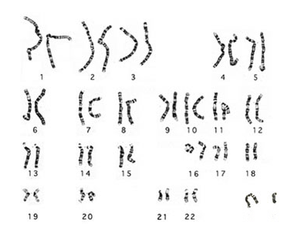
Individual 2:
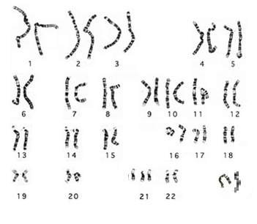
- Answer the Conclusion questions.

Conclusion
- Why do all the normal cells in the human body have the same number of chromosomes?

- Explain why being able to view chromosomes from an individual is a useful tool for scientists and medical professionals.

- Can a genetic disease such as sickle cell anemia be diagnosed with a karyotype? Why or why not?

