Activity 3.3.1: How is DNA Passed through the Generations?

Introduction
In the previous activities, you learned that Anna Garcia lived with a life altering disease called sickle cell anemia. Unlike the flu or colds which are caused by viruses and are contagious, sickle cell disease is inherited, meaning it is passed from parents to children. An enormous number of human diseases are inherited from parents, including Tay Sachs, hemophilia, cystic fibrosis, and Huntington’s disease. These diseases are not infectious; instead, they are caused by mutations in DNA, such as you learned about sickle cell disease and Tay Sachs disease. But how are mutations in DNA passed down from one generation to the next?

Whenever a cell is ready to replicate and divide, our DNA is stored in a compact form called chromosomes. There are a total of 46 chromosomes in most cells of the human body, except for our sex cells, which have half that amount. Each person inherits one chromosome from their mother and one from their father at fertilization, when the egg cell from the mother, which contains 23 chromosomes, fuses with the sperm cell from the father, which also contains 23 chromosomes. Therefore, our body cells contain 23 pairs of chromosomes.

In order to help organize the genetic information found on each chromosome, different human chromosomes were given identification numbers ranging from 1 to 22. One pair of chromosomes is not included in the numbering system because these chromosomes determine whether a person will be male or female. This pair is referred to as the “sex chromosomes.” Instead of numbers, the sex chromosomes are identified as the “X” and the “Y” chromosomes. Women have two X chromosomes, whereas men have one X chromosome and one Y chromosome.

In this activity you will explore in more depth the role that chromosomes play in transferring genetic material from cell to cell as well as from generation to generation, in processes called mitosis and meiosis. You will also explore how inherited diseases are passed through the generations via our chromosomes.
Equipment
- Computer with Internet access
- Laboratory journal
- Activity 3.3.1 Student Resource Sheet
- Scissors

Procedure
Part I: Mitosis and Meiosis
1. Pay attention and take notes in your laboratory journal as your teacher presents the Chromosomes presentation.
2. Visit the Genetic Science Learning Center Tour of the Basics available at http://learn.genetics.utah.edu/content/begin/tour/ and choose the tab labeled What is a Chromosome?
3. Watch each slide in this presentation using the arrows at the bottom of the box to advance the information. Take notes in your laboratory journal about the structure and function of chromosomes. NOTE: Your teacher may show this animation to the class.
Mitosis is a process that our body cells use to replicate. It results in the formation of two cells having 46 chromosomes that are identical to the 46 chromosomes of the original cell. Meiosis is a process used to produce sex cells. It results in the formation of four sex cells, each having 23 chromosomes, half the number of chromosomes of the original cell.

4. Obtain an Activity 3.3.1 Student Resource Sheet and a pair of scissors.
5. Cut out all of the objects on the Student Resource Sheet. Write the name of each chromosome on the back of the paper cut-outs. The circles all represent cells.
6. Read through each step of mitosis outlined below and complete each step with your paper cut-outs of Chromosome 11.
Steps of Mitosis:
o Original cell:
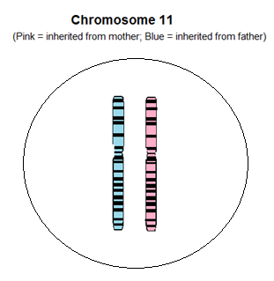
o DNA replicates so that there are two copies.
o DNA condenses into a compact form called chromosomes. Each chromosome contains two identical copies of DNA called sister chromatids.
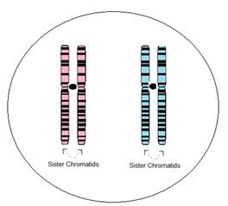
o Chromosomes line up at the center of the cell. Fibers attach to each of the sister chromatids that will pull each chromatid to opposite poles of the cell.
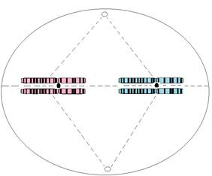
o Each chromosome separates and the sister chromatids are pulled to the opposite poles of the cell.
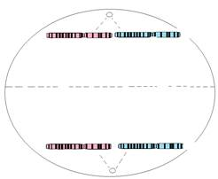
o The cell splits into two, with both cells having an equivalent and complete collection of chromosomes.
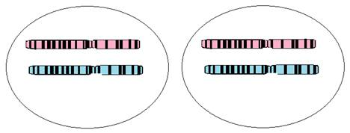
7. Answer Conclusion questions 1 and 2.
8. Read through each step of meiosis outlined below and complete each step with your paper cut-outs.
Steps of Meiosis:
o Original cell:
o DNA replicates so that there are two copies.
o DNA condenses into a compact form called chromosomes. Each chromosome contains two identical copies of DNA called sister chromatids.
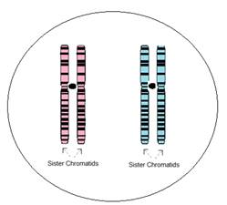
o Chromosomes pair up with their matching chromosome called homologous chromosomes (one chromosome inherited from the father and one chromosome inherited from the mother).
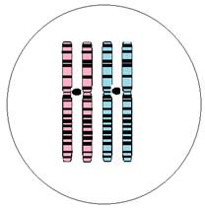
o Homologous chromosomes line up at the center of the cell. Fibers attach to each of the homologous chromosomes that will pull each chromosome to opposite poles of the cell.
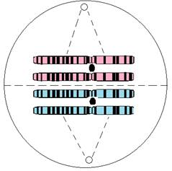
o Homologous chromosomes are pulled to opposite poles of the cell.
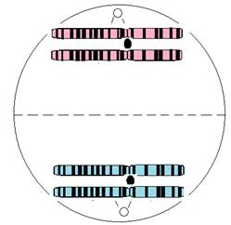
o The cell splits into two, with both cells having one homologous chromosome from each pair.

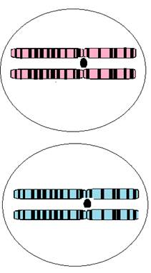
o Chromosomes line up at the center of both cells. Fibers attach to each of the sister chromatids that will pull each chromatid to opposite poles of the cells.
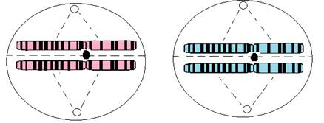
o Each chromosome separates, and the sister chromatids are pulled to the opposite poles of the cells.
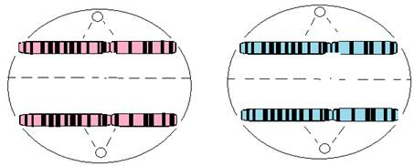
o Both cells split into two, with the resulting cells each containing a single chromosome set. (Half the chromosomes of the parent cell. This is how each egg cell and sperm cell contains half the chromosomes of body cells. Therefore, when the sperm and egg combine, they contain the correct number of chromosomes.)
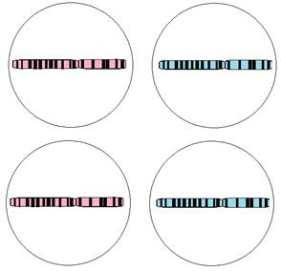
9. Answer Conclusion question 3.
Part II: Inheritance
A gene is a segment of DNA on a chromosome that controls a particular hereditary trait. Because chromosomes occur in pairs, genes also occur in pairs. There are often several forms of each gene. Each form of a gene that is present at a specific location on a specific chromosome is called an allele. For example, the gene for eye color exists in multiple forms, one form or allele for brown eyes and a different allele for blue eyes. The combination of genes, called the genotype, determines the physical characteristics of an individual, called the phenotype. When one allele in a pair of chromosomes is stronger than the other allele, the trait of the weaker allele is concealed. The stronger allele is known as the dominant gene and the weaker allele is known as the recessive gene. For example, when the genes for blue eyes and brown eyes are both present, the person with these two alleles will have brown eyes. Therefore, the gene for brown eyes is the dominant gene and the gene for blue eyes is the recessive gene. An individual will only have blue eyes if they have two alleles for blue eyes. Alleles are represented with letters. Dominant genes are represented as capital letters, whereas recessive genes are represented as lowercase letters. Therefore, the gene for brown and blue eyes can be represented with the letter B (or b). The capital letter B often represents the dominant gene for brown eyes and the lowercase b represents the recessive gene for blue eyes. Therefore, someone with the genotypes BB or Bb will have a phenotype of brown eyes and someone with the genotype bb will have a phenotype of blue eyes.
Sickle cell anemia and Best disease are two disorders whose mutated genes are carried on chromosome 11. The gene for sickle cell anemia is often represented with the letter S. The gene for the mutated form of the beta-globin gene responsible for sickle cell anemia is a recessive gene, meaning that an individual needs to have two alleles of this mutated gene to have the disease. A person with just one allele for the disease is said to be a carrier. Best disease, also known as Vitelliform Macular Dystrophy type 2, is an inherited eye disease resulting in blindness. Best disease is an autosomal dominant disease, in which an individual only needs one copy of the mutated gene for the individual to have the disease. Hemophilia is a recessive disorder carried on the X chromosome. It is a rare bleeding disorder in which your blood does not clot normally. Since men only have one X chromosome, if they inherit the gene, they have the disease. You will explore these three disorders and how they are inherited from generation to generation on chromosomes.
10. Read through the paragraph above and record the definitions for allele, genotype, phenotype, dominant gene, recessive gene, and carrier in your laboratory journal.
11. Obtain all of your chromosome cut-outs. Note that you will be working with a partner for the remainder of this activity and you will only need the chromosomes from one partner. One partner will represent the “father” and one partner will represent the “mother.”
12. Take out all of the chromosomes and lay them out on the table. Remember that the chromosomes are present as sister chromatids because the DNA was replicated. Therefore, remove the replicated chromatid so that there is only one sister chromatid for each chromosome, as shown below.
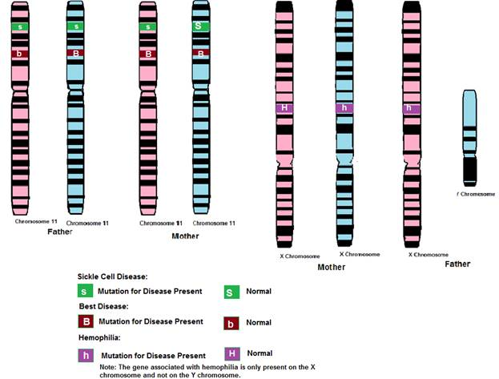
13.Designate which partner will represent the mother and which partner will represent the father. Distribute the chromosomes to the appropriate partner. Note that the mother and father should have the following chromosomes:
Mother
• (2) Chromosome 11s
• (2) X Chromosomes

Father
• (2) Chromosome 11s
• (1) X Chromosome
• (1) Y Chromosome

14.Determine the traits of both parents and complete the information below.
 |  | Genotype  (The genes present for a trait, i.e., BB, Bb, bb, SS, Ss, ss, etc.) | Phenotype  (The traits shown based on the genotype, i.e., Does the person have the disease?)
Sickle Cell Disease | Mother
 | Father
Best Disease | Mother
 | Father
Hemophilia | Mother
 | Father

15.Work with your partner to “start your family.”
• The mother looks away while the father places one of his chromosome 11s in each hand.
• The mother randomly picks the hand she wants for their child. Lay the chosen chromosome on the table in front of you and set the other one aside.
• Repeat this process for the sex chromosomes.
• The mother now repeats all steps by placing the chromosomes behind her back while the father chooses chromosomes.
• Lay all of the chosen chromosomes on the table. These represent the genes of your first child. You should now have two chromosome 11s and two sex chromosomes.
16. Determine the traits of your first child and complete the information below.
 | Genotype  (The genes present for a trait, i.e., BB, Bb, bb, SS, Ss, ss, etc.) | Phenotype  (The traits shown based on the genotype, i.e., Does the person have the disease?)
Sickle Cell Disease
Best Disease
Hemophilia

17. Follow the procedure in Step 15 to produce another child.
18. Determine the traits of your second child and complete the information below.
 | Genotype  (The genes present for a trait, i.e., BB, Bb, bb, SS, Ss, ss, etc.) | Phenotype  (The traits shown based on the genotype, i.e., Does the person have the disease?)
Sickle Cell Disease
Best Disease
Hemophilia

19.Record the traits for your first two children on the class data table on the board. Once the class has filled in their data, complete the data table below with the class information. Note: You will come back to this chart in the next lesson.
 | # of Children with sickle cell anemia | # of Children with just one allele for sickle cell anemia that do NOT have the disease | # of Children with Best disease | # Children with hemophilia | # of Males | # of Females
Group 1
Group 2
Group 3
Group 4
Group 5
Group 6
Group 7
Group 8
Group 9
Group 10
Group 11
Group 12
Group 13
Group 14
Group 15
Totals:

20. Answer the remaining Conclusion questions.

Conclusion
1. What is the purpose of mitosis? What would happen if cells did not undergo mitosis?

2. Why is it necessary for DNA to replicate as the first step in mitosis?

3. Why is it important that the end result of the process of meiosis is sex cells that contain half the amount of DNA that is in body cells?

4. Explain how DNA, chromosomes, and genes are related.

5. Describe the difference between how sickle cell anemia is inherited versus how Best disease is inherited. What causes this difference?

6. Explain why more males are afflicted with hemophilia than females.

7. Explain why a child can have sickle cell anemia even if neither parent has the disease.

