Activity 3.3.1: Concept Map Assignment

In Unit 1 you learned that a concept map is a diagram showing the relationship among concepts. It is a graphical tool for organizing and representing information. In a concept map, the concepts, usually represented by single words enclosed in a box, are connected to other concept boxes by arrows. A word or brief phrase written beside the arrow defines the relationship between the connected concepts. Pictures or diagrams can be added as needed. See the concept map example below on Newton’s Laws of Motion, available in the Inspiration help files:

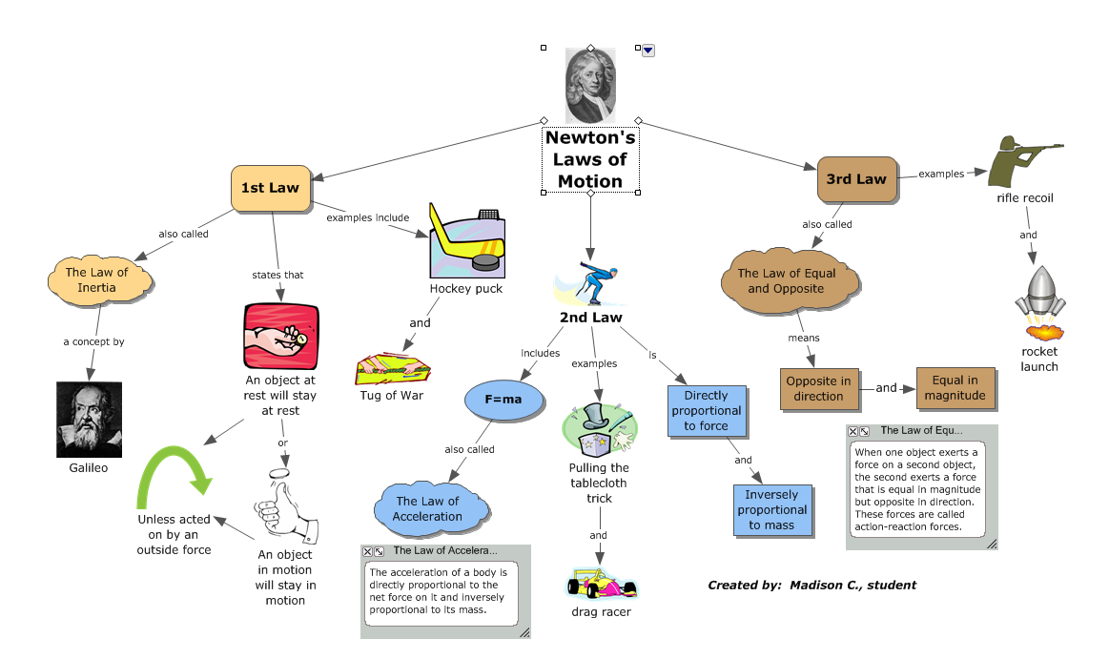

Complete the following to demonstrate what you have learned thus far in PBS about DNA and inheritance.
- Review the relationship between DNA, chromosomes, and genes. Revisit the Genetic Science Learning Center animations available at http://learn.genetics.utah.edu/content/begin/tour/ if necessary and review your notes from Activity 3.3.1.
- Use the software program Inspiration to make and print a concept map about the relationship between chromosomes, genes, and DNA. The map must include the following terms: chromosomes, code, disease, DNA, genes, proteins, alleles, phenotype, genotype, recessive gene, dominant gene, mitosis, meiosis, and traits. Add additional terms and connecting phrases as needed to complete your map.

