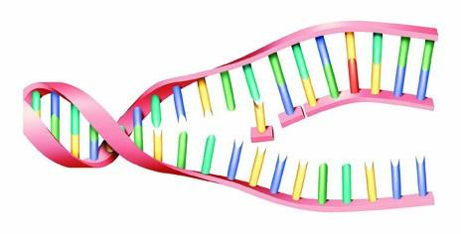
Activity 3.2.3: Does Changing One Nucleotide Make a Big Difference?

Introduction- please read and highlight
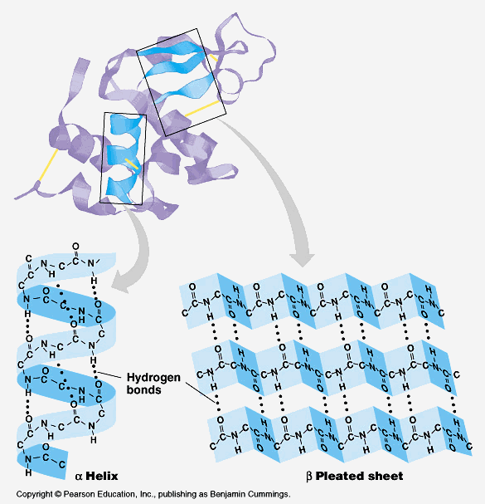
The sequence of nucleotides in a DNA molecule determines the sequence of amino acids in a protein. If the nucleotide sequence is changed, then the amino acid sequence may also change. Any change in DNA is called a mutation. In the previous activity, you observed that sickle cell disease is caused by the mutation of a single nucleotide in the DNA sequence. Hemoglobin has four subunits; it is made by combining two β-globin proteins with two α-globin proteins (β is the Greek symbol for beta, and α is the symbol for alpha). These designations are based on the shape that the protein takes after it has bent and folded (an alpha helix looks like a twisted ladder, whereas a beta pleated sheet looks like a paper fan, See picture below). The change in just one of the over 400 nucleotides that code for β-globin is enough to cause all of the problems associated with sickle cell disease. Imagine if getting only one answer incorrect out of 400 questions on an exam caused you to receive a failing score on the exam! That is how important some DNA nucleotides are to the final structure and function of a protein.

The sickle form of the hemoglobin gene is created when an adenine nucleotide is changed to a thymine. This changes the codon for the sixth amino acid in the β-globin protein from GAG to GUG, which causes the sixth amino acid to become valine instead of glutamic acid. That single amino acid replacement in the β-globin protein alters the shape and the chemistry of the hemoglobin molecule, causing it to polymerize and distort the red blood cell into the sickle shape.

In this activity you will use computer simulations to visualize the interactions between amino acids and how these relate to protein structure. You will visualize how changes in the β-globin protein are due to the mutation associated with sickle cell disease.

Procedure
Pre-work check:
- In your notes, write down the following information and fill in the blanks:
  - The mutation for sickle cell disease occurs in the __________ protein.
  - SCD comes from a ___________ mutation that changes a _________nucleotide to a(n) _________ nucleotide.
    - This results in the _________ amino acid changing from ________(use full name)to a ____________.
Part I: “One Wrong Letter”
We will watch this clip together:
- Watch the NOVA video clip- "One Wrong Letter" and answer the following questions as a class. Video: tinyurl.com/o42b4cl
  - Hayden has a disease called Tay sachs that is a genetic disease with these symptoms:

  - What is the function of the affected protein and how does this mutation affect Hayden?

  - Is this mutation a point mutation or a shift mutation?

  - What is the only outcome for Hayden?

  - Carriers of genetic diseases have inherited the gene for the disease, but it is not expressed (meaning the person doesn’t show signs of the disease). If both parents are carriers, however, their child has a 25% chance of having the disease. If you could be tested to see if you carry any genetic diseases, would you be tested?

- Answer 3.2.3 conclusion question number 1 and 2.

Part II: “Amino Acid Interactions”
- Open up the amino acid properties slideshow and save it to your google drive
SLIDESHOW: https://docs.google.com/presentation/d/1SbCAWrD3ATiio6U5H7XqZMgmoK630u9xJQGzu69BfHU/edit?usp=sharing
- Go to: http://lab.concord.org/embeddable.html#interactives/samples/5-amino-acids.json

- Use the drop down menu to select ‘hydrophobicity’. Make sure this is the option throughout the entire activity.

- Note that the green amino acids are all hydrophilic, and the yellow amino acids are all hydrophobic.

- Set the protein to be mostly hydrophobic Set the Select a solvent type to Water. Keep the molecule labels to hydrophobicity and click the play button.

- Observe the polymer chain. Write a description of what you are observing (how is a protein made of mostly hydrophobic amino acids reacting to a water (aqueous) environment?)
Description:

- Click the ‘restart’ button.

- Set your protein to ‘mostly hydrophobic’ again. Set the Select a solvent type to Oil. Keep the molecule type set to hydrophobicity and click the Run button.

- Observe the polymer chain. Write a description of what you are observing (how is a protein made of mostly hydrophobic amino acids reacting to an oily environment?
Description:

- Click the restart button.

- Now set the protein to be mostly hydrophilic Set the Select a solvent type to Water. Keep the molecule labels to hydrophobicity and click the play button.

- Observe the polymer chain. Write a description of what you are observing (how is a protein made of mostly hydrophilic amino acids reacting to a water (aqueous) environment?)
Description:

- Click the ‘restart’ button.
- Set your protein to ‘mostly hydrophilic’ again. Set the Select a solvent type to Oil. Keep the molecule type set to hydrophobicity and click the Run button.

- Observe the polymer chain. Write a description of what you are observing (how is a protein made of mostly hydrophilic amino acids reacting to an oily environment?
Description:

- Note that you can change the amino acids by clicking on them. Change any one to glutamic acid and another one to valine.

- Answer the following questions:
Glutamic Acid:
Hydrophilic or hydrophobic?

Valine:
Hydrophilic or hydrophobic?

- Put on your headphones. Go to the following link and click on ‘protein folding’ at the top. Answer the questions in step 25 as you are working through the whole protein folding interactive.
http://edheads.site-ym.com/resource/resmgr/activities/DNA/SWF/index.htm

25. Questions to answer:
  - About how many hemoglobin molecules are in a red blood cell?

  - What are the two different amino acid chains in a hemoglobin molecule called? How many of each make up 1 hemoglobin molecule?

  - Which part of an amino acid chemically interacts with other amino acids in a protein?

  - Why does a protein fold?

  - There are four different types of amino acid interactions. Describe them.
    - Hydrogen bonds=
    - charge-charge interactions (AKA salt bridges)=
    - hydrophobic interactions=
    - disulfide bridges=

  - Describe interactions between many sickle cell hemoglobin molecules inside a red blood cell and how that leads to the entire red blood cell to become sickle shaped.

Part III: Normal Hemoglobin (Hb) versus sickle cell hemoglobin (HbS)
Now that you have examined the amino acids that are involved in the change of normal β-globin to the sickle cell form, work with a computer simulation to see how the change from glutamic acid to valine at position 6 in β-globin affects how hemoglobin proteins interact with each other inside a red blood cell.
- Go to http://workbench.concord.org/database/activities/281.html

- Click ‘Go to activity’ and follow the on screen prompts to download the program. You should see it appear at the bottom of your internet window.

3. Once the program is open, you should see a hemoglobin protein. Note that on this page of the interactive is a normal hemoglobin molecule (called Hb). with the correct glutamic acids in the 6th position of the amino acid chains.

5. Click ‘show hemes’, Observe the molecule and read the information.

6. Click ‘show all atoms’, Observe the molecule, read the information.

7. Click ‘show beta 6 glutamic acid’. Observe the molecule, and read the information.
8. Answer the multiple choice questions below the hemoglobin molecule on the bottom of the page.
9. Click the blue next arrow.
10. Note that on this page, two sickle cell hemoglobin molecules are shown. (Called HbS#1 and HbS#2). They appear ‘stuck’ together. That is because of the new mutated hydrophobic valines are causing a hydrophobic interaction between the two hemoglobins.
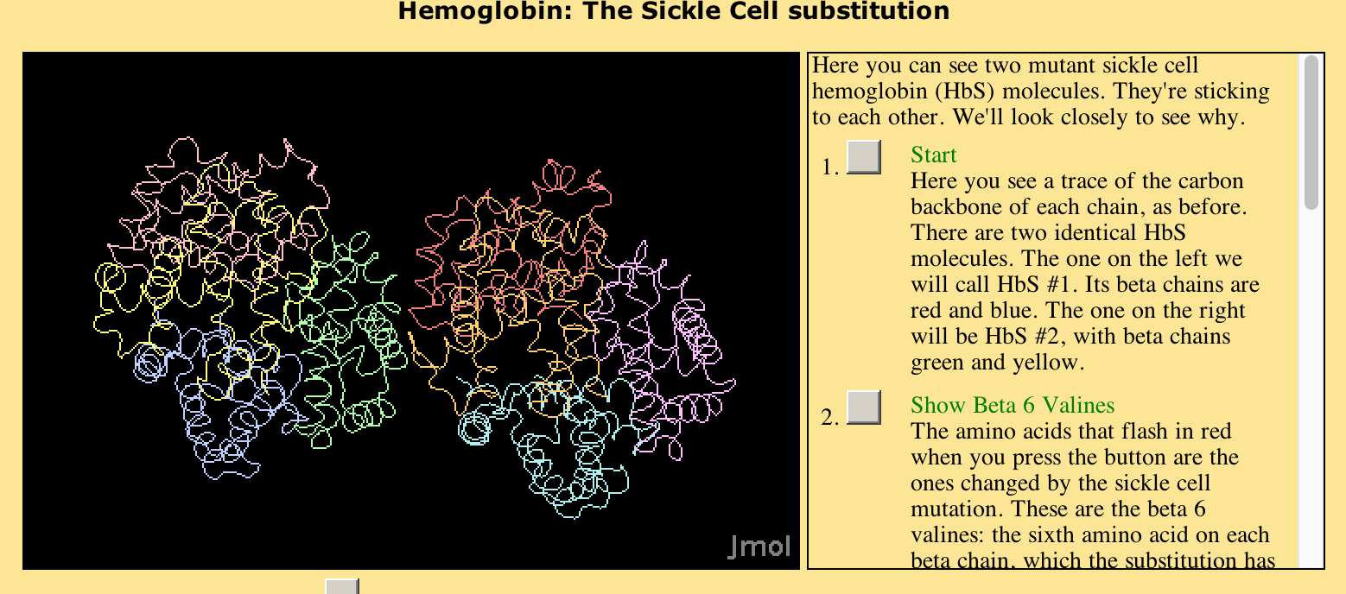
11. Click ‘start’ and read the information. Observe the molecules.

12. Click ‘show beta 6 valines’, observe the molecules and read the information.

13. Click ‘Zoom to Hydrophobic pocket’, observe the molecules and read the information.

14. Click ‘Show only Hydrophobic pocket’, observe the molecules and read the information. Describe what is going on here:

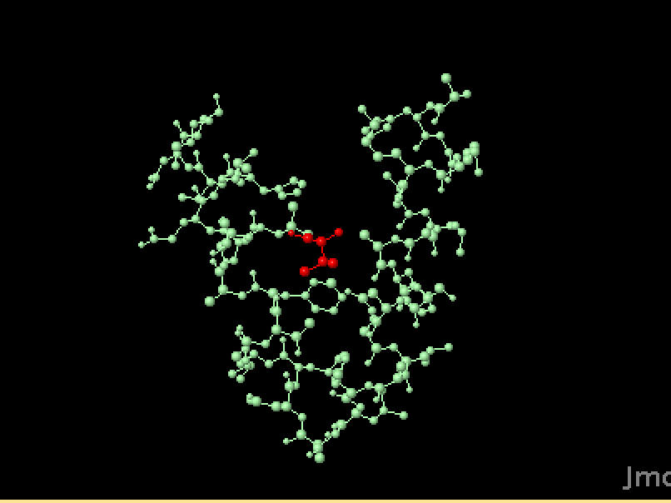
15. Click ‘Hydrophobic pocket in ball and stick mode’, observe the molecules, and read the information.

16. Remember, the interactive is showing you sections of two different sickle cell hemoglobin molecules (HbS#1 and HbS#2). The region in red is the mutated amino acid valine from one sickle cell hemoglobin and the region in green is the hydrophobic area of the other hemoglobin molecule.

17. Click ‘color by hydrophobicity’. Observe the molecules and read the information.

18. Click on ‘Zooming out’. Observe the molecule and read the information.

19. Answer the question below:
You've seen two Hbs molecules stuck to each other. Imagine a third one randomly bouncing up to them. How could it get stuck on? Explain your answer.
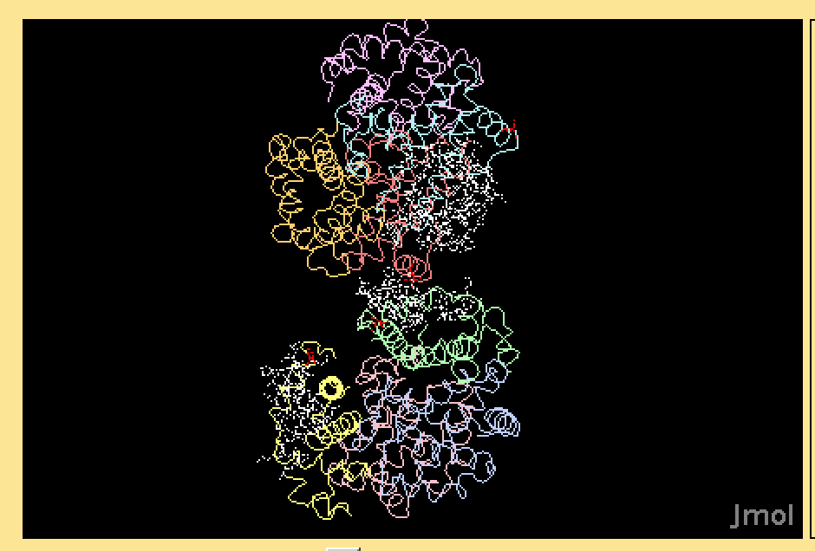
20. Go back to the interactive. Read the information below the text box and observe the pictures.

21. Answer the question below:
Describe how a single amino acid substitution causes hemoglobin molecules to stick together. Use what you know about the structure of Hb and HbS, the properties of glutamic acid and valine, and how hydrophobicity causes molecules to behave in water.

22. Answer the remaining 3.2.3 Conclusion questions.

Assignment Submission
- Complete the assignment submission document
- Turn the assignment submission document into the LMS before the due date.
https://docs.google.com/document/d/1113Fahr10oPbwwi2KMz5_0XFza9HG_cd02Gy2eWL2F0/edit?usp=sharing

