Activity 3.2.3: Does Changing One Nucleotide Make a Big Difference?

Introduction
The sequence of nucleotides in a DNA molecule determines the sequence of amino acids in a protein. If the nucleotide sequence is changed, then the amino acid sequence may also change. Any change in DNA is called a mutation. In the previous activity, you observed that sickle cell disease is caused by the mutation of a single nucleotide in the DNA sequence. Hemoglobin has four subunits; it is made by combining two β-globin proteins with two α-globin proteins (β is the Greek symbol for beta, and α is the symbol for alpha). All proteins are classified as either α (an alpha helix) or β (a beta pleated sheet). These designations are based on the shape that the protein takes after it has bended and folded (an alpha helix looks like a twisted ladder, whereas a beta pleated sheet looks like a paper fan). The change in just one of the over 400 nucleotides that code for β-globin is enough to cause all of the problems associated with sickle cell disease. Imagine if getting only one answer incorrect out of 400 questions on an exam caused you to receive a failing score on the exam! That is how important some DNA nucleotides are to the final structure and function of a protein.

The sickle form of the hemoglobin gene is created when an adenine nucleotide is changed to a thymine. This changes the codon for the sixth amino acid in the β-globin protein from GAG to GUG, which causes the sixth amino acid in the protein to become valine instead of glutamic acid. That single amino acid replacement in the β-globin protein alters the shape and the chemistry of the hemoglobin molecule, causing it to polymerize and distort the red blood cell into the sickle shape.

In this activity you will use computer simulations to visualize the interactions between amino acids and how these relate to protein structure. You will visualize how changes in the β-globin protein are due to the mutation associated with sickle cell disease.
Equipment
- Computer with Internet access
- Laboratory journal

Procedure
Part I: Amino Acid Interactions
- Watch the NOVA – Cracking the Code video clip Chapter 3 of 12: One Wrong Letter available at http://www.pbs.org/wgbh/nova/genome/program_t.html. Pay attention to the genetic cause of the disease along with the effects of the disease.
- Answer Conclusion question 1.
- As a class compare what life would be like living with sickle cell anemia versus living with Tay Sachs disease.
- Answer Conclusion question 2.
- Go to the Concord Consortium Molecular Workbench website and read the article “How Do Amino Acids React to Water and Oil” located at http://www.concord.org/~btinker/workbench_web/unitV/mol_water_bg.html.
- List and describe, in your laboratory journal, the four forces acting on amino acids placed in water. These four forces ultimately determine the shape of a protein.
- Write definitions, in your laboratory journal, for the words hydrophobic and hydrophilic.
- Describe, in your laboratory journal, how hydrophobic and hydrophilic amino acids react to water and to oil.
- Go to the website http://mw.concord.org/modeler/.Make sure to install the latest version of Java if not already installed on your computer. Once Java is installed, click on the Download MW button to install Molecular Workbench on your computer. Click Run when prompted.
- Click on the Molecular Workbench icon on the computer’s desktop.
- Click on Browse entire library link.
- Under Biology, click on Protein and DNA code.
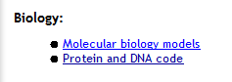
- Click on All Hydrophobic.
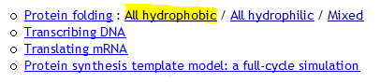
- Notice that a new window appears.
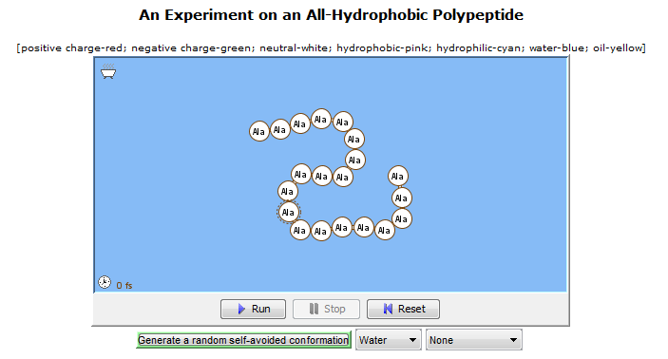
- Note that you will use the drop down menu to select the environment (water, vacuum, or oil). The other drop down menu allows you to select which characteristics of the amino acids are shown (charge, hydrophobicity, or no label). The key to the characteristics is printed above the mini-window that shows the polypeptide.
- Complete a water run. Set the Select a solvent type to Water. Keep the molecule type set to Charge and click the Run button. Observe what happens to the polymer chain and draw the result in your laboratory journal.
- Complete an oil run. Set the Select a solvent type to Oil. Keep the molecule type set to Charge and click the Run button. Observe what happens to the polymer chain and draw the result in your laboratory journal.
- Answer Conclusion question 3.
- Click on the Back button, . This will take you back to the activity menu.
- Click on All hydrophilic.
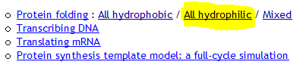
- Notice that a new window appears.
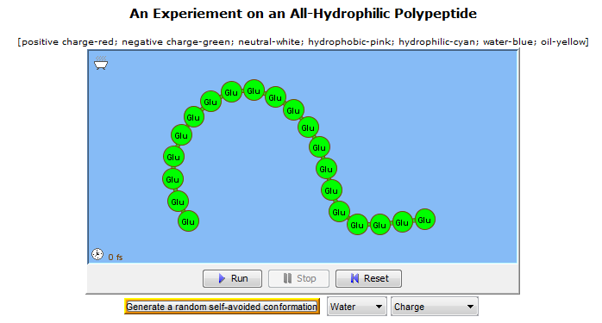
- Note that you can change amino acids in the chain by placing the cursor on the amino acid to be changed, press Alt, and left click. A menu of amino acids will appear and you can select the replacement. Change the first seven amino acids to represent the first seven amino acids in the normal hemoglobin gene: VAL HIS LEU THR PRO GLU GLU. Change the last four amino acids to represent the hydrophobic pocket found on the hemoglobin gene: LEU ALA ALA LEU.
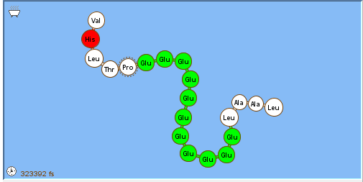
- Make sure the Select a solvent type window shows Water and click the Run button.
- Draw what you observe in your laboratory journal.
- Use the drop down menu to determine the characteristics of glutamic acid and valine. Note that the key to the characteristics is printed above the mini-window that shows the polypeptide (positive charge-red; negative charge-green, etc.).
Glutamic Acid:
Hydrophilic or hydrophobic? __________________
Positive, negative, or neutral? ________________

Valine:
Hydrophilic or hydrophobic? __________________
Positive, negative, or neutral? ________________

- Answer Conclusion question 4.
- Replace the sixth amino acid in your polymer chain to VAL. The first seven amino acids should now be VAL HIS LEU THR PRO VAL GLU. This represents the first seven amino acids in the sickle cell hemoglobin gene.
- Answer Conclusion question 5.
- Make sure the Select a solvent type window shows Water and click the Run button.
- Draw what you observe in your laboratory journal. Compare your prediction in Conclusion question 5 to what is happening on the screen.
- Answer Conclusion question 6.
Part II: Sickle Cell Anemia
Now that you have examined the amino acids that are involved in the change of normal β-globin to the sickle cell form, work with a computer simulation to see how the change from glutamic acid to valine at position 6 in β-globin affects the hemoglobin protein.
- Go to the Molecular Literacy Database for Biotechnology and Nanotechnology Careers maintained by The Concord Consortium located at http://molit.concord.org/database/activities/281.htm to complete activity number 281 A Tour of Hemoglobin.
- Click on the Go to Activity link to begin the simulation. Click the link only once. If a dialog box appears reminding you to only click the link once, you need to click Run so that the program will load.
- To complete the activity, follow the directions on this Activity Sheet instead of the directions on the website.
- Note that you can use the mouse to grab and rotate the hemoglobin molecule, and you can zoom in and out of the view of the molecule by holding down the shift key and dragging the mouse.
- Notice there are four subunits, and each is shown as a different color in the model.
- Make a sketch of the molecule in your laboratory journal.
- Read the information about hemoglobin in the text box on the right side of the window.
- Use the buttons (grey boxes) on the right to color the amino acids, show the heme groups, and spotlight the glutamic acid in position 6 of the β-globin. This is the single amino acid that is changed in the sickle form of the protein.
- Read the selected-response questions at the bottom of the page.
- Go to the next page in the simulation by clicking on the blue arrow near the bottom of the window.
- Note a model of two molecules of β-globin is shown in the window. The two β-globin molecules are sticking together because the glutamic acid at position six has been replaced by valine—the mutation associated with sickle cell disease.
- As you use the grey buttons to change the view of the hemoglobin molecules, be sure to read the information in the text box.
- Use the grey button to highlight the “Beta 6 valines.”
- Notice where the valines are located.
- Next, use the grey buttons to zoom into the hydrophobic pocket and then to isolate it.
- To see the atoms of the amino acids in the hydrophobic pocket, click the grey button to see the ball and stick model.
- Now examine the hydrophobicity of the individual amino acids. Look closely at where the number 6 valine is located and which amino acids it is near.
- Lastly, zoom out so you can see the two hemoglobin molecules sticking together and examine the valine and hydrophobic regions.
- Scroll down the web page and read the rest of the information on the page.
- Type your answers to each of the questions. Copy your answers or print your report and attach it in your laboratory journal.
- Answer the remaining Conclusion questions.
Conclusion
- What type of mutation is responsible for sickle cell disease and Tay Sachs disease?

- Tay Sachs disease is caused by a mutation of one nucleotide for a protein that disrupts the activity of an enzyme in the brain. This leads to a toxic level of a substance to build up in neurons in the brain and spinal cord, leading to severe brain damage and eventually death. Why do you think that the change in one nucleotide can cause Tay Sachs disease to be fatal, whereas the change in one nucleotide causes sickle cell disease, a disease in which a person can lead a functional life?

- What is the property of alanine (the amino acid that makes up this polymer chain) that helps explain its reaction to water and oil?

- How are the properties of glutamic acid and valine different?

- What effect do you think this change in amino acid sequence will have on the structure of the polypeptide?

- Explain how just a change of one amino acid has such an effect.

- Explain why the replacement of the glutamic acid by valine changes the way that molecules of β-globin interact with each other.

- Explain why the change in the way that molecules of β-globin interact with each other lead to the sickling of the red blood cells in sickle cell anemia.

