NAME _____________________________________________
3.1: Review Sheet

3.1.a. What are the resources the human body needs to survive?
Name of resource  How long can you survive without it? | Name of resource  How long can you survive without it? | Name of resource  How long can you survive without it?
Includes macromolecules (lipids, carbs, and proteins) as well as minerals and vitamins. | Taken in through both food and drink (55% of the body is made of this resource). | Air around us is about 20% of this gas necessary for human survival.
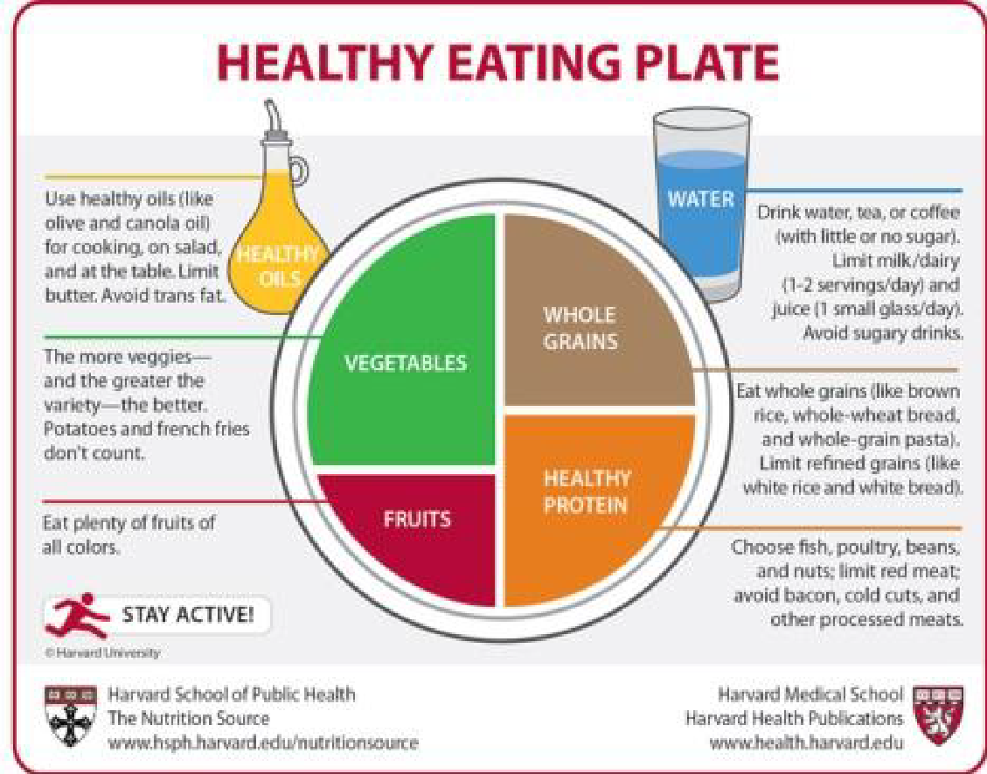 | 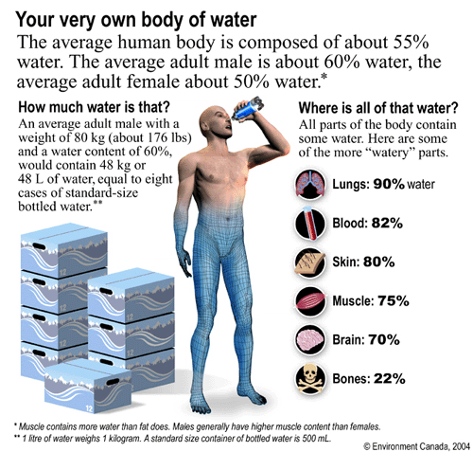 | 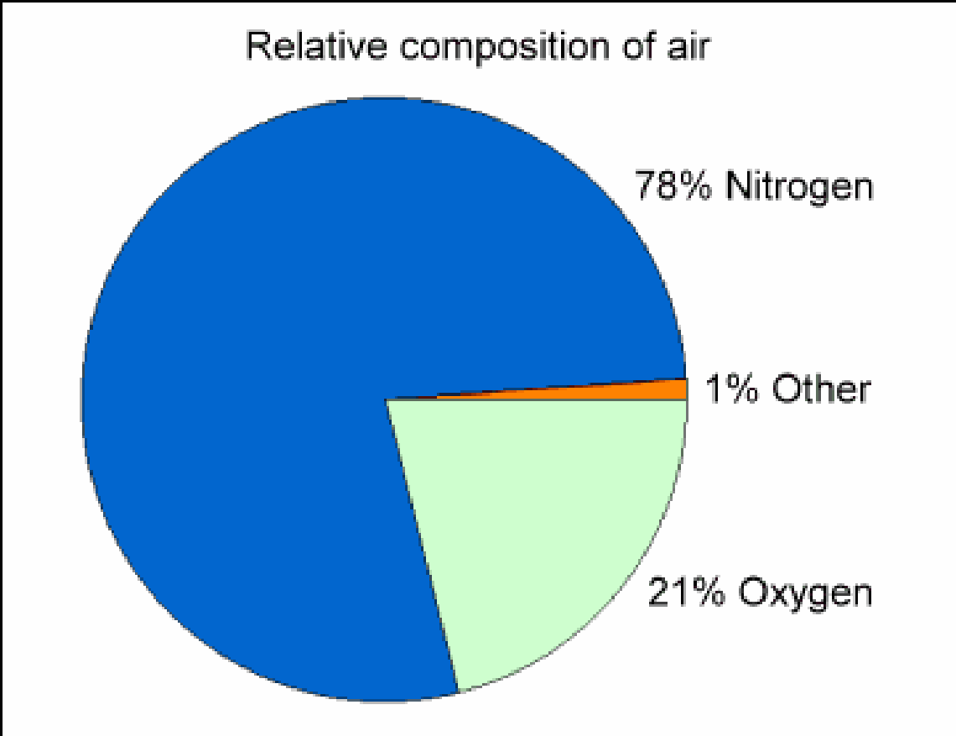

3.1.b. What role does food play in the human body?
Carbohydrates
Lipids
Proteins

3.1.c. What role does water play in the human body?
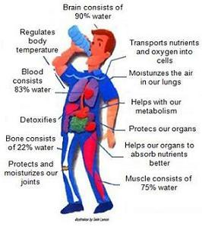

3.1.d. What role does oxygen play in the human body?
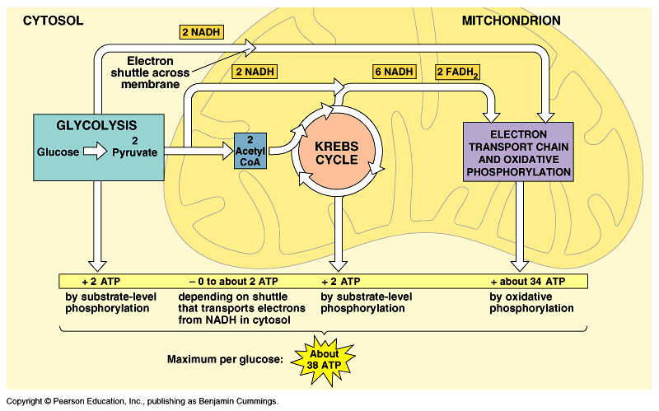 | Oxygen allows humans to metabolize fuel (food) creating energy in the form of __________. Every cell in the human body needs oxygen to survive. Cells turn ___________________ + ___________________ into energy within mitochondria. Without oxygen we can’t process food or make energy.

3.1.e. What human body systems work to create, process, or distribute the body’s main power sources?
Food | Water | Oxygen
Nutrients are broken down by the ___________________ system and transported throughout the body by the ___________________ system. The ___________________ is also involved by providing key hormones responsible for the digestion and maintenance of blood-sugar levels. | Taken in through the ___________________ system and transported throughout the body by the ___________________ system. Wastes are removed by the ___________________ system to maintain homeostasis of fluid levels. | Taken in through the ___________________ system and transported throughout the body by the ___________________ system.
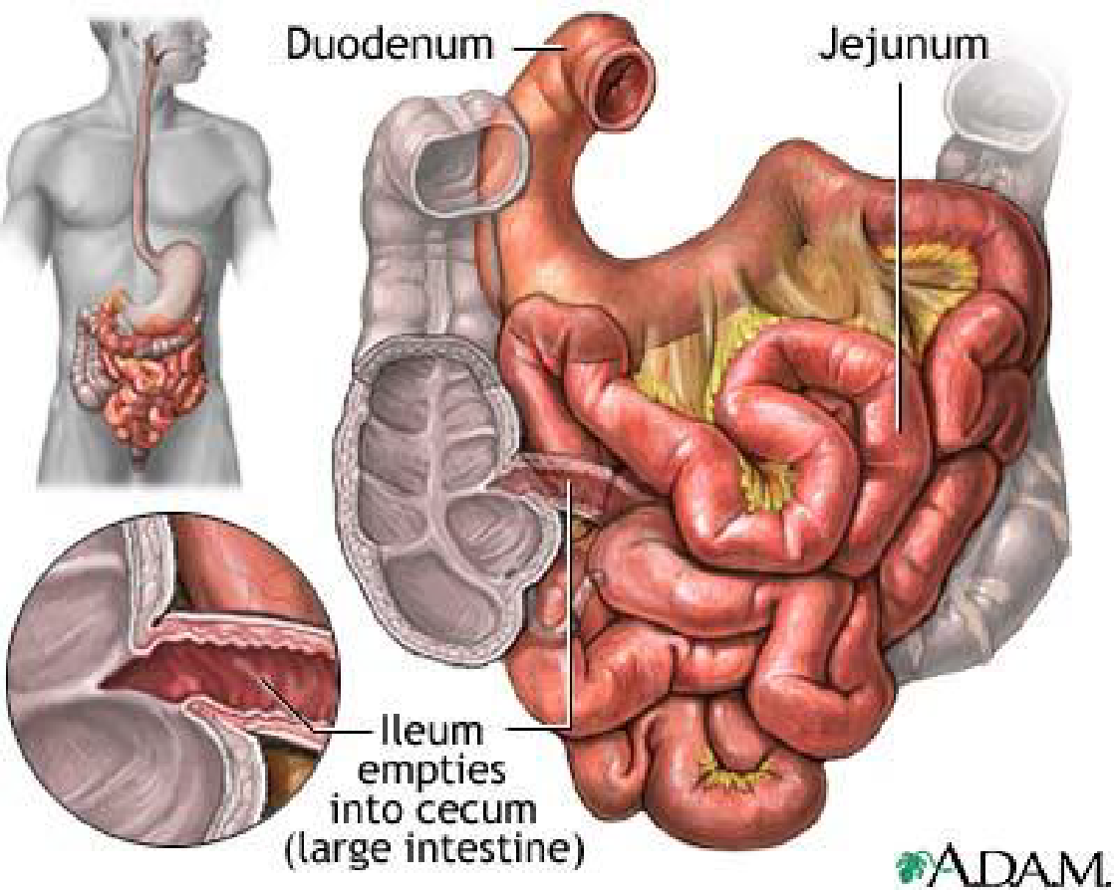 | 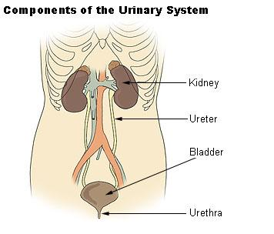 | 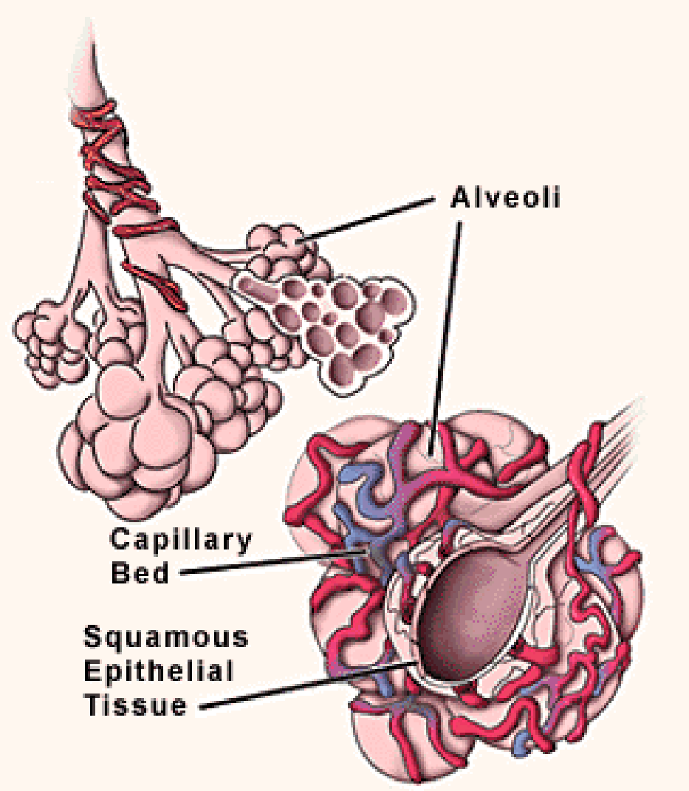

3.1.f. How do personal factors and environmental factors impact the body’s ability to survive without air, food, or water??

Personal Factors | Environmental Factors

