2.1.1 Graphing Help Sheet
- Open a new file in Microsoft Excel.

- Start at A 2 and enter times starting at zero (see below)

- In B1 type in Anna Garcia, in C1 type in Patient A and in D1 type in Patient B, (in the example below I used mom, dad and granny instead of Anna, pt A and pt B)
.
- Enter the data as shown below using your data for Anna, pt A and pt B

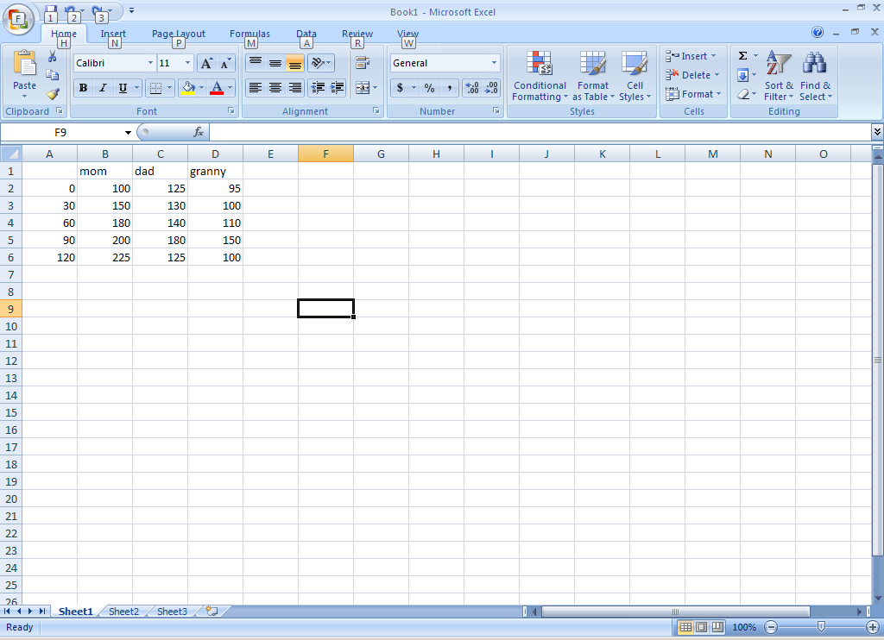

- When you have entered all of the data, then carefully highlight as shown below, do not highlight any extra rows or spaces.
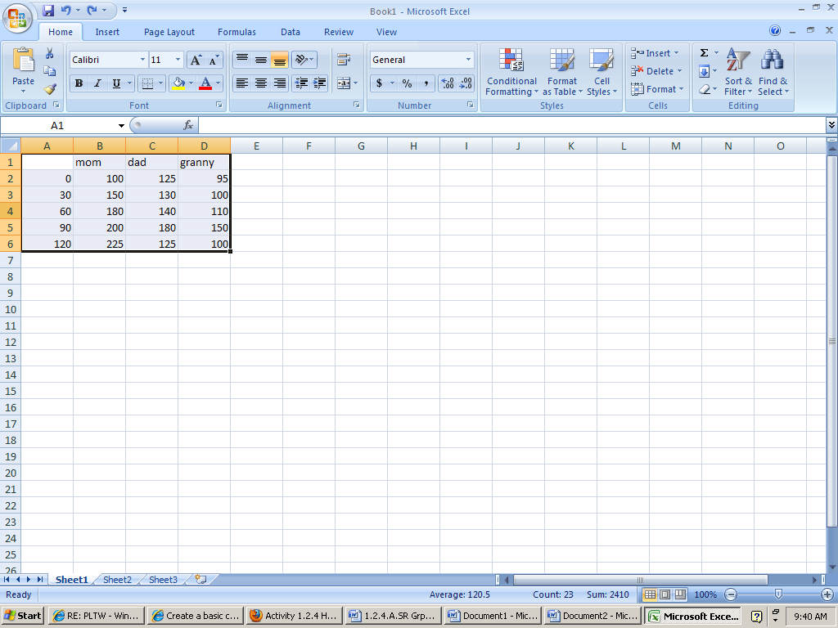

- Then at the top ribbon , select insert, Line Chart , 2d line with markers (see below)
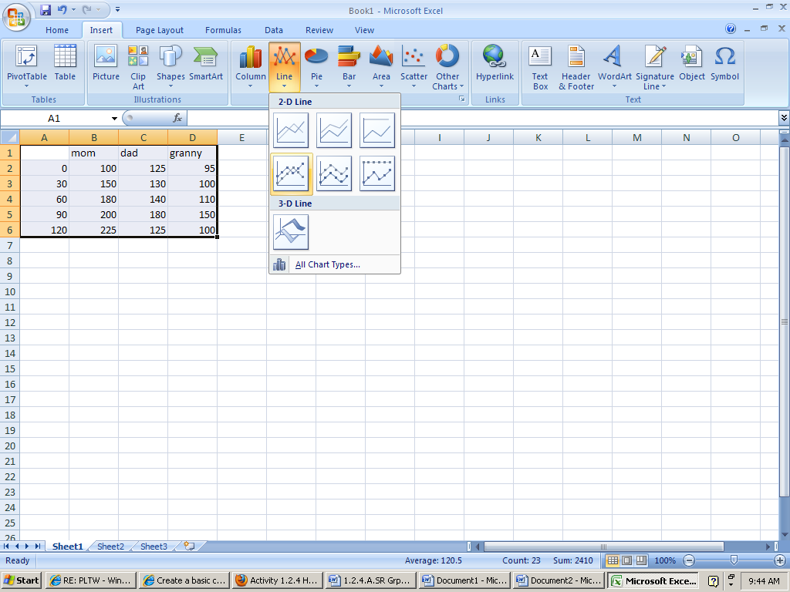

Your page should now look something like this –if it does not, check to see that you did not highlight any cells

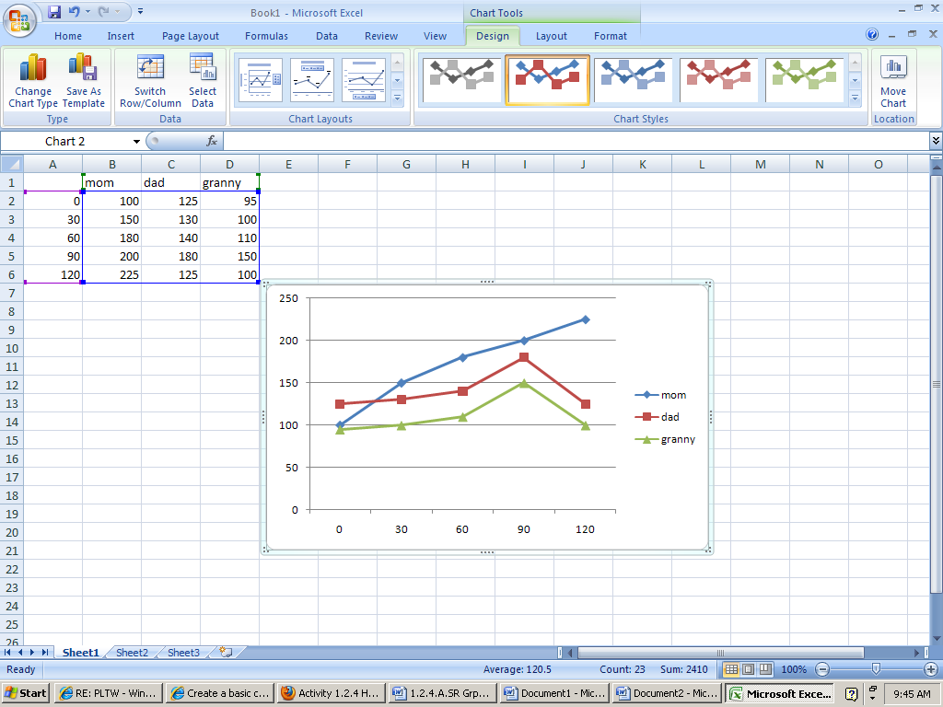

Now you will need to give your Chart a Title and you will need to label the axis. To do that you will click on the Layout tab 