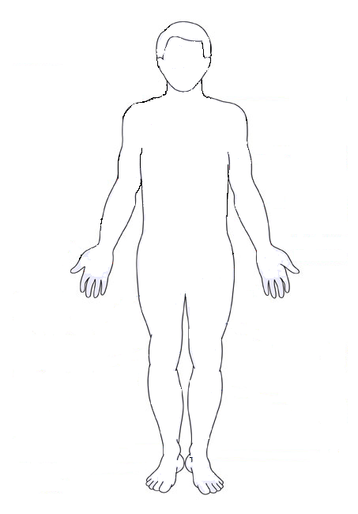
COMPLICATIONS OF DIABETES

