Activity 2.2.4: Reaction Time

Introduction
Every day you react to the huge amount of stimuli that bombards your senses. Sight, smell, hearing, taste, and touch communicate the wonders of the world and make the body respond. These reactions allow us to complete our everyday activities, but the speed at which our nervous system reacts also allows humans to complete amazing tasks. Race car drivers navigate safely past opponents at 200 mph. Baseball players make contact with lightning-quick fastballs. Bullfighters twist out of the way of a charging beast. Think about the sequence of events that must occur to manage events that seem to pass with the blink of an eye.

In the 1800s, scientist Franciscus Donders set out to measure the “speed of thought.” Using a bulky timing device called a Hipp chronoscope (remember, there were no stopwatches or computers), Donders measured how long it took people to react to and complete particular tasks. He then went on to relate the difficulty of the task and the reaction time to what may be happening in the human brain. Modern day psychologists continue to study the link between this “thinking time” and processing in the nervous system. Neuroscientists use sophisticated imaging techniques to look inside the brain as it does its work. Modern technology has expanded the way in which we can peek into the workings of the brain, but the early work of Donders set the stage for really thinking about thinking.

Most actions, except for the simplest reflexes, require a large amount of brain activity. The brain receives and processes input, interprets this information, and controls muscle movements to produce a response. The time it takes to complete this sequence of events is called reaction time. In theory, the more complex the task, the more processing time required to react. Let’s see if this holds true.

Think back to your experiment in Activity 2.2.3. You learned that response time for voluntary actions is longer than for reflexes. But what happens if you have to think before you respond? In this project you will test and compare your reaction time to four different tasks, modern day versions of Donders’ experiments. Each task requires different levels of nervous system input that may affect reaction time.
Equipment
- Computer with Internet access
- Laboratory journal
Procedure
- Complete the Fastball Reaction Time activity found at the Exploratorium site http://www.exploratorium.edu/baseball/reactiontime.html. In your laboratory journal, record your time for 10 trials. Circle your best time.
- Discuss the results with the class. Brainstorm the factors that impact reaction time to simple tasks.
- Open the Bryn Mawr College Serendip activity Time to Think? available at http://serendip.brynmawr.edu/bb/reaction/reaction.html. Read the instructions and if necessary, download the Shockwave plug-in. NOTE: All screenshots in this document are taken from the Bryn Mawr website.
- Note that four tasks are listed. You will collect data for each of the four tasks (labeled cases).
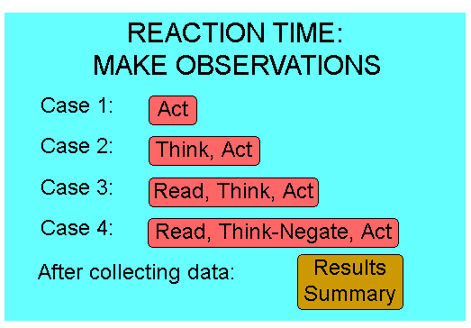

- Click on Case 1 – Act. Follow the instructions on the screen to complete the simple reaction task and collect data. You should collect data for 10 trials. The computer will store your recent times in milliseconds and prompt you to try again. Click on Do Another Trial? until you have recorded 10 times. When you have completed 10 trials, click Done.
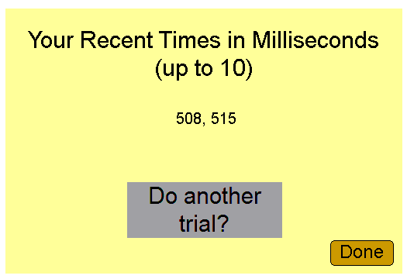
- Record the average reaction time for Case 1 in your laboratory journal.
- Return to the main menu and click on Case 2 – Think, Act. Follow the instructions on the screen to complete the task and collect data. Note that you will now test your reaction to a discrimination task. In this type of task, you must make a decision before you register a response. You should collect data for 10 trials. The computer will store your recent times in milliseconds and prompt you to try again. Click on Do Another Trial? until you have recorded 10 times. When you have completed 10 trials, click Done.
- Record the average reaction time for Case 2 in your laboratory journal.
- Return to the main menu and click on Case 3 – Read, Think, Act. Follow the instructions on the screen to complete the discrimination task and collect data. You should collect data for 10 trials. The computer will store your recent times in milliseconds and prompt you to try again. Click on Do Another Trial? until you have recorded 10 times. When you have completed 10 trials, click Done.
- Record the average reaction time for Case 3 in your laboratory journal.
- Return to the main menu and click on Case 4- Read, Think-Negate, Act. Follow the instructions on the screen to complete the discrimination task and collect data. You should collect data for 10 trials. The computer will store your recent times in milliseconds and prompt you to try again. Click on Do Another Trial? until you have recorded 10 times. When you have completed 10 trials, click Done.
- Record the average reaction time for Case 4 in your laboratory journal.
- Return to the main menu and click on Results Summary. Print the screen or copy the statistics box into your laboratory journal.
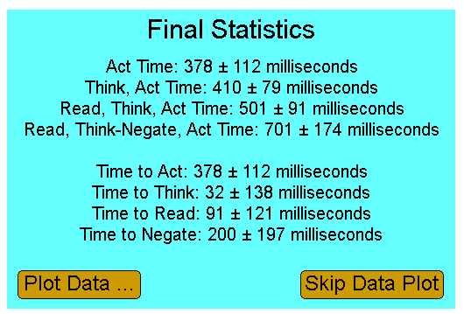
- Discuss your results with a partner. Think about how each time relates to cognitive processing and brain function.
- On the board, write your mean reaction time for Case 1, Case 2, Case 3, and Case 4 next to your name.
- Once every student in the class has recorded their mean reaction times, examine the trends and calculate a mean reaction time for each task. Calculate a mean reaction time for each task broken down by gender. List class results in your laboratory journal.
- Complete the conclusion questions.

Conclusion
- Describe any trends in your simple reaction data – either in the fastball simulation or Case 1. What factors may have attributed to the variation you see over the ten trials?

- Compare your reaction time for Case 2 and Case 3 and for Case 3 and Case 4. How are the tasks different in each case? Explain your results.

- In terms of processing in the nervous system, explain why your reaction time was most likely faster for the simple reaction task than for any of the discrimination tasks.

- Were there any noticeable differences in reaction times between males and females? If so, what might account for this difference?

- How does your reaction time to the voluntary action of your quadriceps in Activity 2.2.3 compare with your reaction time to the simple reaction task in this project? The task in the previous lab involved hearing a sound and reacting with your foot. The task in this lab involved seeing a signal and reacting with your finger. What do reaction times tell you about how these signals are processed?

- Describe how you could simulates one of the Cases from the computer simulation (Case 2, Case 3, or Case 4) using the basic laboratory setup from the Activity 2.2.3. Be sure that the task you design using the EMG sensor and accelerometer represents the same level of discrimination used for that Case on the computer. Be creative. Think about what type of cues you want to use.

- Provide an example of how delayed reaction time can impact body systems.

