Activity 2.2.4: How Much Energy Is in Food?
Introduction
Your everyday actions are powered by the energy obtained from food. Your body disassembles what you eat, bit-by-bit, and captures the energy stored in the molecules that make up the food. This disassembly requires multiple body systems working together. The digestive system begins the process by mechanically and chemically breaking down the food into its component molecules. These molecules are then absorbed through the small intestine and travel via the circulatory system to all the regions of the body. Finally, the cells in the tissues of the body capture the energy as the food molecules are broken into ever smaller molecules with the help of oxygen obtained from the respiratory system.

Carbohydrates, fats, and proteins each provide varying amounts of energy for the body. The amount of energy that can be tapped is related to the structure you observed in Activity 2.2.3. The preferred macromolecule to use as an energy source is a carbohydrate. Carbohydrates are further broken down into their component sugar molecules through the process of hydrolysis. Sugars, such as glucose, are then absorbed into the bloodstream from the small intestine. The glucose molecules travel to the body’s cells where a series of chemical reactions, known as cellular respiration, ultimately make adenosine tri-phosphate, ATP. Using the analogy of a car, ATP is the human body’s gasoline. It is the energy compound that powers all metabolic reactions.

As you observed earlier in the unit, food labels list the number of calories in a serving of a food. The number of calories is an indication of the amount of energy that a serving of food provides to the body. When referring to food, a calorie is the amount of energy needed to raise the temperature of 1 kg of water 1° C. The number of calories in a piece of food is determined by measuring the increase in temperature of a known volume of water when a portion of the food is burned. This process for measuring the amount of energy in food is called calorimetry.

As you observed when you analyzed the food labels, different foods contain different amounts of calories. An average person should consume about 2000 calories per day. To measure the number of calories in a piece of food, the food is ignited and the amount of energy in the food is determined by measuring the increase in temperature of water due to the heat given off by the burning food. This process is performed in an apparatus called a calorimeter. In this activity you will make a simple calorimeter to measure the amount of energy in a variety of food samples. Begin to think about the specific energy content of food as you continue your investigation into Anna Garcia’s mysterious death.

This activity is based on “Experiment 1: Energy in Food” in the book Biology with Vernier written by Kelly Redding and David Masterman and is used with permission.
Equipment
- Computer with Vernier Logger Pro® Software
- Vernier LabQuest Mini® with USB cable
- Stainless Steel Vernier temperature probe
- Logger Pro® resource sheet
- Label Analysis Chart resource sheet from Activity 2.2.2
- Project 2.2.1 Autopsy Report
- Activity 2.2.3 Student Response Sheet
- PBS Course File
- 100 mL graduated cylinder
- Electronic balance
- Food holder (aluminum foil shaped into a small dish)
- Samples of food you investigated in Activity 2.2.2 ( e.g., marshmallow, peanut, chip, cube of bread, piece of cereal)
- Long wooden kitchen matches
- Ring stand
- Small utility stand
- Size 24 cork, wrapped in aluminum foil
- Metal can (e.g., soda or other aluminum can)
- Utility clamp
- Water
- Safety goggles
- Laboratory apron
- Metal disposal can (e.g., quart paint can)
- Laboratory journal
- Career Journal
- Career Journal Guidelines
- Documentation Protocol
Procedure
- Refer to your Label Analysis Chart resource sheet from Activity 2.2.2 and your Activity 2.2.3 Student Response sheet.
- Using what you have learned in Activity 2.2.3 about the structure of macromolecules, make predictions as to which of the four food items you investigated will provide the most energy to your cells. Record your predictions in your laboratory journal. You will test two of these foods in this experiment. Obtain information about the other two foods from another lab group.
- Read the background information below about the term calorie. Return to this information as needed as you calculate the calorie content of food items in your experiment.
The word calorie is confusing because there are two definitions of the word and they differ by a factor of 1000. In chemistry, a calorie is the amount of energy needed to raise the temperature of 1 g of water 1° C. The calories listed on a food label are actually kilocalories in chemistry because the amount of water being heated is a kilogram instead of a gram. A kilogram is 1000 times more than a gram.
It was considered cumbersome to use the term kilocalorie when referring to food, so the prefix was dropped. For years when the term calorie was used to refer to food, it was written with a capitol C. A Calorie was the energy to raise the temperature of 1 kg of water, and a calorie was the energy to raise the temperature of 1 g of water. Even that practice has fallen out of favor in recent years and both types of calories are written with lower case letters. Because of the confusion, most scientists have abandoned the term calorie in favor of the Standard International metric unit of measure for energy called the Joule. One calorie (chemistry) is equal to 4.186 joules, and one Calorie (food) is equal to 4186 joules.
- Draw the following data table in your laboratory journal.
I believe that ______________will have the most calories, burn the longest because…..
I believe that ______________will have the least calories, burn the quickest because……..
Measurements | Sample 1 | Sample 2 | Sample 3
Food used
Mass of empty can (g)
Mass of can plus water (g)
Minimum temperature of water (°C)
Maximum temperature of water (°C)
Initial mass of food (g)
Final mass of food (g)

- Follow you teacher’s instructions to assemble the ring stand, utility stand, cork, metal can, and utility clamp into a simple calorimeter. One example of a simple calorimeter is shown below.
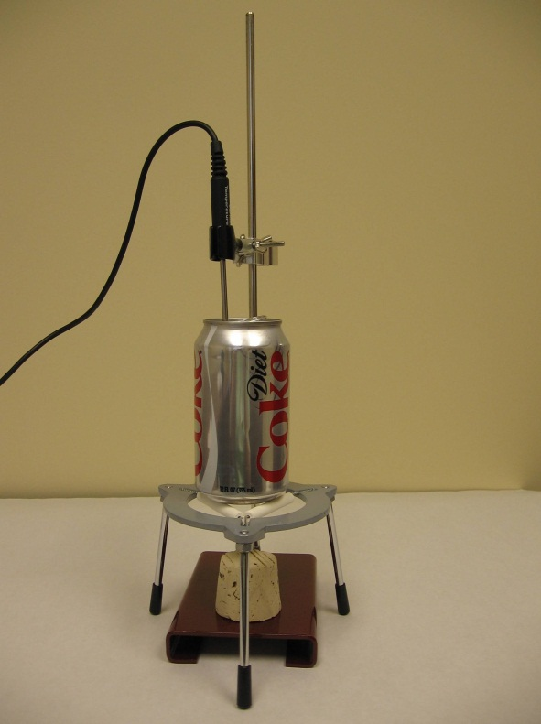
- Put on your goggles and laboratory apron.
- Measure the mass of the metal can in grams using the balance and record your measurement in your data table.
- Measure 50 to 100 mL of room temperature water and carefully pour it into the metal can. The amount of water you use will depend on the size of metal can you use. You need enough water in the container so the temperature probe does not touch the bottom of the can. However, you do not want too much water because there may not be enough energy in the food sample to heat a large quantity of water.
- Measure the mass in grams of the metal can with the water. Record your measurement in your data table.
- Fold a piece of aluminum foil to make a small dish that will hold the sample of food you want to test. You may want to wrap the cork in aluminum foil to make it easier to clean.
- Choose a food sample (e.g., a single nut, one marshmallow, one Cheerio) and place it in the aluminum foil dish you made. If you are allergic to any of the food samples, especially nuts, inform your teacher and take appropriate precautions.
- Measure the mass in grams of the food sample and the foil dish. Record in your data table the mass of the food sample.
- Open Logger Pro® software.
- Obtain and read through the Logger Pro® resource sheet and acquaint yourself with the software. Your teacher may provide a demonstration of the sensors and software.
- Click on File Open and open the Biology with Vernier folder.
- Open the program titled 01Energy in Food.
- Connect the LabQuest Mini to the computer using the USB cable.
- Connect the Temperature Probe into CH 1 of the LabQuest Mini.
- Place the metal can with water onto the small stand or assemble as instructed by your teacher.
- Attach the temperature probe to the ring stand using the utility clamp; be careful not to tighten the clamp too tightly around the probe or you will damage it.
- Lower the probe so that about an inch or more of the tip of the probe is submerged in the water in the can. The probe should not touch the bottom or side of the can.
- Click on the 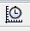 button on the toolbar to set the Length of Experiment to 10 minutes and click Done.
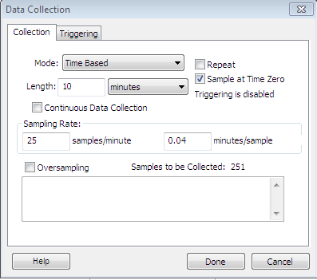
- Place the food sample that was massed in Step 9 in the foil dish onto the cork and place the cork under the metal can. Be sure the food sample is centered under the can. If there is more than a one inch distance between the food and the bottom of the metal can, either lower the can so that it is closer to the sample or make a stand that raises the food sample closer to the can. You can bend a large paper clip to make a small stand for the food dish. The end of the bent paper clip can be inserted into the cork and the foil dish placed on top of the bent clip to bring it closer to the metal can.
- Click the green Collect arrow in the top toolbar.
- Record in your data table the initial (minimum) temperature of the water.
- Ignite the food sample using a long wooden kitchen match. Be careful not to ignite any papers or other materials. Be sure to keep your hair, sleeves, or other clothing away from the flames.
- Extinguish the match flame and place the match in the metal disposal can.
- Watch the temperature of the water rise by observing the data collection graph. If the temperature exceeds 60°C, carefully extinguish the burning food by blowing on it. Be careful not to blow so hard that the food sample is blown away. Do not stop the data collection yet.
- Watch the time. If the food sample is still burning after 4 minutes, extinguish it by blowing on it. Be careful not to blow so hard that the food sample is blown away. Do not stop the data collection yet.
- Once the water temperature begins to decrease, end data collection by clicking the red Stop button on the toolbar.
- Place the cursor over the highest point on the graph to determine the maximum temperature of the water.
- Confirm the maximum temperature by clicking on the Statistics button 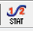 on the toolbar. The maximum and minimum temperatures will be displayed.
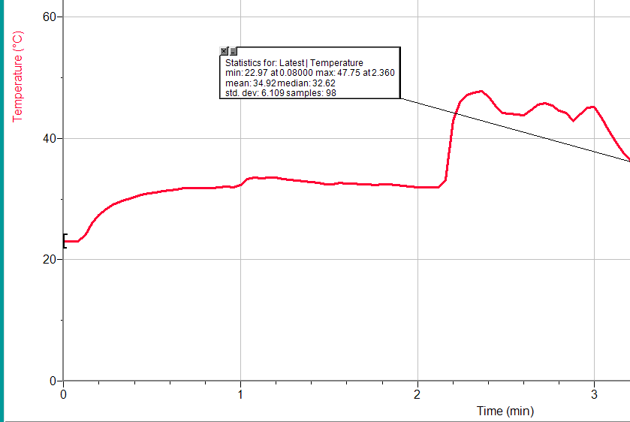
- Measure the mass of the remains of the food sample and the aluminum foil dish. Be careful not to burn yourself.
- Record in your data table the mass of the remaining food and dish.
- Enclose the remains of the food sample by folding the aluminum foil dish.
- Place the wrapped food sample remains in the metal disposal can.
- Remove the temperature probe from the metal can.
- Empty the water from the metal can. Be careful not to get any of the soot from the bottom of the can on your hands or clothes.
- Repeat steps 7 to 38 with a second food sample.
- Draw the following Data Analysis Table in your laboratory journal.
Calculations | Sample 1 | Sample 2 | Sample 3
Mass of water (g)
Change in temperature of water (°C)
Change in mass of food sample (g)
Energy gained by water (chemistry calorie)
Energy content of food sample (chemistry calorie per gram)
Energy content of food sample (food calorie per gram)

- Complete the calculations described in steps 43-48 in your laboratory journal; show and label each step of your calculations.
- Record each of the final calculated values in the Data Analysis Table in your Laboratory Journal.
- Calculate the mass (g) of water used for each food sample experiment.
- Calculate the change in temperature (°C) of the water.
- Calculate the change in mass (g) of the food sample.
- Calculate the energy gained (chemistry calories) by the heated water. Show your work and include all units of measurement in the space below. Use the following equation:
Energy gained = (mass of water) x (change in temperature) x (specific heat of water)
Note: The specific heat of water is 1 calorie ÷ (1 g x 1°C).

- Calculate the energy content of the food sample in chemistry calories. Show your work and include all units of measurement in the space below. Use the following equation:
Energy content of food sample = Energy gained by water ÷ change in mass of food

- Calculate the energy content of the food sample in food calories. One food calorie is equal to 1000 chemistry calories.
- Share your results with your classmates as instructed by your teacher. If multiple groups tested the same type of food, compare the calculated values for the energy content (food calories) per gram of food.
- Note that in this lesson, you looked at the science of food. Many science professionals focus their work or research on the composition of food, the manipulation of the specific components in food, or the relationship of nutrients in food to good health.
- Follow the Career Journal Guidelines and complete an entry in your Career Journal for the following two careers.
  - Biochemist
  - Food Scientist or Technologist
- Follow the Biomedical Sciences Documentation Protocol to correctly document or cite the sources of information you used.
- Take out the Project 2.2.1 Autopsy Report. Using everything you have learned in this lesson about food, energy, and macromolecules, analyze Anna’s last meal and how it could have related to her untimely death. Add this information to the Autopsy Report under the Possible Causes of Death section.
- Update the classroom evidence board with information from Lesson 2.2.
- Answer the Conclusion questions.
Conclusion
- Which of the foods you tested had the greatest energy content? Compare your findings from the experiment to the predictions you made in Step 2.

- Calculate the food energy (joules/g) of one of your food samples. One chemistry calorie is equal to 4.186 joules. Convert the energy you calculated to kilojoules (1 kJ = 1000 J). Show and label your work for your calculations.

- Explain how knowledge of the energy content of food can help diabetics make smart diet choices.

- Explain how both a biochemist and a food scientist may assist in making sure people consume a more nutritious diet.

