Activity 2.2.3: The Biochemistry of Food

Introduction
The foods we eat contain the nutrients and molecules we need to survive. Some of these molecules are used to build our body parts, some are used to drive chemical reactions necessary for life, and others are used as sources of energy. Many of the molecules in our bodies are very large and are made by combining smaller molecules. These very large molecules are called macromolecules.

In this activity you will take a much closer look at the structure of some of the molecules listed on the food labels you observed in the previous activity and begin to develop an understanding of their functions in your body. You will complete a series of puzzles to explore the biochemistry of food. You will begin to see how the body works to harness the power of what we eat through the assembly and disassembly of macromolecules.
Equipment
- Computer with Internet access
- Chemistry of Life presentation
- Activity 2.2.3 Student Response Sheet
- Anna Garcia Food Diary
- Molecular Puzzles kit
- Colored pencils
- PBS Course File
- Laboratory journal or notebook
Procedure
Part I: Chemistry Basics
- Open the interactive presentation Chemistry of Life. Note that you will be working through this presentation in bits and pieces as you complete this activity. The presentation will prompt you to return to this activity document when appropriate.
- Complete Part I: Chemistry Basics of the interactive presentation. Take notes in your laboratory journal so you can refer to them later. Be sure to pay close attention to the information on chemical bonds.
- Answer Conclusion question 1.
Part II: Molecular Puzzles
- Obtain oxygen and hydrogen puzzle pieces from your teacher.
- Following the two rules listed below, fit the puzzle pieces together to make a complete molecule.
- Oxygen and hydrogen atoms can bond with anything they fit with. Remember that each snap represents a covalent bond.
- A molecule is stable (complete) only if it has no available pegs or slots.
- Draw the molecule you created in the space below. If you know the name of the molecule, write the name next to your drawing.

- Note that water plays a vital role in harnessing the energy from food. Pay particular attention to the interaction between water molecules and macromolecules.
- Obtain an Activity 2.2.3 Student Response Sheet. You will fill in important information on each type of macromolecule on this graphic organizer as you work through the remainder of the interactive presentation. NOTE: You will fill out the final column – Food Examples from Anna’s Diet – at the end of this activity.
- Begin Part II: Macromolecules of the interactive presentation.
- With a partner, obtain one set of molecular puzzle pieces. Complete each puzzle set one at a time as described under each Puzzle Set heading to explore the structure of the macromolecules found in the foods we eat. As you complete each puzzle set, make sketches in your laboratory journal. Use colored pencils for all sketches and match as closely as possible the colors in your sketches to the colors of the pieces in the puzzle. These should be rough sketches that you can use to recall what the model looked like; they do not need to be exact drawings of each model.
- Note that for each macromolecule, you will work through the corresponding section in the Chemistry of Life interactive presentation. As you work through each section, fill-in the appropriate information on the Student Response Sheet.
- Note that there are four basic rules to using the puzzles. If desired, copy these rules into your laboratory journal.
- Oxygen and Hydrogen atoms can bond with anything they fit with. Remember that each snap represents a covalent bond.
- A molecule is stable (complete) only if it has no available pegs or slots (Note: proteins are an exception).
- Macromolecules are assembled by connecting puzzle pieces of the SAME color and oxygen and hydrogen atoms.
- The lettering on the puzzle pieces must be visible and all in the same general direction when assembling the puzzle pieces.
Puzzle Set #1 – Carbohydrates
- Work through the Puzzle Set #1 – Carbohydrates section of the interactive presentation until it directs you back to this activity document. Add all relevant information from the presentation to your Student Response Sheet.
- Take out the monosaccharide base piece (shown below) and some hydrogen and oxygen atoms.
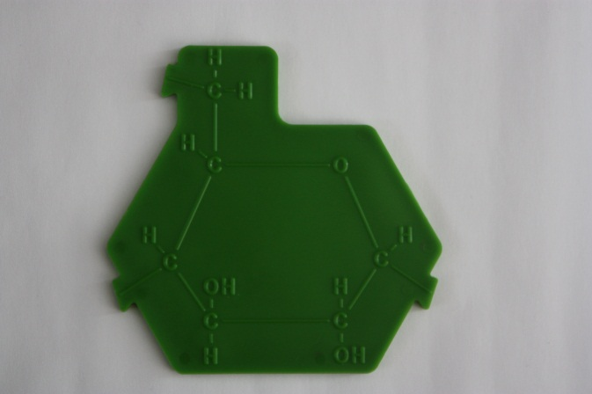
- Use the rules described in step 12 to assemble your monosaccharide. Make sure your completed molecule is visible on your desk. Your teacher will check for accuracy.
- Sketch the monosaccharide in the space below. Clearly indicate each C, H, or O and show each bond. Note the arrangement of bonds and the unique ring structure.

- Continue to work through the Puzzle Set #1 – Carbohydrates section of the interactive presentation until it directs you back to this activity document.
- Combine with a neighboring group so you have two completed monosaccharides.
- Work together with your team of four to decide how to link two monosaccharides to form a disaccharide. Note that the prefix di refers to two. Hint: You may have to remove pieces. If you remove pieces, remember to link them following the four basic rules. Note that there are two ways for monosaccharides to come together. Both are correct and both can be found in the same polysaccharide. These units may assemble in a straight line or as branches from an initial line. For the following exercises, you may use either connection.
- When you believe you have completed the puzzle, show your result to your teacher and sketch your completed disaccharide (as well as any additional molecules you assembled) in the space below.

- Note that this type of reaction is referred to as dehydration synthesis. Based on the action you took to complete the puzzles, provide a definition for this term in the space below.

- Reverse the process you just completed to break down the disaccharide into two monosaccharides.
- Note that this type of reaction is referred to as a hydrolysis reaction. Based on the action you took to complete the puzzles, provide a definition for this term in the space below.

- Continue to work through the Puzzle Set #1 – Carbohydrates section of the interactive presentation until it directs you back to this activity document.
- Combine with additional groups so you have 3 to 4 monosaccharides. Continue combining these molecules via dehydration synthesis until you have a completed polysaccharide. Remember to link extra puzzle pieces into the proper molecules.
- Sketch your completed polysaccharide in the space below.

- Reverse the process you just completed to break down your macromolecule and retrieve your monosaccharide.
- When you are called to the central building location, add your monosaccharide to the class chain via a dehydration reaction. Your teacher will help you assemble your monosaccharides into starch by forming a straight chain. Starch is a complex carbohydrate formed of thousands of monosaccharide units (in this case, the monosaccharide glucose). Draw a very simple sketch of starch in the space below.

- Answer Conclusion question 2.

Puzzle Set #2 – Proteins
- Complete the Puzzle Set #2 – Proteins section of the interactive presentation until it directs you back to this activity document. Add all relevant information from the presentation to your Student Response Sheet.
- Obtain an amino acid base piece (shown below) and some hydrogen and oxygen pieces.
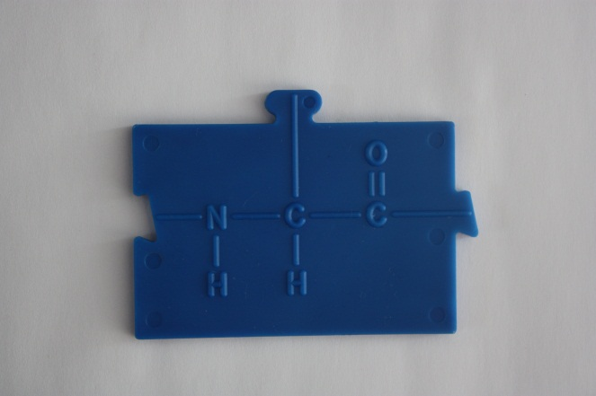
- Follow the rules stated in Step 12 to assemble the puzzle pieces. Note any problems with your puzzle.
- Locate the additional blue piece called a variable group, or R group. Note that there are 4 different variable groups in the kit even though there are 20 variable groups that exist in nature. Add this piece to your puzzle.
- Sketch your completed amino acid in the space below. Label the hydrogen, amino group, carboxyl group, and variable group in your sketch. Note that you may have a different amino acid than your neighboring group. The specific chemical structure for each of the 20 amino acids is shown at the Chem4Kids website http://www.chem4kids.com/files/aminoacids/index.html.

- Merge with a neighboring group.
- Place your two amino acids side by side. Note that amino acids are the building block of proteins.
- Using what you have learned in the carbohydrate exercises, combine the two amino acids to make a dipeptide, a molecule of two amino acids. If you remove pieces, remember to link them following the four basic rules. Note the use of a dehydration reaction.
- Sketch the completed dipeptide in the space below.

- Reverse the process to complete a hydrolysis reaction and break apart the amino acids.
- Combine with additional groups as directed by your teacher.
- Carry out dehydration reactions until your completed protein is assembled and all of the amino acids in your group are joined. Your teacher may combine all of the amino acids in the class into one macromolecule, called a polypeptide.
- Observe your completed molecule. The sequence of different amino acids is referred to as the primary structure of a protein. This sequence specifies the overall function of the protein. Note that a polypeptide strand continues to bend and fold and may possibly combine with other folded polypeptide strands to build a completed protein.
- Answer Conclusion question 3.
Puzzle Set #3 – Lipids
- Complete the Puzzle Set #3 – Lipids section of the interactive presentation until it directs you back to this activity document. Add all relevant information from the presentation to your Student Response Sheet.
- Note that triglycerides are composed of a glycerol molecule and chains called fatty acids.
- Obtain the two pieces that make up a glycerol molecule (shown below) as well as some hydrogen and oxygen pieces.
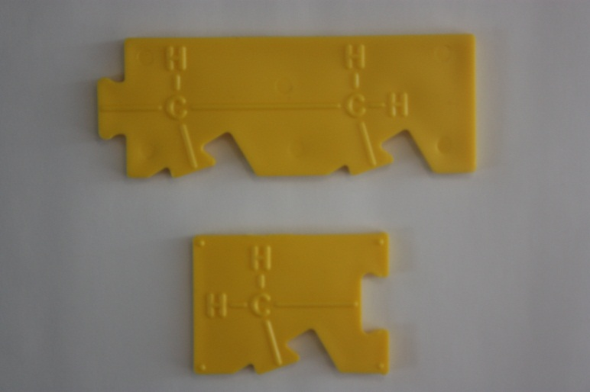
- Assemble your pieces according to the rules in Step 12 to form a completed glycerol molecule.
- Sketch your glycerol molecule in the space below.

- Obtain one fatty acid chain piece (shown below) and additional hydrogen and oxygen molecules. Note that this type of chain is referred to as a saturated fatty acid. Count the number of hydrogen atoms on the fatty acid chain.
- Assemble your pieces to form a completed fatty acid chain.

- Note that triglycerides are the combination of one molecule of glycerol and three fatty acids chains.
- Combine with additional groups so you have one completed glycerol and 3 completed fatty acids.
- Assemble a triglyceride molecule by completing a dehydration reaction. If you remove pieces, remember to link them following the four basic rules.
- Sketch your completed triglyceride molecule in the space below.

- Remove one fatty acid chain from your molecule.
- Obtain an unsaturated fatty acid (shown below) from your kit and lay this chain next to the saturated fatty acid chain. Describe the differences you notice between the saturated and unsaturated fatty acid chain in the space below the picture. Count the number of hydrogen atoms on the fatty acid chain.
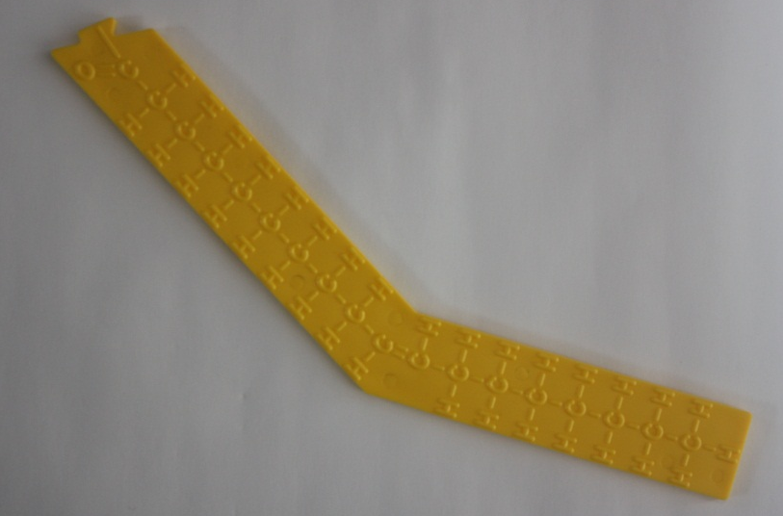

- Reassemble your fatty acid, replacing one of the saturated fatty acids with an unsaturated fatty acid. Notice how this changes the structure of the molecule.
- If asked to by your teacher, return your triglyceride to its saturated form.
- Bring your triglyceride to the designated spot in the classroom. Line up all of the saturated triglycerides side by side. Line up all of the unsaturated triglycerides side by side below the saturated triglycerides. Describe differences in how these molecules can pack together in the space below.

.
- Complete the Nucleic Acids section of the interactive presentation. Note that you will not be using the molecular puzzles to work with nucleic acids, as you already built DNA in Unit 1. Add all pertinent information to your Student Response Sheet.
- Refer to the Anna Garcia Food Diary and the results of your food testing experiment to determine food examples that contain carbohydrates, lipids, and proteins. Add these foods to the final column in your Student Response Sheet.
- Answer the remaining Conclusion questions.

Conclusion
- Explain the relationship between the food we eat and energy in the body.

- Explain what has to happen to join two monosaccharide units into a disaccharide.

- Explain how it is possible to have thousands of different proteins when there are only 20 different amino acids.

- How do saturated triglycerides compare to unsaturated triglycerides in how tightly they pack together? Based on this information, which of these triglycerides is likely to be a solid at room temperature? Explain your reasoning.

- Why aren’t lipids considered polymers?

- Even though lipids and carbohydrates are made from the same elements (carbon, hydrogen, and oxygen), why is it easy to tell them apart when viewing a model of each?

