USDA SuperTracker Resource Sheet

- Open the United States Department of Agriculture SuperTracker - Food Tracker available at https://www.choosemyplate.gov/SuperTracker/foodtracker.aspx and create a user profile for Anna Garcia. This site will compile the nutritional content of foods consumed in a set time period and provide a summary report.
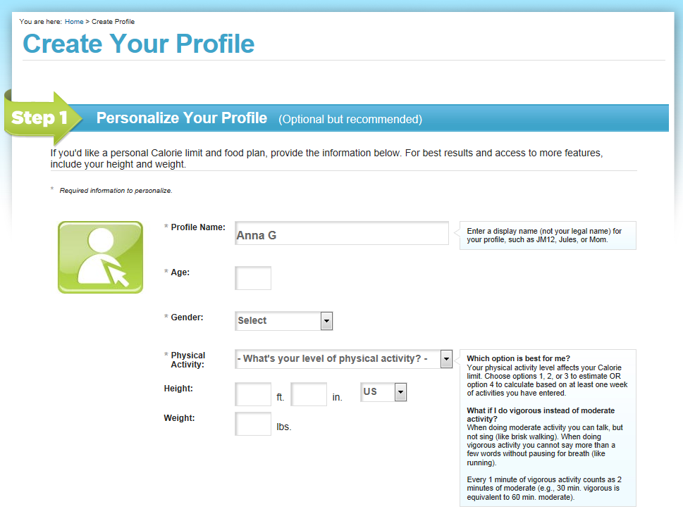
- Enter basic information about Anna using the detail provided on the autopsy report. Note that Anna had previously classified her physical activity level as “less than 30 minutes a day of moderate exercise.”
- Fill in the necessary information to create a user profile. Submit your information. When prompted, choose the option that reflects a plan where Anna is moving toward a healthier weight.
- Note that you will be taken to the Food Tracker database.
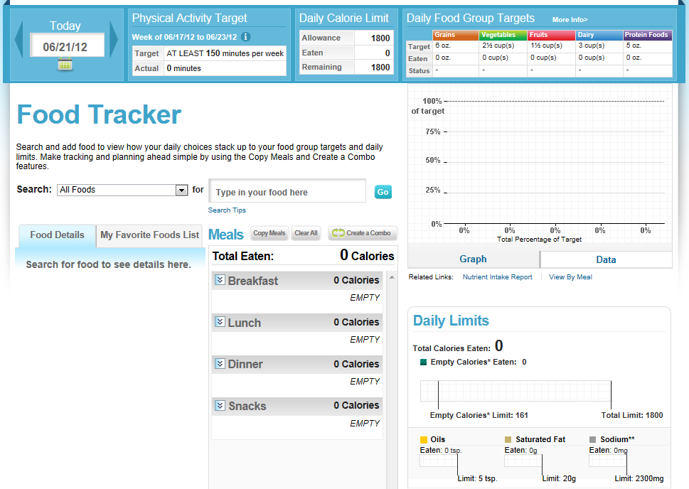

- Enter each food item Anna consumed on August 12, 2012 to obtain a summary of her nutritional intake.
- Note that the top right hand corner lists the recommended daily food group targets as described by the United States Department of Agriculture. As you enter foods from Anna’s food diary into the food tracker, pay attention to how well she was hitting these targets.
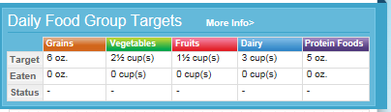
- Use the search box to search for a food item or simply type the food name into the “Type in your food here” box and choose the best fit from the dropdown menu.
- Note that the food item you picked will be listed under the Food Details tab. Choose the appropriate amount consumed from the dropdown menu and then check the box next to the appropriate meal time. Click the Add button to add this item to Anna’s meal plan.
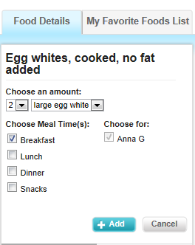

- Continue adding food items from Anna’s diary to the online tracker. Note that foods you have added will compile on the Meals box in the middle of the window. You can edit or remove foods as needed.
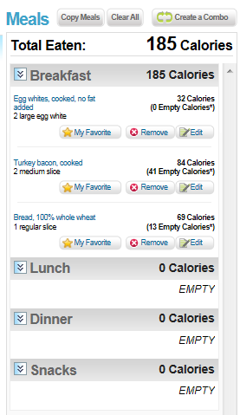
- Once you have added all of the items for the day, review the graphs and tables shown on the right hand side of the page. These organizers show how well Anna was addressing her daily food target groups and basic daily limits. The full nutritional report (generated in the steps below) will give you a detailed look at each individual nutrient.
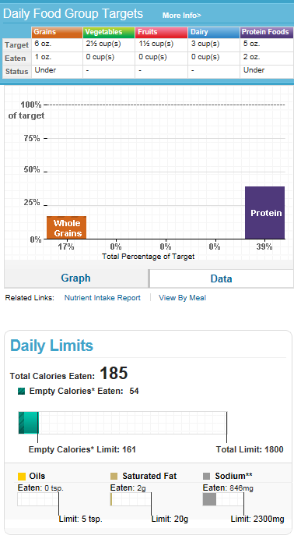
- Find the My Reports tab at the top of the page. Click on Food Groups and Calories Report.
- Enter the date you entered all of the food items into the tracker (most likely today’s date) into both boxes and click Create Report.
- Note that the report that is generated lists average intake of calories and specific food groups. Print a copy of this report and include it in the appropriate section in your course file. Note that you can export the file as a Word or Excel file or as a PDF.
- Find the My Reports tab at the top of the page. Click on Nutrient Reports.
- Enter the date you entered all of the food items into the tracker (most likely today’s date) into both boxes and click Create Report.
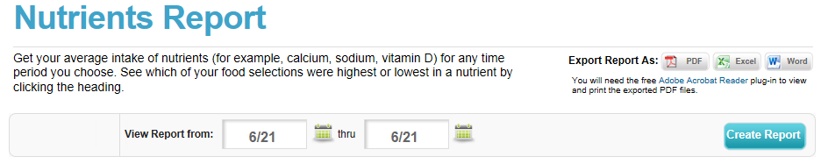
- Note that the report that is generated lists target values for all nutrients as well as how much Anna is actually consuming. Print a copy of this report and include it in your Anna Garcia file. Note that you can export the file as a Word or Excel file or as a PDF.

