Activity 2.2.1: Food Testing
Introduction
Toxicology reports ordered during Anna’s autopsy reveal that Anna had high amounts of glucose in her blood at the time of her death. This finding suggests that Anna most likely ate a large meal near the time of her death. In the first lesson of this unit, you explored the relationship between blood glucose and diabetes. Glucose levels are related to the food we consume. Given that Anna was a diabetic, she had to think carefully about her diet and choose her foods wisely. Analysis of her stomach contents at the time of her death may reveal information about Anna’s last meal and provide additional evidence regarding the conditions surrounding her mysterious death.

Eating a balanced diet is necessary for good health. The main nutrients in our food are classified as carbohydrates (sugars and starches), lipids (fats and oils), and proteins. Carbohydrates, including simple sugars such as glucose, are a great source of energy. Proteins are crucial in our diet as they help build tissue, fight disease, and facilitate chemical reactions. Lipids, commonly called fats, have equally important functions, including cell membrane and hormone production. An adequate amount of each of these nutrients is needed to keep the body in balance. In this project you will perform chemical tests to determine what foods contain carbohydrates, lipids, and proteins.

Scientists analyze the chemical components of a substance in a variety of ways; one of the simplest methods is to use chemical indicators. An indicator is a substance that changes to indicate the presence of a particular compound or type of compound. The indicator may change color or temperature or may produce some other substance, such as bubbles or a distinctive odor. The change in the indicator is due to a chemical reaction between the indicator and the tested substance. Indicators are very specific and function based on the chemical compositions of the indicator and the substance being detected. Some indicators are sensitive to temperature, pH, and other environmental conditions. Generally, the easiest indicators to use are ones that change color to indicate the presence of a substance.

In this activity, you will use chemical indicators to tests for the presence of sugar, starch, protein, and lipids in three common food items as well as in the stomach contents of the ill-fated Anna Garcia.
Equipment
- Positive controls for each test:
  - Starch solution, 5% corn starch or other starch soluble in water
  - Protein solution, 5% albumin in water
  - Sugar solution, 5% glucose in water
  - Lipid solution, cooking oil
- Anna Garcia simulated stomach contents
- Project 2.2.1 Autopsy Report resource sheet
- Project 2.2.1 Anna Garcia Food Diary resource sheet
- 3 small samples of food
- 200 mL of distilled water in a beaker
- 8 transfer pipettes
- Hot plate with beaker containing distilled water (to make a hot water bath)
- 12 test tubes
- Test tube rack
- Test tube holder
- Test tube brush
- 1 beaker, 250 mL
- 1 beaker, 500mL
- 1 graduated cylinder, 10mL
- Mortar and pestle (optional)
- Oven mitt
- Benedict’s solution
- Lugol’s Iodine stain
- Biuret stain
- Brown paper, multiple pieces, approximately 2 to 3 cm square
- 2 stirring rods
- Safety goggles
- Gloves
- Laboratory apron
- Laboratory journal
- PBS Course File
Procedure
Part I. Positive Controls—Standard Positive Tests
- Obtain a Project 2.2.1 Autopsy Report resource sheet from your teacher. Read updated information from Anna’s autopsy. Highlight any information you feel requires further investigation.
- Obtain a Project 2.2.1 Anna Garcia Food Diary resource sheet. Note that because Anna was a diabetic, she kept a detailed record of her food intake. Scan the document that covers the two days before she died and the morning of her death. Note any obvious differences between the first and second day. Also note that the final entry is incomplete. Food items in italics will be tested in this activity.
- Use the information in the data table below to understand the changes when certain macromolecules are present.
- For each of the controls, water was used as the negative control. The positive controls for each test were as follows biuret (albumin better known as egg white), Benedict’s (glucose solution), Iodine (cornstarch), Lipids (vegetable oil).

Positive and Controls for Each Indicator
Indicator | Description of results | Color Change
Biuret Results  Proteins | Biuret has a light blue color when there are no proteins present. It turns purple or magenta when proteins are present. | 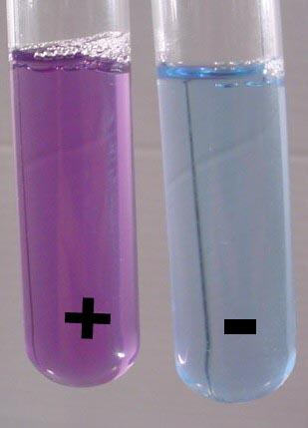
Benedict’s Results  Simple Sugars | Benedict’s tests for monomers and dimers of sugar. It is aqua blue when no sugars are present and green, yellow, orange, or red depending of the amount of sugars. | 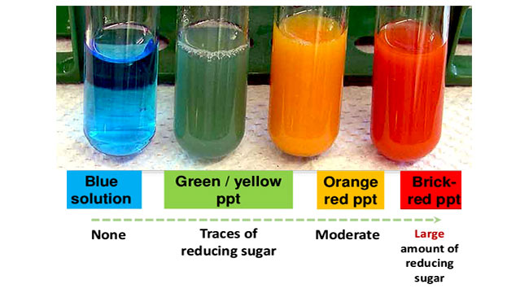
Iodine Results  Complex sugars (starches) | Iodine tests for the starches which are complex sugars. Iodine appears light yellow to orange when no starches are present. It is black or dark purple when starch is present. | 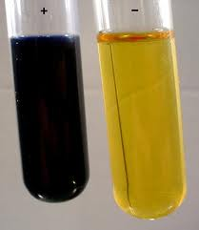
Lipid Test Results | The brown paper tests for lipids (fats) If lipids are present the paper will have a greasy spot. If there are no lipids the paper will dry and not leave a traslucent spot. | 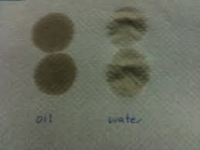

The following are the testing procedures for each indicator.
Standard Test #1: Glucose (simple sugar)
Benedict’s solution is an indicator that can be used to test for simple sugars, such as glucose. Benedict’s solution is light blue in color. However, when it is heated in the presence of simple sugars, it turns from blue to green or yellow/orange or even to red. The final color depends on the amount and type of sugar. Benedict’s solution needs to be heated to work properly.

- Make sure your goggles are covering your eyes.
- Make a hot water bath by heating 200 mL of distilled water in a 500mL beaker to near boiling. Use caution around the hot plate and hot water. Use the oven mitt to handle the beaker.
- Place 1 mL of Benedict’s Solution in a test tube
- Note the color of the Benedict’s solution before adding any samples.
- Add 1 ml of sample
- Using test tube holders, submerge the bottoms of the test tube in the hot water bath for three minutes.
- Observe and record in your data table the color of the test tube.
Standard Test #2: Starch (complex sugar)
Lugol’s Iodine can be used as an indicator for starch, a complex carbohydrate. Lugol’s Iodine is yellow or light brown in color; in the presence of starch, it turns dark purple or even black.

- Make sure your goggles are covering your eyes.
- Place 3 drops of Lugol’s iodine in the test tube
- Note the color of the Lugol’s Iodine before adding any sample.
- Place 1 mL of the sample in the test tube.
- Observe and record the results in your data table.
Standard Test #3: Protein
Biuret solution is a protein indicator. Biuret solution is a light blue color; in the presence of protein, the color changes to violet or purple. The shade or darkness of the color depends on the type and concentration of the protein, and can range from a very light violet to a deep purple.

- Make sure your goggles are covering your eyes.
- Place 1 mL of Biuret solution in a test tube.
- Notice the color of the Biuret solution before adding any sample.
- Place 1 mL of the sample in the test tube.
- Observe and record the results in your data table.

Standard Test #4: Lipid
Fats and lipids leave a translucent mark on brown paper. Translucent means light can pass through, although distinct images may not be seen through it. Moist foods can be applied directly to brown paper to test for lipids; dry foods can be tested once they are made into an alcohol extract. This is done by grinding the food, and applying samples of the food on the paper.

- Make sure your goggles are covering your eyes.
- Place the sample on the brown paper (In this situation the brown paper is the indicator if the sample is positive it will leave an oily translucent spot or spots).
- Set the paper aside and allow it to dry.
- Observe and record the results in your data table.

Refer back to your completed positive control table as needed during your experiment in Part B.
Answer Conclusion Questions 1 and 2.
Part II. Testing Food Samples
You are tasked to test Anna’s stomach contents to determine the makeup of her last meal. You will also test some common foods. You will follow the same basic procedure for these unknown samples as you did for the standards in part 1.
- Copy the following data table.
Food sample | Simple Sugar test (benedict’s) | Starch test  (iodine) | Protein test  (Biuret) | Lipids test  (Brown paper)
1.
2.
Anna’s stomach contents

- Obtain two food samples in addition to a sample of Anna’s stomach contents (simulated),
- Follow the same testing procedures from part one. Dried samples need to be ground up with the mortar and the pestle. Add about 1 ml of water to dried samples.
- Test each food sample and Anna’s stomach contents with all four indicators. Record data in the table.
- Make sure to thoroughly wash test tubes between and after testing.
- Summarize your findings below your data table by listing which food samples tested positive for each of the four molecules. The summary should follow the pattern shown below.
- Glucose is found in:
- Starch is found in:
- Protein is found in:
- Lipid is found in:

- Share information about the foods you tested with other lab groups. Add information from other groups to your summary lists in Step 6. See what you can learn about the content of all of the italicized food items on Anna’s food diary.
- Add information about Anna’s last meal to the Project 2.2.1 Autopsy Report – under the heading Gastrointestinal System. Include a summary of how this finding could link to her diabetes and her death.
- File the Project 2.2.1 Autopsy Report and the Anna Garcia Food Diary in the Resources tab of your binder.
- Answer the remaining Conclusion questions on the provided worksheet.

