Activity 2.1.2: Build-A-Brain

Introduction
Your alarm goes off and your arm flies up to hit the snooze button. You drag yourself out of bed and decide what to wear and what to have for breakfast. Your sister’s pancakes smell good so you grab a few bites while she’s not looking and head out the door. Running late (as usual), you sprint to catch your bus. You struggle to keep your balance as you head to the back of the already moving vehicle. A younger kid slams into your side with his book bag. You are about to yell, but you figure it’s not worth it and grab a seat. You finish up the last of your math homework and turn on your iPod to clear your head. You have two tests and then a game after school. You think to yourself, “How am I going to get through the day?”

All the events of your morning and all the events of the day to come are controlled by your control center, the brain. The brain allows us to move, to breathe, to make decisions, to solve problems, to feel emotions and to interact with the world around us. This 3lb, jellylike organ is often compared to a computer, but the brain is so much more complicated than even the biggest, fastest supercomputer- thanks to the 100 billion nerve cells that keep our body functioning (that’s more nerve cells than stars in the galaxy!). The brain is the key to communication in the human body. This organ not only allows your systems to communicate with one another, but allows you to communicate with and respond to your surroundings.

The central nervous system (CNS) consists of the brain and the spinal cord, while the peripheral nervous system (PNS) consists of a system of nerve cells that transmit information to and from the control center. These two systems work together to make sure important information gets to your brain to be processed and interpreted and to make sure that the correct response is generated.

In this activity, you will build a model brain and create the spinal cord on your Maniken®. As you build, you will begin to see connections between specific parts of the brain and specific actions, thought processes and functions that make us human.
Equipment
- Computer with Internet access and Microsoft Excel or other spreadsheet software (optional)
- Anatomy in Clay® Maniken®
- Terra cotta, blue, pink, green and bone colored clay
- Wire loop or wooden knife
- Body system graphic organizer handouts
- Directional terms graphic organizer
- Laboratory journal
- Reference textbook (optional)
Procedure
Directions for this activity were modified from Starla on Maniken® by Zahourek Systems Inc. and were used with permission.

- Research the structure and function of the Central Nervous System (CNS) and the Peripheral Nervous System (PNS). Use a reference textbook or a reliable Internet resource.
- Obtain a body system graphic organizer from your teacher. Draw and label the main structures of the CNS and the PNS on a human body system handout labeled “Nervous System.”
- In this activity, you will be working with your partner to build the CNS on your Maniken®. However, you will pair with another group; your “team” of four members should work together to determine placement of each structure. Refer to your directional terms organizer (if needed) as you work through the directions.
- Turn your model sideways so the hollow portion of the skull is facing you.
- From the outside, notice that the brain appears as three distinct structures- the cerebrum (which is divided into four different parts, or lobes; each plays a unique role), the cerebellum and the brain stem. View this basic structure at Centre for Neuro Skills: http://www.neuroskills.com/brain.shtml#map. Refer to this diagram as you build on your Maniken®.
- First, construct the four lobes of the cerebrum.
- Notice that the surface of the brain does not look so neat and smooth. The bumpy surface of the cerebrum is covered with peaks and valleys called gyri and sulci. Make a loose fist with your right hand. The top of each finger represents a gyrus; the fold between two fingers is known as a sulcus. Note these folds on the brain shown on your computer.
- Take a small ball of terra cotta clay about the size of a jawbreaker and roll out a piece of “spaghetti” about half the width of a pencil.
- Quickly fold this piece of spaghetti back into a ball, adding folds to represent gyri and sulci. Add these folds randomly; the pattern of peaks and valleys can vary considerably from person to person. This ball will represent the frontal lobe of the cerebrum.
- Press this ball of clay into the front top corner of the skull. The frontal lobe should not drop below the eyes and should extend half-way posterior.
- Check the placement of the frontal lobe with your team.
- Notice that at the back of the frontal lobe is a region called the motor cortex. Place a small piece of terra cotta spaghetti vertically at the posterior edge of the frontal lobe to represent this gyrus.
- Check the placement of the motor cortex with your team.
- With blue clay, form a ball that is just about the size of the frontal lobe. Roll out a piece of “spaghetti” about half the width of a pencil.
- Quickly fold this piece of spaghetti back into a ball, adding folds to represent gyri and sulci.
- Place this ball of blue clay posterior to the frontal lobe to form the parietal lobe. The parietal lobe should touch the back of the skull.
- Check the placement of the parietal lobe with your team.
- Know that at the front of the parietal lobe is a region called the sensory cortex (or somatic sensory cortex). Place a small piece of blue spaghetti vertically at the anterior edge of the parietal lobe, right next to the motor cortex, to represent this gyrus. The fold between these two areas is called the central sulcus.
- Check the placement of the sensory cortex with your team.
- Using pink clay, roll out a ball about half the size of the two previous lobes. Roll out a piece of “spaghetti” about a quarter of the width of a pencil.
- Quickly fold this piece of spaghetti back into a ball, adding folds to represent gyri and sulci.
- Place the occipital lobe you have created, the smallest of the four lobes, into the posterior cranial fossa (the flat space at the back of the skull) below the parietal lobe.
- Check the placement of the occipital lobe with your team.
- Use green clay to roll a ball a bit larger than the one you used for the occipital lobe. Roll this ball into a piece of “spaghetti” about a quarter of the width of a pencil.
- Quickly fold this piece of spaghetti back into a ball, adding folds to represent gyri and sulci.
- Place the temporal lobe anterior to the occipital lobe, extending under the parietal and halfway under the frontal lobe. This lobe takes on more of an oval shape.
- Check the placement of the temporal lobe with your team.
- Now construct the cerebellum. Using bone colored clay, form a ball about the size of the ball you used for the temporal lobe.
- The cerebellum is placed under the occipital lobe and extends anterior for one quarter of the temporal lobe.
- Check the placement of the cerebellum with your team.
- Use bone colored spaghetti to make the gyri and sulci. Unlike the folds on the four lobes of the cerebrum, the gyri on the cerebellum are parallel to one another, thinner than those on the cerebrum, and placed in a horizontal arrangement.
- Notice that the brain stem consists of three parts: the midbrain, the pons and the medulla oblongata. Build the pons and the medulla oblongata. The midbrain sits at the top of the brain stem and will not be sculpted separately.
- Use bone clay to form a two inch spaghetti strand (about the width of a pencil).
- Fold the tip of the strand back over so there is a half-inch of overlapping clay. Gently work with the clay to round the edge of this overlap. The final shape should look like an apostrophe. The bump you have created will represent the pons. Smear out any folds in the pons.
- Note that you should still have about an inch of bone clay extending from the bottom of the pons. This portion of clay represents the medulla oblongata.
- Attach the brain stem so that the pons rests on the anterior edge of the cerebellum and touches the inferior edge of the temporal lobe. The medulla oblongata should extend down to the second cervical vertebrae. Break off any clay that extends beyond this point.
- Check the placement of the brain stem with your team.
- Compare the brain you have constructed to the picture shown below. Modify your model as needed.
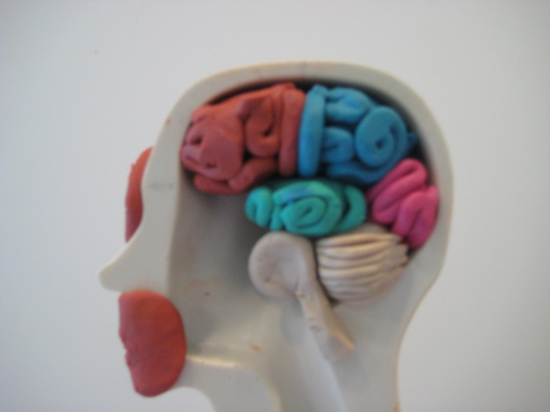
- Be aware that the spinal cord connects the brain to the body and controls for input to the control center and output to the rest of the body. Together, the brain and the spinal cord form the central nervous system. You will now add the spinal cord to your Maniken®.
- Using bone colored clay, form two, foot-long pieces of spaghetti (about half the width of a pencil).
- Use a single strand and attach it to the end of the medulla oblongata. Then press the clay onto the most dorsal surface of the model behind the chest cavity. Continue the strand until you reach the lumbar region (lower back).
- Turn the back of the model so it faces you and look at the bumps of the vertebrate. If you bend over slightly and run your fingers along your lower back, you will feel these bones that protect your spinal cord.
- Note that the spinal cord should extend to the first vertebrate in the lumbar region (called L1). Find the last vertebrate to line up with a rib and count one below. Break off your bone clay parallel to this landmark.
- Use a pencil tip or one of your tools to draw arrows in the clay going upward.
- Place another single spaghetti strand next to the piece you just attached. This piece should rest next to the opening for the chest cavity and also attaches to the medulla oblongata and ends at L1.
- Use a pencil tip or one of your tools to draw arrows in the clay moving downward.
- Check the placement of the spinal cord with your team.
- Compare your completed central nervous system to the picture shown below. Modify your model as needed.
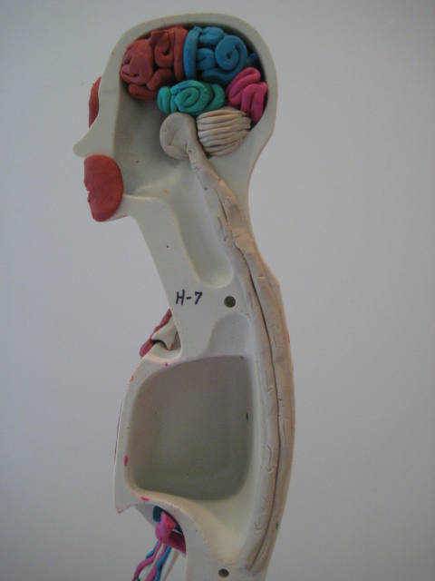
- Draw a picture of the brain and spinal cord you have created in your laboratory notebook. Label each part (shown in bold text in the directions) on this drawing.
- Investigate the function of the following brain regions:
- Cerebrum
- Frontal lobe
- Parietal lobe
- Occipital lobe
- Temporal lobe
- Cerebellum
- Brain stem
- Use the websites found below or reference textbooks to complete your investigation.
- PBS: The Secret Life of the Brain - 3-D Brain Anatomy http://www.pbs.org/wnet/brain/3d/
- Centre for Neuro Skills: Brain Map http://www.neuroskills.com/brain.shtml#map
- Create a table as shown below. This table can be drawn in your laboratory journal or assembled using Microsoft Excel or a comparable spreadsheet program. For each region listed in Step 49, describe the location of the area (using appropriate directional terms) and the primary function of the region. Limit your description of function to one sentence. Leave room at the bottom to add more regions and leave the two columns on the right blank. You will continue this table in the next activity.
Region of the Brain | Location | Primary Function
Cerebrum

Conclusion
- The gyri and sulci on the brain greatly increase the brain’s surface area. How do you think this increase in surface area relates to improved brain function?

- Can you think of another organ in the human body that is shaped specifically to increase surface area? How does this organ’s structure relate to its function in the body? (Hint: Think about those few bites of pancakes you ate in the opening paragraph.)

- Why do you think you created the frontal lobe of the cerebrum in the same color clay you used to create the three muscles of the face?

- From the names alone, what do you think are the specific functions of the motor cortex and the sensory cortex of the brain?

- What do you think the up and down arrows you carved into the spinal cord are meant to represent?

- How do the central nervous system and the peripheral nervous system work together to control the body?

- A man slips, falls and bangs the back of his head on the tile floor. The doctor tells him he has some minor swelling in the occipital lobe of his cerebrum. His doctor sends him home to rest and tells him that if there are any changes, he should come back in. What changes would be worrisome, given the area that was injured?

