Activity 1.2.1: What is DNA?

Introduction
In the last lesson, you analyzed the bloodstain patterns found at the home of Anna Garcia. Crime scene investigators use blood found at a crime scene to help them piece together the events that took place during the crime. They also identify the owner of the blood droplets to determine whether the blood belonged to a suspect, potentially placing that person at the scene of the crime. This process can help an investigator determine whether the death was the result of foul play. But how is blood used to identify a person? Blood contains a molecule found in all living organisms called Deoxyribonucleic Acid (DNA).

DNA is the hereditary material in humans and all living organisms. DNA can be thought of as the blueprint necessary for building all of the cells that make up organisms. DNA is a large molecule whose information is stored as a chemical code. The basic structural unit of DNA is called a nucleotide, which is composed of a deoxyribose sugar molecule, a phosphate group, and a nitrogenous base. The nucleotides link together in a series spiraling clockwise around a central axis forming a twisted ladder called a double helix. There are only four types of nitrogenous bases, and the sequence of these bases encodes the information that determines an organism’s traits.

The structure of DNA was not known until 1953 when two scientists, James Watson and Francis Crick, published a paper describing the three-dimensional structure of DNA as a double helix. They were able to deduce the structure through the information gleaned from numerous other scientists investigating DNA, including Erwin Chargaff, Maurice Wilkins, and Rosalind Franklin. Determining the structure of DNA marked a monumental milestone in the new field of genetics, opening the door to the detection of genetic predisposition to disease, the creation of new drugs to treat disease, and personalization of medicine based on individual genetic profiles. DNA can also be used to determine guilt or innocence of a suspect in a crime, and much more.

In this activity you will begin to investigate the structural composition of DNA by building a three-dimensional model of the molecule.

Equipment
- Computer
- Laboratory journal
- DNA Discovery Kit by 3-D Molecular Designs
- Student handout from DNA Discovery Kit

Procedure
Part I: DNA Overview
- In your laboratory journal, write down all of the information that you currently know about DNA.
- Share your ideas with your class.
- Watch the short video on DNA and write a summary in your notebook
https://learn.genetics.utah.edu/content/basics/dna
- With a partner, discuss how DNA evidence might be used in the case of Anna Garcia.
Part II: Build DNA
- With a partner, obtain a DNA Discovery Kit.
- Remove all the model pieces for the DNA molecule from the kit. Make sure each piece has been pulled apart into the following pieces.
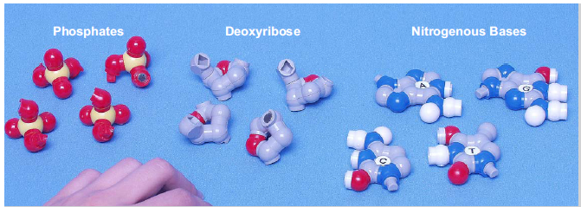

- Look carefully at each of the shapes. The “bumps” and round balls represent atoms. The different colors represent different types of atoms. The red ones represent oxygen; white represents hydrogen; blue represent nitrogen; yellow represent phosphorous, and grey represent carbon.
8. Sort the model pieces into piles so that each pile contains only like shapes. Examine the pieces carefully to be sure all pieces in one pile are alike.

9. Draw the following picture in your laboratory journal, make a sketch of a nitrogenous bases, a phosphate, and a deoxyribose. Note that there are four different nitrogenous bases: adenine (A), thymine (T), guanine (G), and cytosine (C). You are drawing all three parts together, which is called a nucleotide.
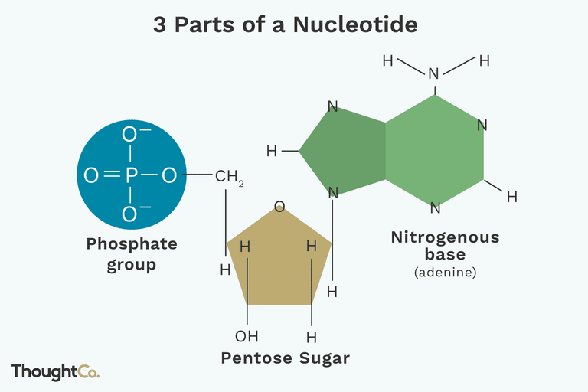
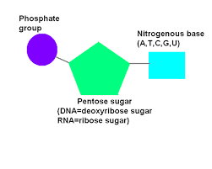

10. Note that DNA is a polymer, a large molecule made of repeating units (or monomers) called nucleotides. A nucleotide is made by combining a phosphate, a sugar, and a nitrogenous base, with the deoxyribose combining both to the phosphate and the nitrogenous base. Combine the three appropriate model pieces to make one nucleotide monomer. The model’s nucleotides are made by joining the appropriate pieces without using the magnets, as shown below.
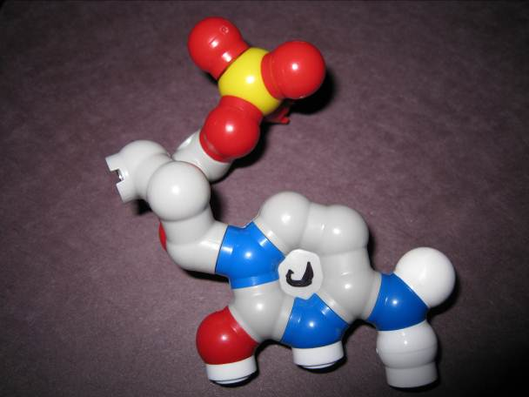

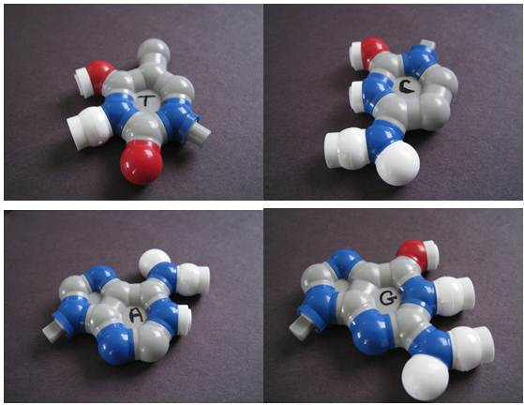
Here are the four nitrogenous bases:

11. Combine the rest of the model pieces to form a total of 24 nucleotides.
12. Compare the four types of nucleotides to each other. Note the similarities and differences you observe between the four nucleotides. Look very carefully.
13. In your laboratory journal, write a description of the similarities and the differences you observe between the four nucleotides. Look very carefully. If any of the nucleotides look more like each other than the other two, make a note of that similarity in your laboratory journal.
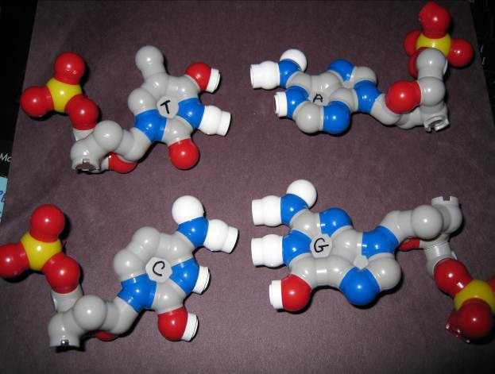

14. Note that in 1947, Erwin Chargaff determined that while the four nucleotides were not present in equal amounts in the DNA from different organisms, the amount of adenine was always the same as thymine and the amount of guanine was always the same as cytosine. This is what is known as Chargaff’s Rules. Look at the four nucleotides. What do you notice A and T have in common? What do C and G have in common? Record your observations in your laboratory journal.
15. Note that A and G both belong to a class of compounds called purines and that C and T belong to a class of compounds called pyrimidines. What do you notice that A and G have in common? What do you notice that C and T have in common? Write this in your lab journal.

16. Notice that the nucleotides have magnets on selected atoms. Try to combine the appropriate nucleotides together using the magnets to bond the two model pieces together. These bonds between paired nucleotides are called hydrogen bonds. Try to form nucleotide pairs using all of the nucleotides. Lay all of your pairs out on the table. Correctly paired nucleotides will easily stay linked to each other because their bonds are very stable. Where they bond to one another, there will not be any unpaired magnets.
17. Assemble the DNA molecule. To complete this task, use the experimental data outlined below as your guide. This is the same information that was available to Watson and Crick when they were working to determine the structure of DNA more than 50 years ago.

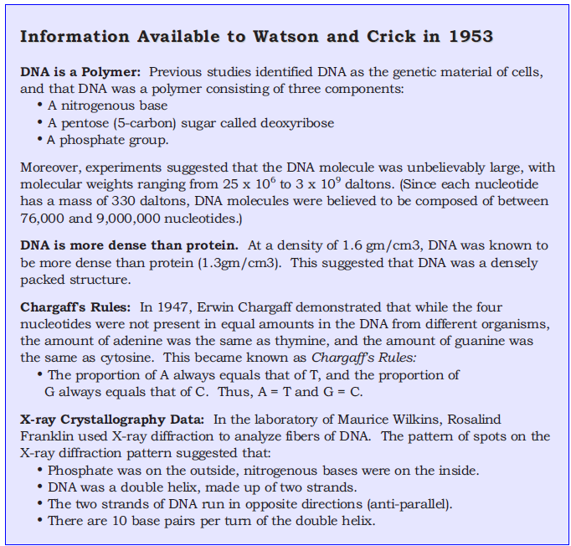

Conclusion
- What is the difference between the purines and the pyrimidines?

- Why do you think purines bond with pyrimidines in the DNA ladder?

- DNA has two strands. If the sequence of nucleotides of one strand was known, is it possible to use that information to determine the sequence of the second strand? Explain your reasoning for your response.

- Carefully compare your model to the model created by another group. Are the two models exactly the same? If they are not exactly the same, explain how they differ from one another and how these differences relate to human differences.

- Label the following on the diagram of DNA below: a base pair, a nucleotide, a deoxyrobose sugar, and a phosphate group. Designate at least one adenine (A), thymine (T), cytosine (C), and guanine (G) with the appropriate letter.

