Activity 1.1.2: Examining the Scene

Introduction
It was 10:20am on August 28th, 2019 in San Diego, CA. The police have searched the house and secured the scene. Because the manner of death has not been determined and there are no witnesses, the police are temporarily referring to the scene as a crime scene until they have more information. The scene appears to be limited to the front entry hallway, a 10’ x 10’ space. It is essential that the scene is systematically searched, documented, and all evidence is properly collected. You have already begun and will continue to play the role of crime scene investigators to examine the scene for clues.
Equipment
- Computer
- Laboratory journal
- PBS Course File
- Activity 1.1.2 Crime Scene Sketch
- Unit 1 – Investigative Notes Resource Sheet
- Activity 1.1.2: Crime Scene Search Methods (Optional)
Procedure
Part I: Organizing Ideas
- Note that it is your job in this unit to determine Anna’s manner of death. Was her death a homicide, an accident, or due to natural causes?
- Think about the best way to organize all of your evidence from Unit 1. Pay attention to the following listed below. Note: You will continue evidence analysis in the remaining parts of this unit.
  - Examination of the scene
  - Information gathered from the persons of interest, including whereabouts and potential motives
  - Analysis of evidence from the scene
  - Evidence from initial examination of the body

- You will use your Crime Scene Investigative Notes to help craft a final case report and determine the manner of death at the end of the unit.
Part II: Crime Scene Search Methods (Optional)
- Obtain a Crime Scene Search Methods resource sheet from your teacher.
- Familiarize yourself with each search method.
- Based on what you know about the scene, determine which search method you think is most appropriate. Discuss your ideas with a partner.
- Answer the question – Which search method do you think is most appropriate for this crime scene? Explain your reasoning.

Part III: Crime Scene Examination
- Create a new heading in your notebook -that says Clues.
- Review the background information about the crime scene below and add any clues that you believe can help you to determine the manner of death.
It was a hot, 92°F summer morning. The emergency call came in at 9:45 am. A man contacted the police to report that he was worried about his next door neighbor, a woman named Anna Garcia. He informed the police that he had spoken to Anna the previous morning when he saw her walking her dog around 6:30 am. He noted that she was wearing a sweater even though they were currently experiencing a heat wave. He decided to call the police that morning because Anna’s dog had been barking excitedly for the last two hours (which is extremely unusual in this normally quiet suburban neighborhood). He tried to call Anna on the telephone, but no one answered. Next he tried ringing her doorbell, but there was no answer. The 911 operator notified the local police and the emergency medical technicians (EMT). Both the police and the EMT arrived at the scene at 9:56 am. The front door had to be broken down. Upon entering the house, they found Anna lying face down in the entry hallway. It was a comfortable 73˚F inside the house. The EMT determined that Anna was dead. The police immediately notified your team of crime scene investigators as well as the medical examiner, both of whom were dispatched to the house. Has a crime been committed? The mystery begins! It is your job to put together as many pieces of information as you can find. (Don’t worry – the dog was taken to the home of close family friends and is doing just fine.)
- Add any pertinent information from the background information to your notebook. Note that you will now process the scene (either in person or via presentation).
- Obtain a Crime Scene Sketch Resource Sheet.
- Create a sketch of the scene on the Resource Sheet that includes a scale (remember that the crime scene is 10’ x 10’), a key, and a legend (which includes the date, time, location, and temperature). Use the crime scene sketch below as your example. NOTE: This diagram does NOT relate to Anna Garcia and is provided for clarification of what a diagram should include.
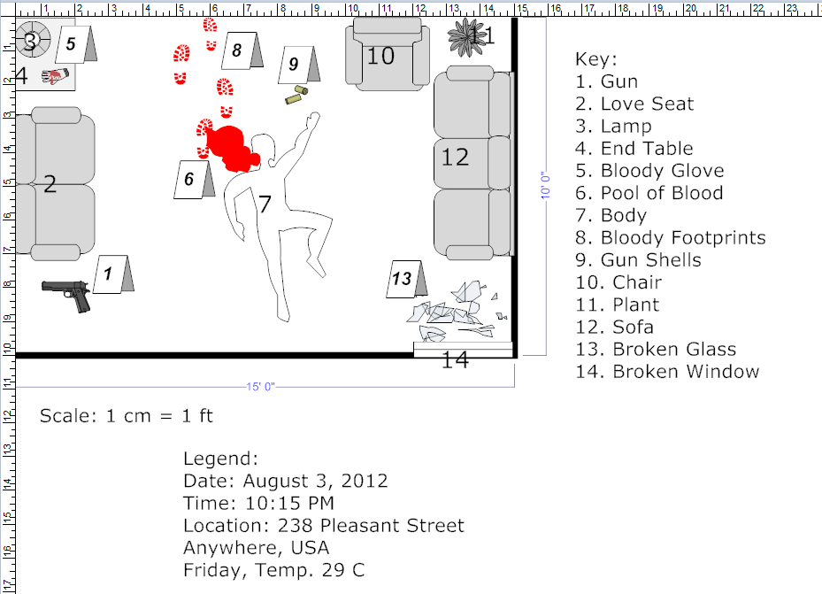
- Add a heading in your notebook sheet that saysTheories.
- Based on what you know so far, write down three theories for what you think might have happened to Anna. These should be detailed and include all the evidence from the crime scene.
- Answer the Conclusion question.
Conclusion
1. Why must your crime scene sketch use a scale and be very detailed and accurate?

