Activity 1.1.1: A Mysterious Death

Introduction
The biomedical sciences are involved in many facets of our day to day lives, including but not limited to research, medicine, health care, pharmacology, medical technology, and even forensics. Throughout this course, you will explore many of these areas and also experience some of the fields first hand as you play the role of biomedical science professionals. To begin your work, you find yourself in the middle of a mystery. A woman has died, and it is your job to uncover the clues that will lead you to determine how she died.

It was a hot, 92°F summer morning. The emergency call came in at 9:45 am. A man contacted the police to report that he was worried about his next door neighbor, a woman named Anna Garcia. He informed the police that he had spoken to Anna the previous morning when he saw her walking her dog around 6:30 am. He noted that she was wearing a sweater even though they were currently experiencing a heat wave. He decided to call the police this morning because Anna’s dog had been barking excitedly for the last two hours (which is extremely unusual in this normally quiet suburban neighborhood). He tried to call Anna on the telephone, but no one answered. Next he tried ringing her doorbell, but there was no answer. The 911 operator notified the local police and the emergency medical technicians (EMT). Both the police and the EMT arrived at the scene at 9:56 am. The front door had to be broken down. Upon entering the house, they found Anna lying face down in the entry hallway. It was a comfortable 73˚F inside the house. The EMT determined that Anna was dead. The police immediately notified your team of crime scene investigators as well as the medical examiner, both of whom were dispatched to the house. Has a crime been committed? The mystery begins! It is your job to put together as many pieces of information as you can find. (Don’t worry – the dog was taken to the home of close family friends and is doing just fine.)

In this activity you will set up a notebook that you will maintain throughout this course. You will use a strategy called concept mapping. A concept map is a diagram that visually represents the connections between ideas, concepts, or items. The concepts or items are connected by labeled arrows; the words on the arrows clarify the connections between the items. Because concept maps are good learning tools, you may find it very helpful to use them throughout this course to visualize ideas and to make connections. In this activity, you will follow directions to learn how to use the Inspiration® software and learn about the steps investigators use in order to process a crime scene.
Equipment
- Computer with Inspiration® software
- Inspiration® Resource Guide
- Laboratory journal
- 3-ring binder, file folders, or electronic file or portfolio
- Course Materials Organization Resource Sheet
- PBS Course File – Table of Contents
Procedure
Part I: Course Materials Organization
In this course you will compile many documents related to your exploration of the biomedical sciences as well as your investigation of the mysterious case of Anna Garcia. Organization of your files will be key to help you succeed in the course and solve the case. Throughout the year you will compile a PBS course file, either electronic or physical, to maintain a record of your work. Follow the directions below to organize your course materials.

- Obtain a Course Materials Organization Resource Sheet and read the directions on how to set up your course file.
- Follow the instructions on the Resource Sheet to make the necessary tabs/folders for your course file.
- Obtain a PBS Course File – Table of Contents. Place this document at the beginning of your course file. Throughout the year, place a check mark in the appropriate column whenever you file a document. Use this table of contents to help you organize your materials and to assure that you have every necessary document.
- File the Course Materials Organization Resource Sheet in the PLTW Resource Sheets tab of your course file. Place a check mark in the appropriate column on the PBS Course File – Table of Contents.
Part II: Processing a Crime Scene Concept Map
Although every crime scene is unique, five basic tasks need to be completed in order to properly process a crime scene. These tasks are: interview, examine, photograph, sketch, and collect the evidence. NOTE: The order of these tasks may vary depending on the particular situation.

- Start Inspiration® software on your computer. You are going to build a concept map showing information about crime scene processing.
- Obtain an Inspiration Resource Guide to use as a resource as you navigate through the software. Play around with Inspiration to become familiar with how it works.
- Open the program, click on the Diagram icon 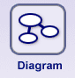 in the Inspiration Starter window. You will see an oval symbol appear with the term main idea printed and highlighted in the center. This oval symbol represents the main idea or topic of the concept map. If the Starter window does not appear when you open the program, then look to see if a symbol appears in the main window. If not, select the Diagram icon from the top toolbar.
- Type the title Processing a Crime Scene. What you typed should replace the main idea label. If not, press the control key and the letter z at the same time to undo your typing, then use the mouse cursor to select the text main idea and type Processing a Crime Scene.
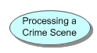
- On the left side of the window screen, and you should see a Symbol palette. If you don’t see a selection of symbols, press the Control key and the number 8 at the same time. The palette should now appear.
- Move the cursor to the left of the Processing a Crime Scene symbol you just made and click. You should see two crossed lines. The lines indicate the target where the next symbol will be placed. If you don’t like where the target is, just move the cursor where you want the next symbol and click again.
- Go to the symbol palette and click on the oval symbol. An oval symbol should appear on your screen where the crossed lines were.
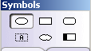

- Type Interview to label this symbol. What you type should appear in the center of the new symbol. If not, click inside the symbol so that a dotted box appears inside the oval, and then type the label.

- Click on the Processing a Crime Scene symbol, and then select the Link icon on the top toolbar. A line will appear; click on the Interview symbol. Your diagram should look like the picture below.
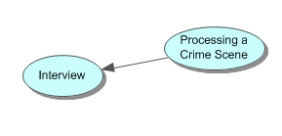
- Click to the bottom of the Processing a Crime Scene symbol and create a new oval symbol.
- Type Examine to label the new symbol. Attach an arrow between the Processing a Crime Scene symbol and this new one by clicking on the Processing a Crime Scene symbol and using the Link tool.
- Create three new symbols labeled Photograph, Sketch, and Collect Evidence around the Processing a Crime Scene symbol.
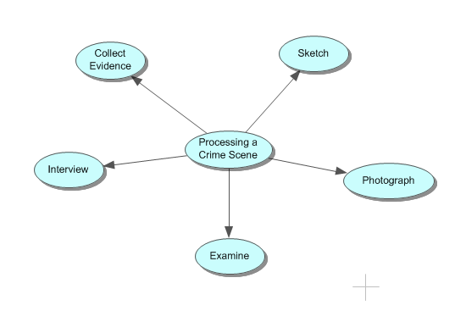
- Click on the Processing a Crime Scene symbol and select the rectangular shape from Symbols palette. Your diagram should look like the picture below.
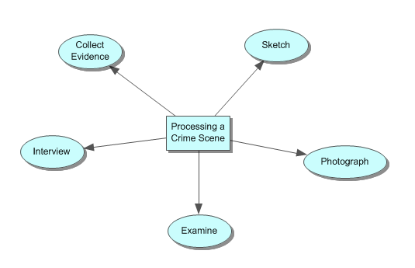
- Change the color of the rectangular symbol by choosing the Fill Color icon in the bottom tool bar. The icons that control the color of the symbols and lines are located on the bottom tool bar and look like this:. Each of these icons has a different function. The one on the far left is the Undo button. The middle one controls the fill color of the selected symbol, and the far right one controls the color of either the connecting lines or of the symbol border depending on what is selected. Click on the rectangular symbol, and then click on the middle color icon. A color chart appears; choose a different color.
- Go to the side of the Interview symbol and create a new oval symbol labeled Establish the theory of the case. Connect this symbol to the Interview symbol using the link tool.
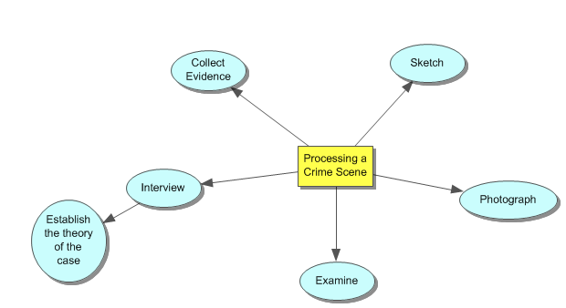
- Click on the connecting arrow between Interview and Establish the theory of the case. A text box appears. Type the word goal is to. Concept maps have words indicating the connection between the items linked by the arrows. These connections can be presented as single words or phrases.
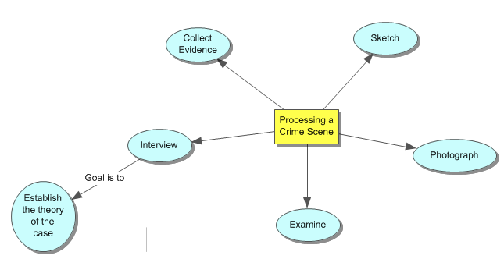
- Go to the side of the Establish the theory of the case symbol and create three new oval symbols. Label the symbols What happened? Did a crime take place? How was the crime committed? Connect these symbols to the Establish the theory of the case symbol using the link tool.
- Click on the connecting arrow between Establish the theory of the case symbol and each of the symbols containing questions. Type the phrase asks the question. You can now see how these connecting terms help with reading the map. Your map should look similar to the diagram below.
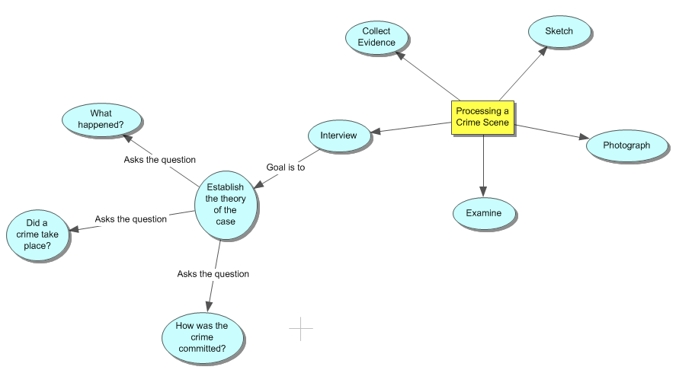
- Complete the concept map using the diagram below as your guide. Feel free to experiment with the colors, fonts, and styles as you complete your map.
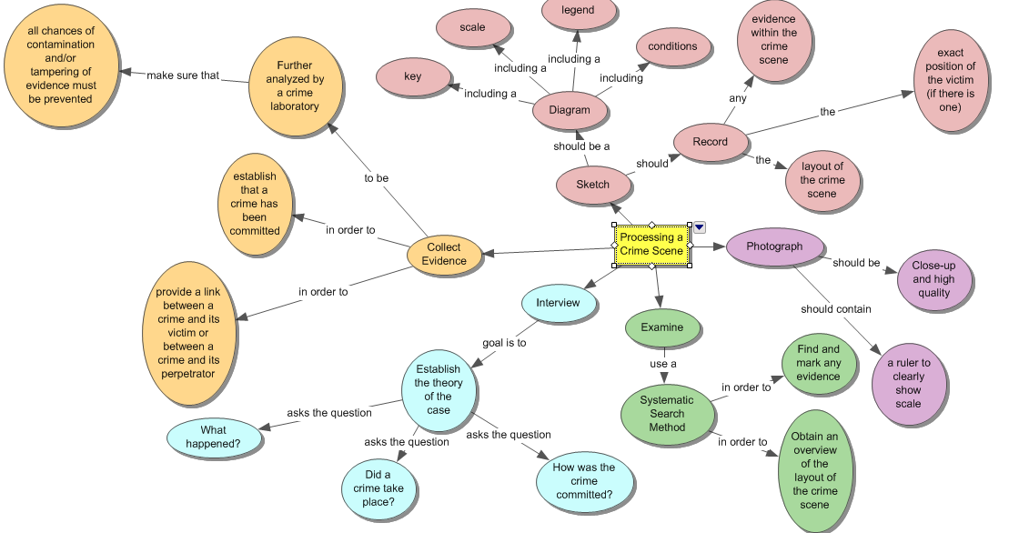
- Read through your completed map and print and attach a copy in your laboratory journal.
- Click on the Outline icon in the top toolbar. The diagram becomes an outline. Notice that the words on the arrows are not included in the outline; however, the hierarchical structure is maintained and represented in the structure of the outline. You can use Inspiration to produce both outlines and diagrams, and you can begin with either format. If you prefer outlines, you can type the outline and have Inspiration make the diagram. If you prefer diagrams, you can make the diagram and have Inspiration make the outline. You choose which form you want to work with by selecting the appropriate icon from either the Starter window or the top toolbar.
- Answer the Conclusion questions.
Conclusion
- Why are concept maps a useful tool for organizing information?

- Why do you think it is important to complete the five steps of crime scene processing when investigating a suspicious death?

- Throughout this unit, you will investigate the mysterious death of Anna Garcia. Make a list of six specific questions that need to be answered during the investigation of Anna’s death. At least half of the questions must directly involve the medical condition of the victim. Note: The questions must be specific—not “What caused the death?”

